**DeepAR Electric Vehicle Demand Prediction**

Jose Peeterson

Research Engineer

NTU-Continental Corporate Lab

Table of Contents

1. Introduction 5

1.1 Problem statement 5

1.2 Proposed solution 5

1.2.1 Vehicle Rebalancing 5

1.2.2 Summary of feasible Demand Prediction solutions 6

1.2.3 Mindmap 7

2. Data Wrangling 8

2.1 Spatial and Temporal Aggregation 8

3. Exploratory Data Visualization and Analysis 10

3.1 Input data 10

3.2 Exploration of Target time series 10

3.2.1 Stationarity 12

3.2.2 Target Frequency distribution 12

3.2.3 Hourly seasonality 13

3.2.4 Daily seasonality 19

3.2.5 Weekly seasonality 25

3.2.6 Indirect and direct Correlation due to lags 27

3.3 Exploration of Covariate time series 31

3.3.1 Pearson correlation between target and covariate time series 33

3.3.2 seasonal analysis of covariate time series 41

3.3.3 Cross-correlation plots and Granger Causality 54

4 Spatial and Temporal Segregation of predicted cluster demand 61

4.1.2.5.1 Persistence model 61

4.1.2.5.2 XGBOOST model 61

5 Baselines 62

5.1 Persistence Model 62

5.1.1 Test Results 62

5.1.2 Shortcomings 62

5.1.2 Target time series analysis in the prediction horizon 63

5.2 Statistical Models 64

5.2.1 SARIMA 64

5.2.2 Autoregressive conditional Negative-binomial model (ARCNBM) 69

6. DeepAR 74

6.1 Introduction 74

6.2 Sequence to Sequence Model 78

6.2.1 Working Principle 79

7. DeepAR Code Development 81

7.1 Codebase specifications 81

7.2 Reproducibility 82

7.3 Data Pre-processing 82

7.3.1 Weather data 82

7.3.2 Demand data 83

7.3.3 Data visualization and Feature Engineering 84

7.3.4 Train, Validation and Test dataset creation 88

7.4 Training, Validation and Testing using Pytorch-forecasting 89

7.5 Automatic Hyperparameter Tuning 90

7.5.1 Optuna 90

7.5.2 Loss curves 93

7.6 DeepAR Test results 94

7.6.1 Cluster-wise Results 94

7.6.2 Region-wise Results 100

8. Troubleshooting and debugging 103

8.1 Model Troubleshooting 103

8.1.1 Error Troubleshooting example 103

8.1.2 Comparison between cluster-wise and Region-wise DeepAR prediction 104

8.2 Code errata and bug fixes 105

9 Gaps and Improvement suggestions 106

10 Github Code repository 107

11 Production 107

11.1 Deployment 107

12 Appendix 108

FFT of weekly demand time series (10 weeks) 108

IFFT of weekly demand time series (10 weeks) 111

Seasonality near weekend 114

Seasonality near weekdays 114

Daily Seasonality across weeks (HEATMAP) 115

Daily Seasonality across weeks (TREEMAP) 117

Weekly distribution for each month 119

Seasonality across different days of a week (TREEMAP). 120

Seasonality across different days of a week (HEATMAP). 123

Frequency distribution plot of temperature 126

Hourly temperature boxplot 127

Treemap of weekend temperature seasonality 127

Treemap for weekdays temperature seasonality 128

Daily temperature boxplot 128

Frequency distribution plot of humidity 129

Hourly humidity boxplot 129

Treemap of weekend humidity seasonality 130

Treemap for weekdays humidity seasonality 130

Daily humidity boxplot 131

ARCNBM of the remaining 5 models 131

Detailed Block DiagrAM 135

13 FAQ 136

14 Bibliography 136

# 1. Introduction

## 1.1 Problem statement

Station-based EV (Electric Vehicle) systems (human drivers or autonomous) suffer from **spatial-temporal supply-demand imbalance** problem due to the disparity in the popularity of the stations, i.e., there are no EVs at stations where the customers need them, while at the same time there are idle standing EVs at other stations. This leads to sub-optimal fleet utilization, high waiting times for the customers and unmet demands.

## 1.2 Proposed solution

### 1.2.1 Vehicle Rebalancing

To mitigate this problem, there is a requirement for a system that can control the EV distribution among the stations.

More specifically, a system that can calculate which idle standing EV should be removed from the station where it is currently parked (where it has a low chance of getting rented) and moved to which destination station - vehicle rebalancing decisions.

Vehicle rebalancing decision is a complex decision that requires information about the idle standing vehicles, enroute vehicles, upcoming demands, and available parking station capacity to be considered.

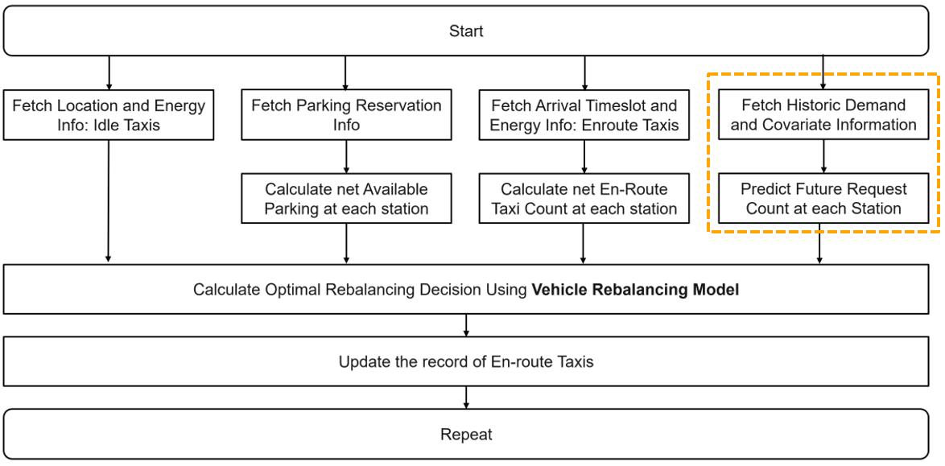

Figure : Vehicle Rebalancing Solution block diagram with demand prediction blocks

### 1.2.2 Summary of feasible Demand Prediction solutions

Electric Vehicle (EV) Demand Prediction is necessary to perform effective EV rebalancing and meet future demand to maximise the expected profits at the end of a period. Historical EV demand data is considered as a count time series made up of small positive integer values denoting the number of cars. This data can be supplemented by information such as present and future weather, vehicle request queues, subscriber driving patterns, locality patterns and date information.

Classical time series Prediction techniques such as ARIMA are mainly tailored for real values that change continuously and exhibit visible trends and seasonality. However, count time series are made-up of sporadic spikes that show no visible patterns to the naked eye. Deeper analysis of the count time series using time series decomposition, Autocorrelation and Partial autocorrelation plots are required to reveal trends, seasonality and autoregressive terms that will help to model the count time series using probabilistic methods.

Count time series prediction models can be broadly classified into Statistical and Machine Learning techniques.

Statistical count time series modelling approaches include historic averaging (HA), exponential smoothing, Conditional Poisson and Negative Binomial autoregression models and Zero-inflated models. These models have the advantage of being interpretable, but they are not complex enough to capture all the patterns and correlations in the data. These models are also labour intensive as they require manual analysis for model parameter selection. They also require some contextual information provided manually to group the right time series when performing cross correlations between time series from the right clusters that may be geographically distant from each other. Statistical models are generally used as baselines to compare with machine learning techniques.

Machine learning techniques for Demand Prediction include Autoregressive Recurrent Neural Networks that can predict the probability distributions of data at different time intervals. Albeit less interpretable, they can handle cross-correlations between different clusters at different times for all the time series automatically. They can learn the complex patterns in data and improve prediction accuracy.

### 1.2.3 Mindmap

Mind map of the brainstorming and solution development process is summarized in the image below:

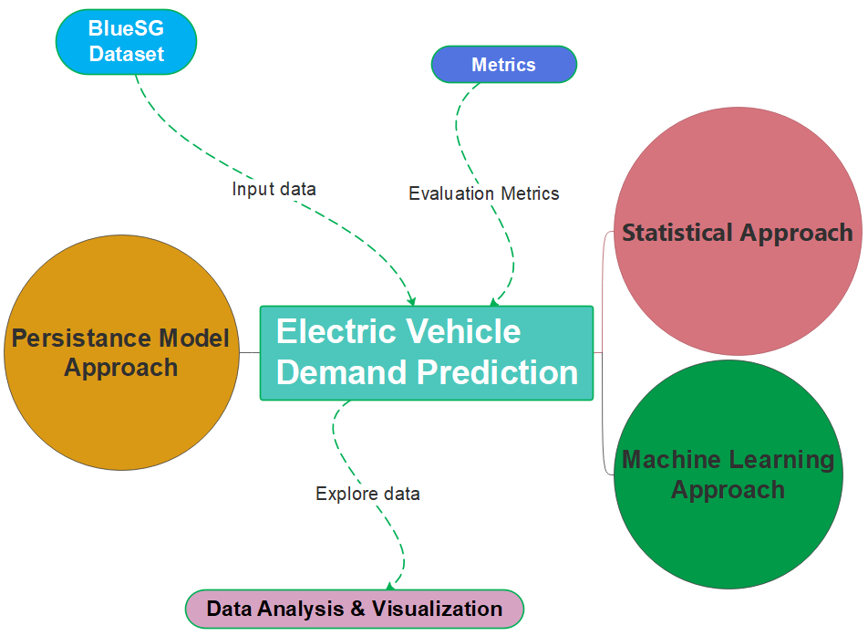

The details of each of these blocks can be see in the mind map file below:

**Source files:**

1. Mind_map.emmx

# Data Wrangling

## 2.1 Spatial and Temporal Aggregation

The instantaneous historic EV inflows and outflows at all charging stations are aggregated every hour. A cluster is then formed by grouping a few neighbouring charging stations. A cluster is chosen such that all stations within the cluster are no farther than 0.5KM from each other. In this way a person making a request from within the cluster can easily walk to the EVs.

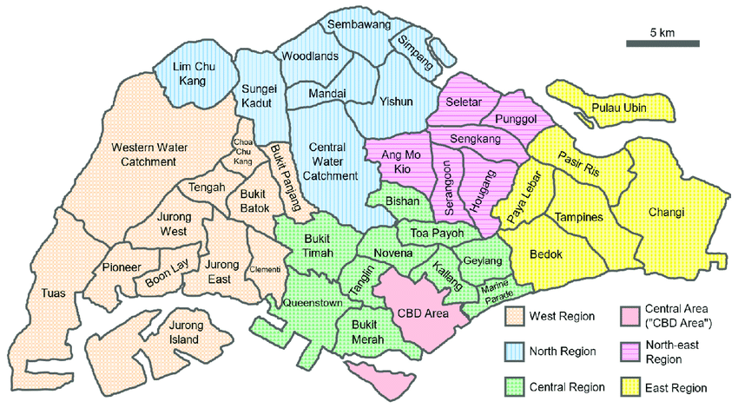

Figure : All regions in Singapore

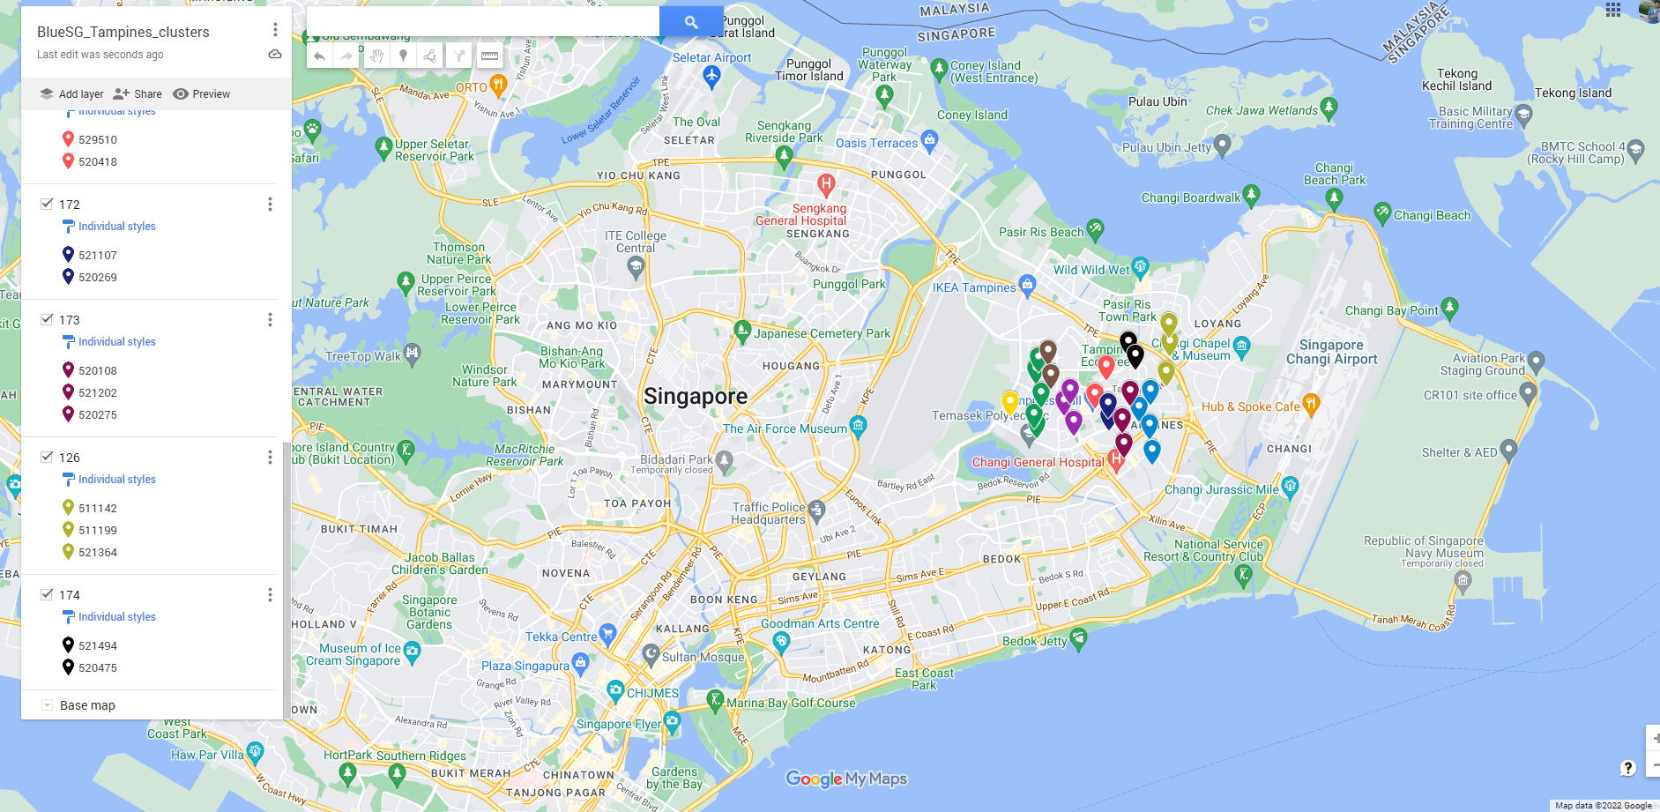

Figure : Clusters (distinct colour) marked in the Tampines region

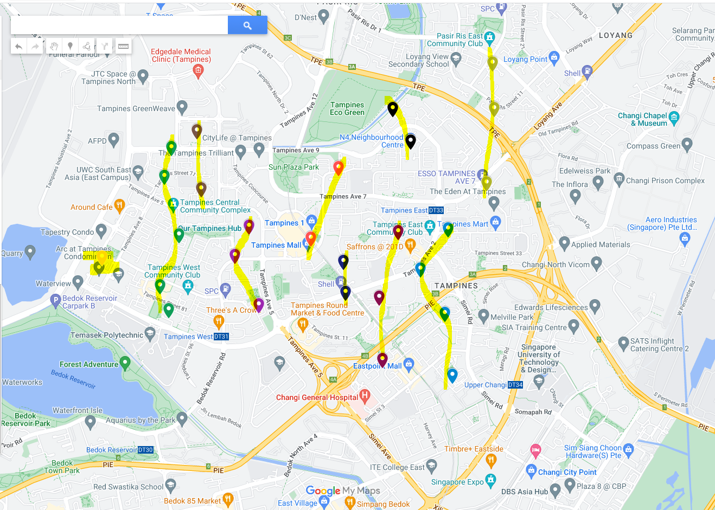

Figure : charging stations (same colour) in each cluster of the Tampines region

EV Demand Prediction is typically performed at a cluster level every 1-hour time steps for a few time steps into the future. Cluster-wise hourly predictions ensure a good trade-off between Demand Prediction accuracy and station-level predictions. The demand data at station-level is very sparse and therefore requires some form of aggregation temporally or multiple station-wise to make any patterns discernible. It is imperative that the models learnt are based on data that show some underlying persistent and learnable patterns so that the predictions will be accurate and consistent.

# Exploratory Data Visualization and Analysis

## 3.1 Input data

In cluster-wise prediction, the target time series is the EV demand time series of a **single** cluster within a region. The covariate time series are 2 neighbouring cluster demands, weather data, EV supply, and date information of the target cluster. The covariates also include known lagged versions of the demand time series based on seasonality. The weather data is composed of a categorical time series called weather description and two numerical time series called humidity and temperature. Date information includes 7 categorical time series including hour-of-the-day, day-of-the-week, day-of-the-month, day-of-the-year, week-of-the-year, month-of-the-year, and year.

In region-wise prediction, the target time series is the demand time series of **all** the clusters within a region. The covariates from all the clusters in the region are included.

## 3.2 Exploration of Target time series

Covariate information may not be necessary every time as most of the information needed to predict the target time series can be found within the target time series itself. Therefore, it is necessary to explore the persistent underlying patterns that is propagated in the target time series.

***Identifying these patterns in advance through exploratory studies enables us to cross-check the existence of these patterns in the predictions of the learned models. Thus, ensuring that the models also learn these patterns to make accurate predictions.***

***These exploratory studies aid in troubleshooting wrong predictions from models. It identifies which patterns are not learnt by the model.***

Here onwards, 10 weeks of hourly demand time series of Cluster 175 of the Tampines region is chosen as the target time series for illustration.

**Source code files:**

1. *data_viz_analysis_3_lags.ipynb*

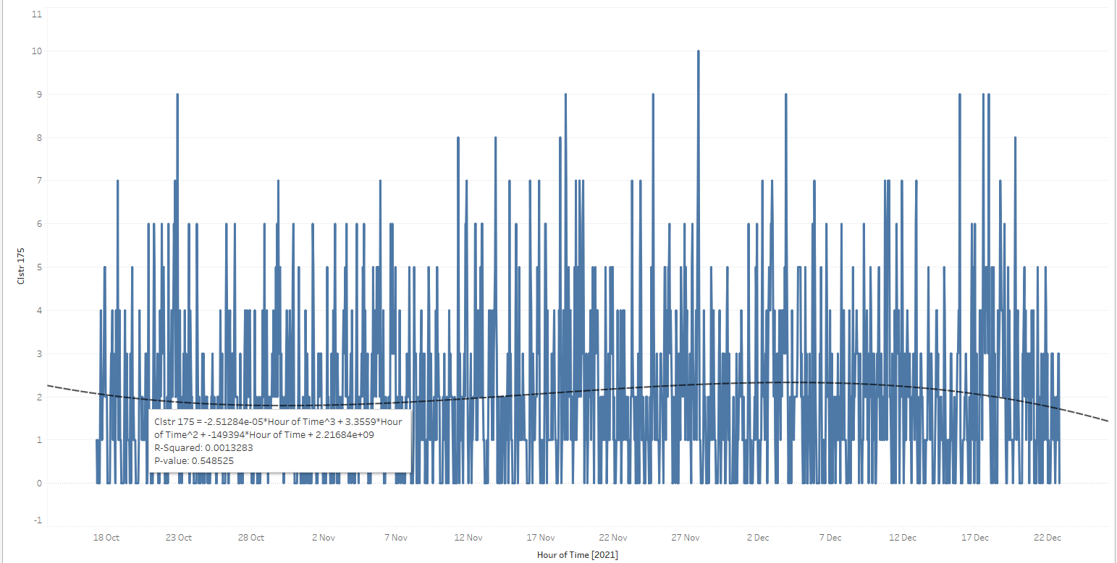

Figure : 10 weeks of Hourly demand time series of cluster 175 in Tampines region

Visually, the target time series does not have a trend, and this is true for most of the clusters in Singapore. The mean is relatively constant around 2 cars for cluster 175 as shown above. Therefore, exploring seasonality in detail is more meaningful for the demand time series.

The following seasonal patterns are explored:

1. Hourly seasonality

* FFT and IFFT of demand time series
* Total demand distribution at each hour of the day. (Boxplot)

1. Daily seasonality

* Hours of same day across weeks
* Total demand distribution at each day of the week. (Boxplot)
* Trend cycle within a day

1. Weekly seasonality

* Different week across weeks
* Summed hours of days of week across weeks
* Total demand distribution at each week of the data. (Boxplot)
* Trend cycle within a week
* Trend cycle within a month (sub-seasonal charts)

1. Indirect and direct Correlation due to lags

* ACF
* PACF

Seasonality is not exactly deterministic but stochastic with a small variance on the seasonal period.

### 3.2.1 Stationarity

**Purpose:** The Augmented Dickey–Fuller (ADF) test ensure that statistical properties are time-invariant. All numerical time series are checked for ADF test.

**Observation:**

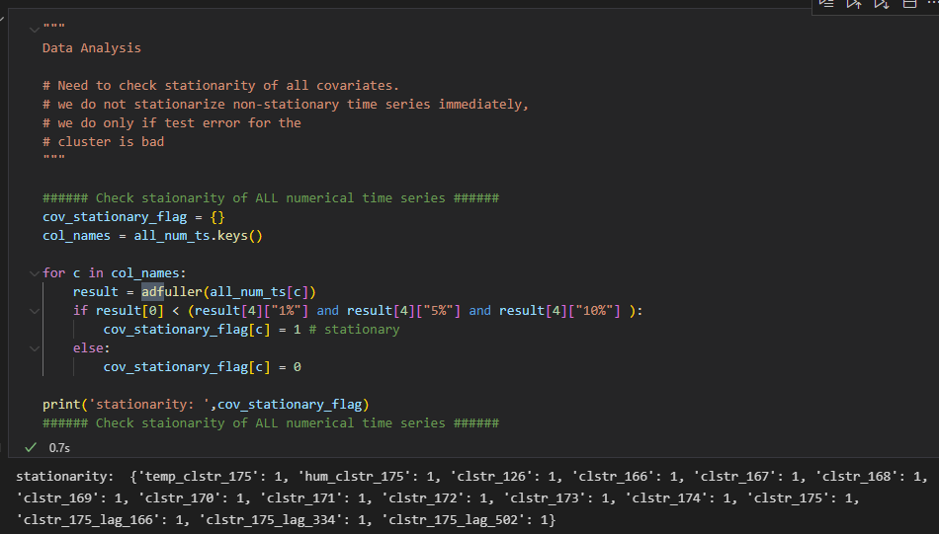

Figure : Stationarity of all the time series

**Inference:** The time series are stationary.

### 3.2.2 Target Frequency distribution

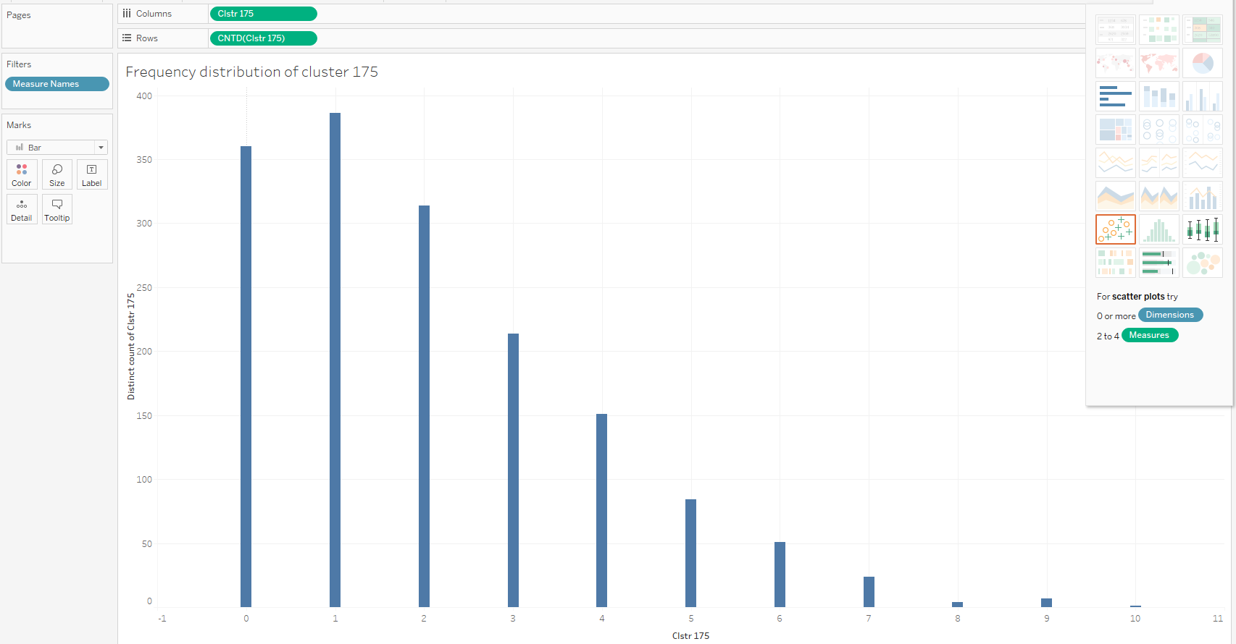

Figure : Frequency distribution of demand time series

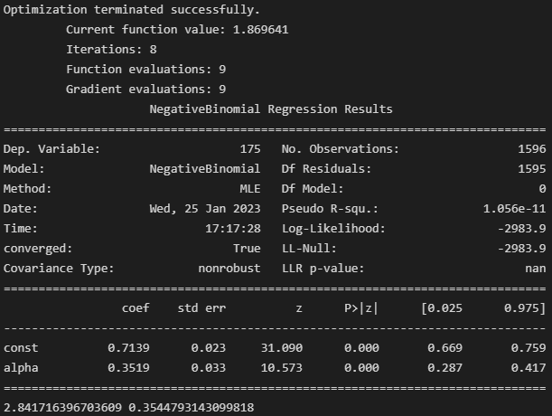

Figure : Fitting a negative binomial distribution to data

**Purpose:** Identify if the data distribution follows a negative binomial distribution as this is an assumption made by the models.

**Observation:** k = 2 and P = 0.35

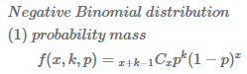

**Inference:** Target follows a negative binomial distribution.

### 3.2.3 Hourly seasonality

#### 3.2.3.1 FFT and IFFT of demand time series

**Purpose**: Fast Fourier Transform (FFT) of the hourly demand time series can identify cyclic behaviour like business/economic cycles that may be unique to the cluster and do not follow the regular seasonal patterns. It is difficult to make educated guesses of these patterns. E.g., for residential clusters, there is a regular activity every 5-6 hours indicating that people go to office in the morning, go for lunch in the afternoon, go to shopping in the evening, go for dinner at night and go home late at night and repeat the cycle.

Through FFT, the significant frequencies and their phase can be identified. These frequencies account for the largest peaks of the demand time series.

Reconstructing the demand time series using Inverse Fast Fourier Transform (IFFT) by only including the significant frequencies allows for locating the peak occurrences at specific times of the day and week. This helps to identify the busy times at the cluster. It will be advantageous to ensure sufficient supply at this cluster during these times. The prediction model is expected to not make very low or other erratic predictions at these times.

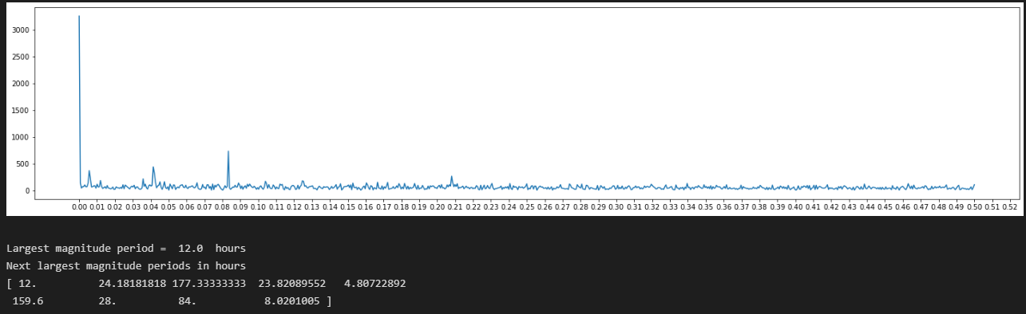

Figure : FFT of demand time series for 10 weeks

The FFT of weekly time series for 10 weeks is given in appendix. IFFT is obtained using the 11 largest frequencies. IFFT of demand time series for every week is given in appendix.

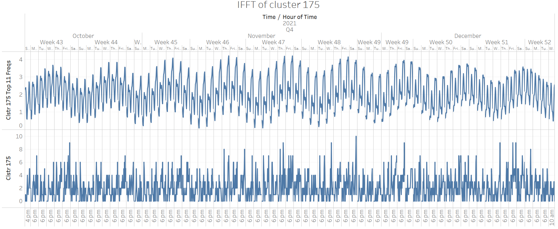

Figure : IFFT of cluster 175

**Observation**:

FFT

* Full 10 weeks data
  + Persistent periods at: 12, 24,177.33, 4.8, 8.02 hrs
* Weekly data for 10 weeks (in appendix)
  + Persistent periods across weeks at: 12, 24, 4.8, 8 hrs

IFFT

* Largest demand for full 10 weeks data
  + In weeks 43 and 44, on Wednesday and Thursday
  + In weeks 45 to 49, on Wednesday, Thursday, Friday, and Saturday
  + In weeks 50 to 51, on Thursday, Friday, Saturday, and Sunday
* Weekly data for 10 weeks (in appendix)

Table : Busy hours

|  |  |  |
| --- | --- | --- |
| **Week** | **AM (Busy)** | **PM (Busy)** |
| 43 | 5, 6, 8, 10 | 5, 7, 8, 9 |
| 44 | 6, 10 | 4 ,7 ,8 |
| 45 | 6, 10 | 4, 8, 9 |
| 46 | 6, 7 | 4, 6 ,8, 9 |
| 47 | 7, 9 | 4, 6, 8, 9 |
| 48 | 6, 7, 8, 11 | 5, 6, 7, 8, 9 |
| 49 | 7, 11 | 5, 7, 9 |
| 50 | 7, 11 | 5, 7, 9 |
| 51 | 7 | 5, 6, 7, 9 |
| 52 | 7 | 5, 6, 7, 8, 9 |

**Inference**:

IFFT

* Largest demand for full 10 weeks data
  + In general, largest demands are near the end of the week (Friday).
  + Within each week, there is a rising trend near Thursday, Friday and Saturday and falling trend near Sunday, Monday, and Tuesday.
* Weekly data for 10 weeks (in appendix)
  + Table 1 appears to show that 6-7 AM, 5-6 PM and 7-9 PM every day is a busy period in the morning and evening. 10-11 AM is a lesser busy period.

#### 3.2.3.2 Demand distribution at each hour of the day.

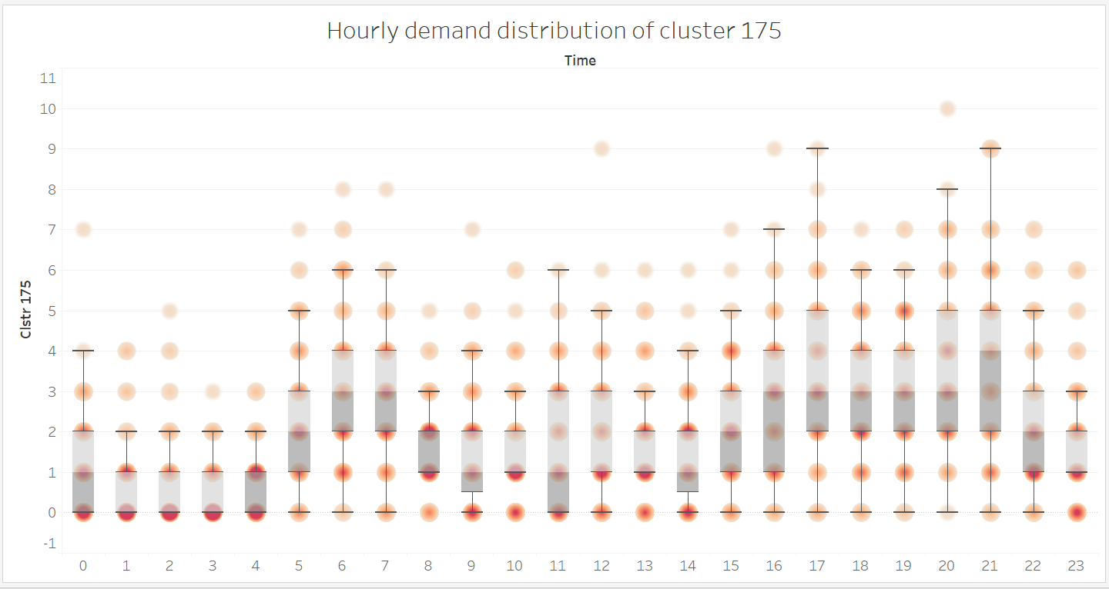

Figure : Hourly demand distribution of cluster 175

**Purpose:** The boxplot identifieshours with high and low demand. Identify the highest frequency demand value (mode) using density (darker shades). It shows the 25th, 50th (median) and 75th percentile. It also shows hours with extreme values that lie outside 1.5x Interquartile range (whisker).

**Observation:**

* For 6 AM, 25% of data lies below demand value of 2, 50% of data lies below demand value of 3, 75% of data lies below demand value of 4.
* The hours between 1 – 4 AM have the least variance and have demand value closest to zero. The density is darkest at 0 demand value.
* In the morning, the darker shades of 5 AM to 8 AM has non-zero demand value between 1 and 4. Mode of 2. 10 AM also has a non-zero demand value of 1.
* In the afternoon, the darker shades of 12 PM to 4 PM has non-zero demand value between 1 and 4. The variance is large at 4 PM.
* In the evening, 5 – 9 PM is the busiest of hours with mode demand value of 3. There is a 50% chance that demand value will be > 3. At 9 PM, there is a 50% chance that demand value will be > 4.
* At night, from 10 PM – 12 AM, the mode value is 0 or 1.

**Inference:**

* Low variance (shorter box length) indicates that predictions can be made in a tighter confidence interval and vice versa. The lower and upper quartile of the box encloses 50% of the data. The high median value of hours 5 – 9 PM indicates demand is easier to predict here.

#### 3.2.3.3 Seasonality during Weekend for entire data

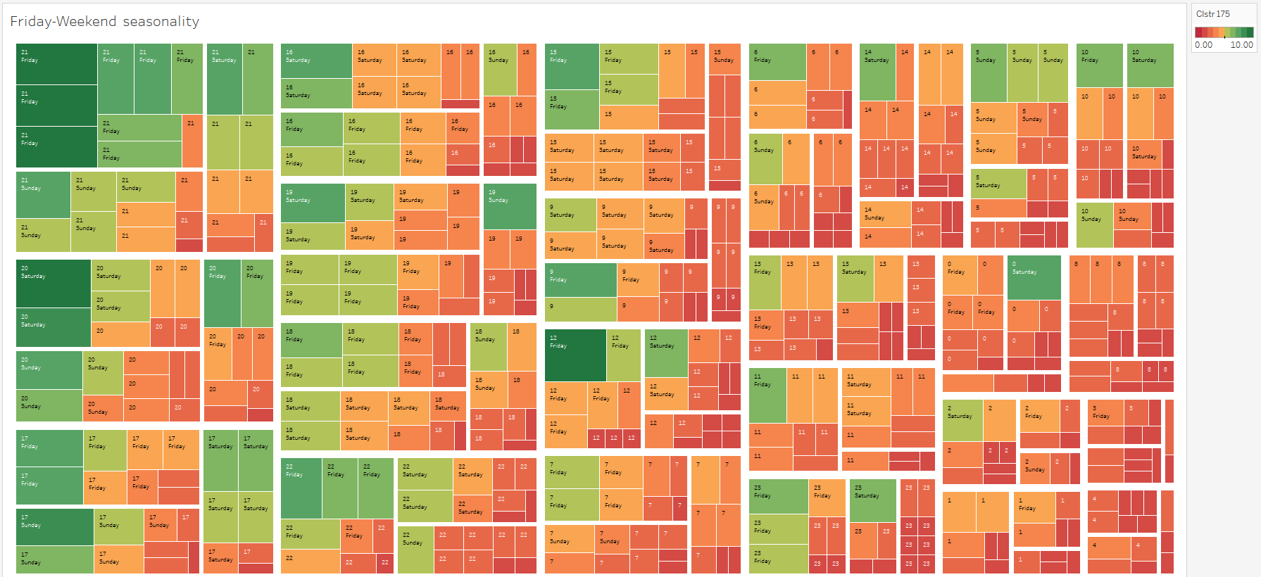

Figure : Treemap of weekend seasonality in demand

A similar TREEMAP for Thursday, Friday and Saturday can be found in the appendix.

**Purpose:** For the days Friday, Saturday and Sunday the TREEMAP identifies hours with number of occurrences of non-zero demand by the number of boxes and identifies magnitude of demand value through colour. The cluster of boxes top left corner indicates busy hours with the most non-zero demand occurrences and the largest demand value. Vice versa for the bottom right corner. It shows hours with high/low demand that is common to the 3 days in the top-left and bottom-right.

**Observation:**

|  |  |  |  |
| --- | --- | --- | --- |
| **DAYS (Weekend)** | **Idle hours**  (majority reddish) | **Moderately busy hours**  (greenish and reddish) | **Busy hours**  (majority greenish) |
| Friday, Saturday, and Sunday | 1,2,3,4,8AM | 6,7 PM | 4,5,8,9 PM |

**Inference:**

* Busy hours are in early evening and early night
* Moderately busy hours are in the evening
* Idle hours are in the morning and early mornings

#### 3.2.3.4 Seasonality during Weekdays for entire data

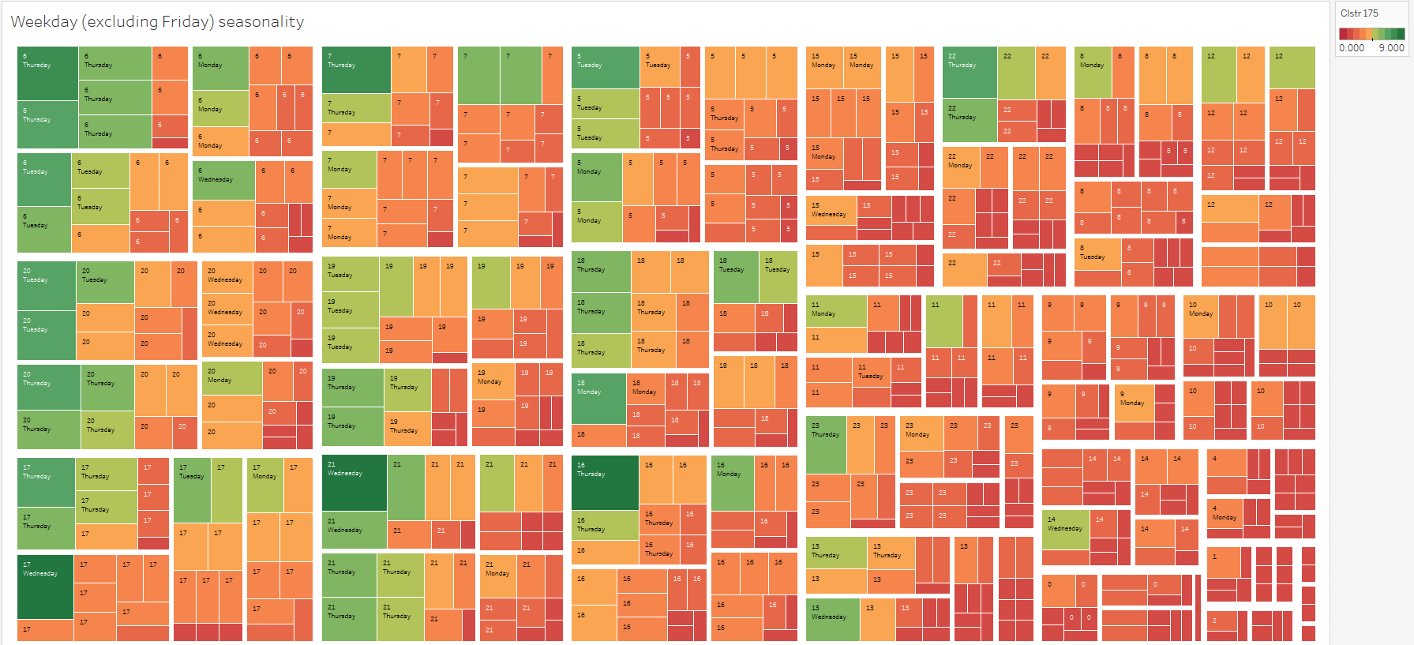

Figure : Treemap of weekdays seasonality in demand

**Purpose:** For the weekdays Monday, Tuesday, Wednesday, Thursday we want to see hours with high/low demand that is common to the 4 days in the top-left and bottom-right of the TREEMAP.

**Observation and Inference:**

|  |  |  |  |
| --- | --- | --- | --- |
| **DAYS (Weekdays)** | **Idle hours**  (majority reddish) | **Moderately busy hours**  (greenish and reddish) | **Busy hours**  (majority greenish) |
| Monday, Tuesday, Wednesday, Thursday | 9,10 AM 2 PM | 6,7 PM | 6,7 AM, 5,8 PM |

### 3.2.4 Daily seasonality

#### 3.2.4.1 Hourly demand of same day across weeks

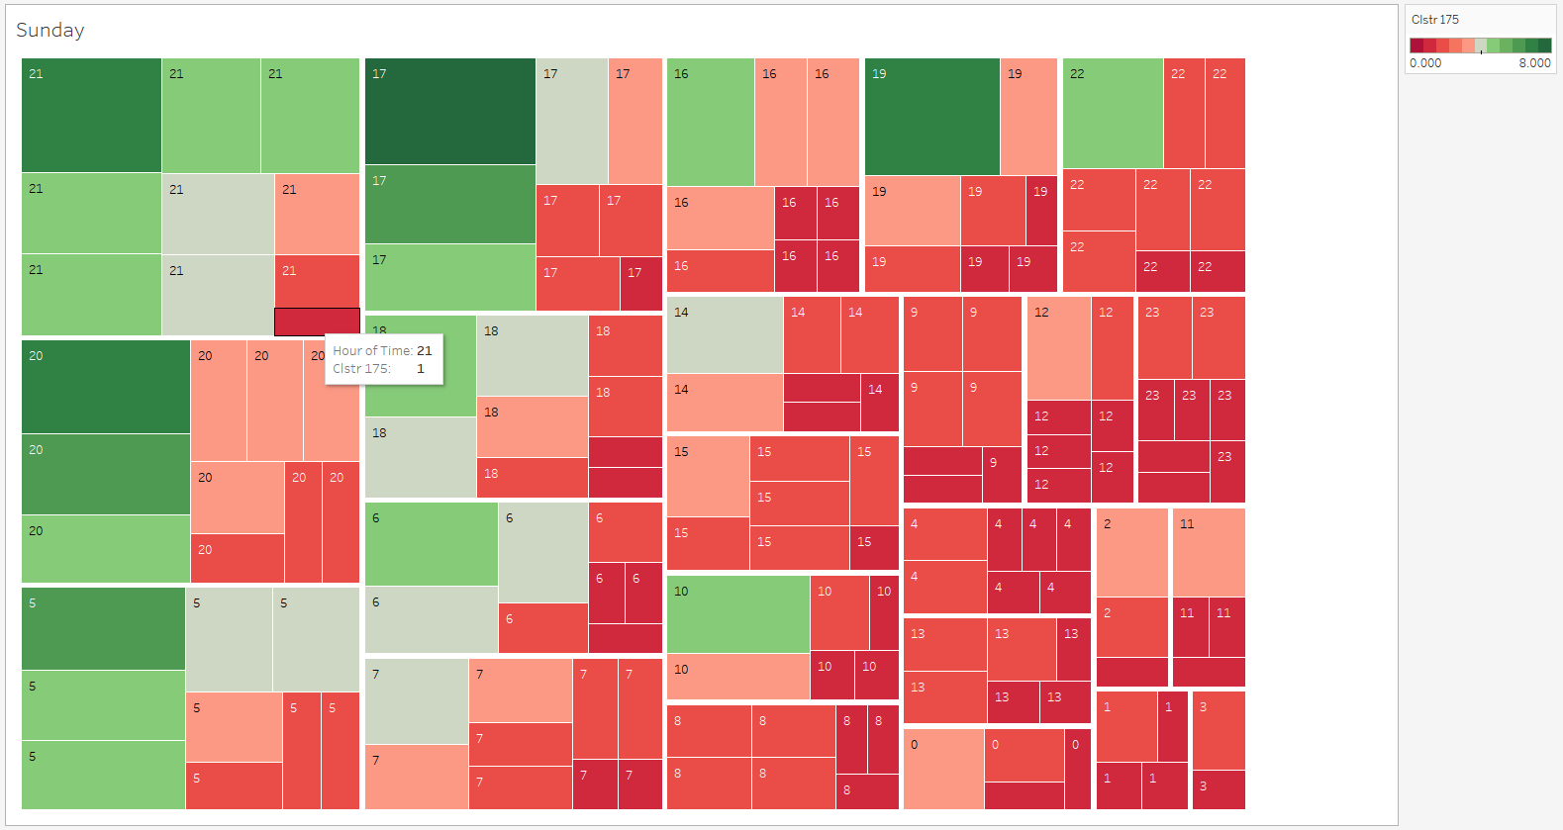

Figure :TREEMAP of hourly demand on all Sundays

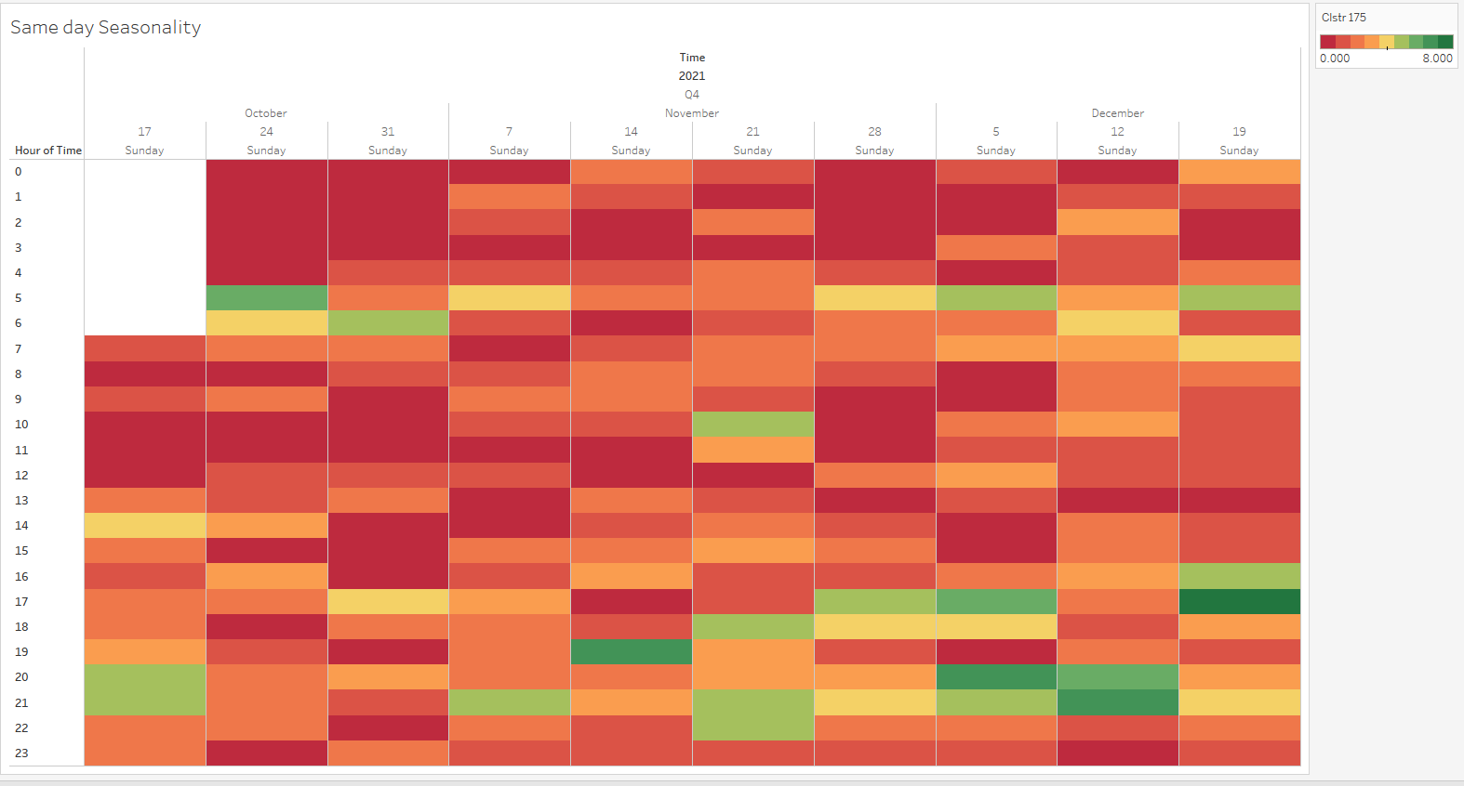

Figure : Heatmap of hourly Sunday’s demand over the 10 weeks.

Seasonality across other days of the week can be found in the appendix.

**Purpose:** A) TREEMAP: For the day Sunday this TREEMAP Identifies hours with number of occurrences of non-zero demand by the number of boxes and identifies magnitude of demand value through colour. The cluster of boxes top left corner indicates busy hours with the most non-zero demand occurrences and the largest demand value. Vice versa for the bottom right corner.

B) HEATMAP: Check which hours have similar demand. Check which hour has mostly reddish horizontal band indicating lower demand and which hour has greener horizontal band indicating higher demand.

**Observation and Inference:**

TREEMAP:

Table : Idle, Moderately Busy and Busy hours from Treemap

|  |  |  |  |
| --- | --- | --- | --- |
| **DAY** | **Idle hours**  (majority reddish) | **Moderately busy hours**  (greenish and reddish) | **Busy hours**  (majority greenish) |
| Sunday | 12,1, 3, 11AM | 6AM 6 PM | 5AM 4,5,7,8,9 PM |
| Monday | 8,11AM, | 10,11 PM, 12,4,9 AM | 6,7,5 AM 3,5,4,6,8 PM, |
| Tuesday | 12,1, 4 AM 1 PM | 7AM 6,9 PM, | 5,6 AM 8,7,3PM, |
| Wednesday | 12,1,2,3,4AM 10,11 PM | 11 AM 12,7,1,2 PM, | 7 AM 9,7 PM, |
| Thursday | 1,2,4,10 AM, 2 PM | 7 AM 12,1,7 PM | 6,7 AM 6,5, 8, 4, 9,10 PM |
| Friday | 2,3,4,5,8 AM 2PM | 9,7 AM 8,11 PM, | 9,4,3,5,10,6,7,12 PM, |
| Saturday | 4,3,8 PM | 12,9,10 AM 6,10, 2 PM, | 8 AM 9,7,4,5 PM, |

HEATMAP:

Table : Moderately Busy and Busy hours from Heatmap

|  |  |  |
| --- | --- | --- |
| **DAY** | **Moderately busy hours**  (demand value: 0 - 5) | **Busy hours**  (demand value: 4 - 10) |
| Sunday | 5,6 AM 5,6,7,10 PM | 8,9 PM |
| Monday | 8,10,11 AM 3,4,6,9 PM | 5,6,7 AM 8 PM |
| Tuesday | 7 AM, 9 PM | 5,6 AM 5,7,8 PM |
| Wednesday | 6,7 AM 5, 7 ,9 PM | 9 PM |
| Thursday | 5 AM, 11 PM | 6,7 AM, 6,8,9,10 PM |
| Friday | 7 AM 7,10,11 PM | 3,4,5, 8,9 PM |
| Saturday | 4,5,9,10 PM | 7,8 PM |

#### 3.2.4.2 Seasonality across different days of a week.

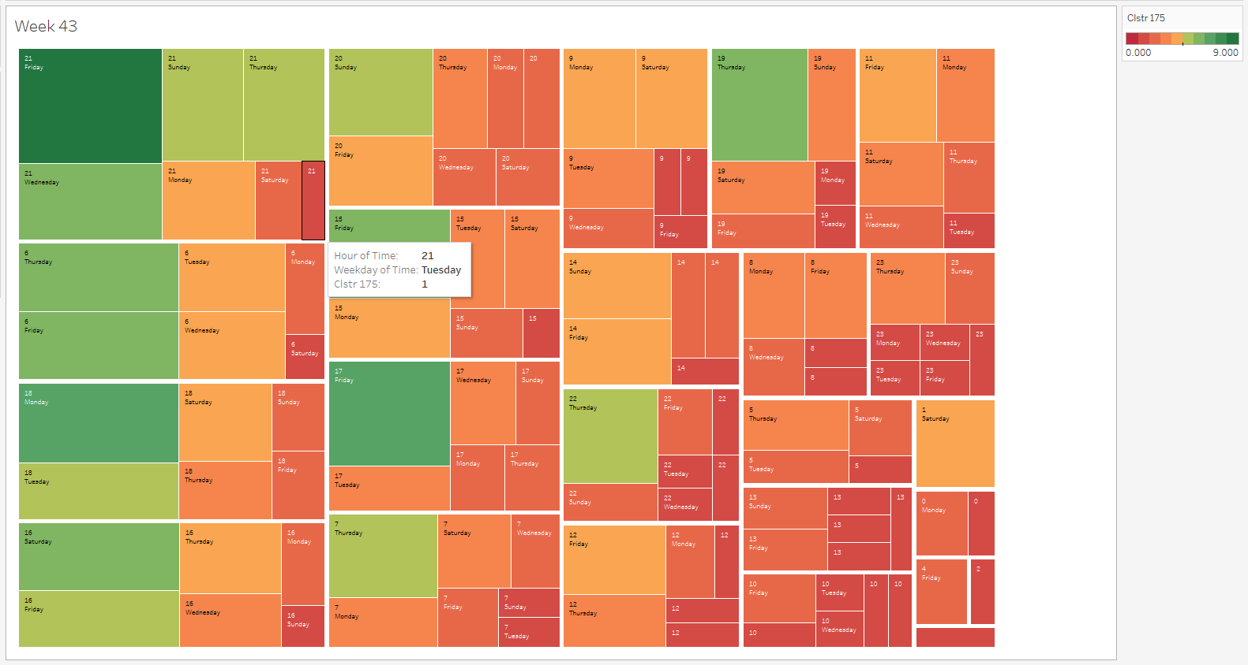

Figure : Hourly demand on different days of week 43

HEATMAPs are not analysed because of the difficulty in visualizing the negligible seasonality patterns across different days of the week. They are shown in the appendix

**Purpose:** Identify busy hours common to all days within the week. Same day seasonality is stronger than seasonality across different days.

**Observation and Inference:**

|  |  |  |
| --- | --- | --- |
| **Week** | **Busy hours**  (majority reddish) | **Idle hours**  (majority greenish) |
| 43 | 10 AM 1PM | 6 AM 9,8 PM |
| 44 | 8,9 PM | 12 AM 9 PM |
| 45 | 5,6 PM, | 12,1,3,4 AM 11 PM, |
| 46 | 8,9 PM, | 12,8 AM, 11,12,1,2 PM |
| 47 | 7 AM 8 PM, | 10 AM 2,10 PM |
| 48 | 8 AM 7,9 PM, | 4,8, AM 1 PM |
| 49 | 5,8,9 PM, | 9,11 AM, 12,2 PM |
| 50 | 4,5,9,6 AM 4,5,9 PM, | 8 AM 2 PM |
| 51 | 5,7,9,8 PM, | 1,2,3,10,11 AM |
| 52 | 5,7 AM 5 PM, | 9 AM, 1, 9 PM |

#### 3.2.4.3 Total demand distribution at each day of the week for entire data

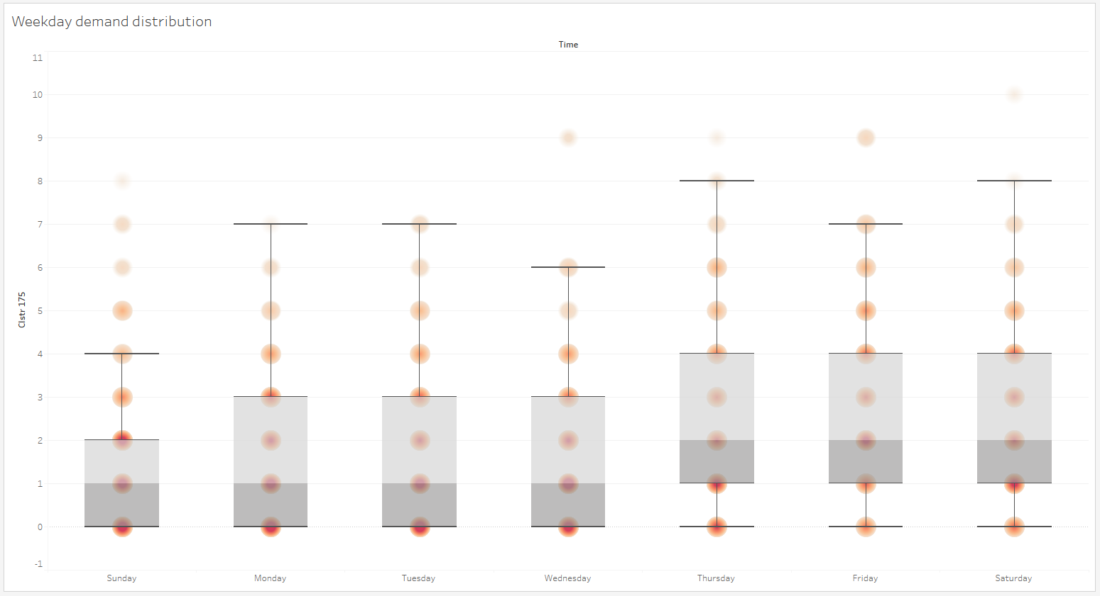

Similar boxplot for every month can be found in appendix.

**Purpose:** Check total demand distribution at each day of the week.

**Observation:**

|  |  |  |  |
| --- | --- | --- | --- |
| **DAY** | Lower Quartile | Median | Upper Quartile |
| Sunday | 0 | 0,1 | 0,1,2 |
| Monday | 0 | 0,1 | 0,1,2,3 |
| Tuesday | 0 | 0,1 | 0,1,2,3 |
| Wednesday | 0 | 0,1 | 0,1,2,3 |
| Thursday | 0,1 | 0,1,2 | 0,1,2,3,4 |
| Friday | 0,1 | 0,1,2 | 0,1,2,3,4 |
| Saturday | 0,1 | 0,1,2 | 0,1,2,3,4 |

**Inference:**

* The distributions of Sunday to Wednesday are similar. Likewise, the distributions of Thursday to Saturday are also similar.
* The mode for Sunday to Wednesday is 0 while, the mode for Thursday to Saturday is 1,2 and 1 respectively.

#### 3.2.4.4 Trend cycle across days

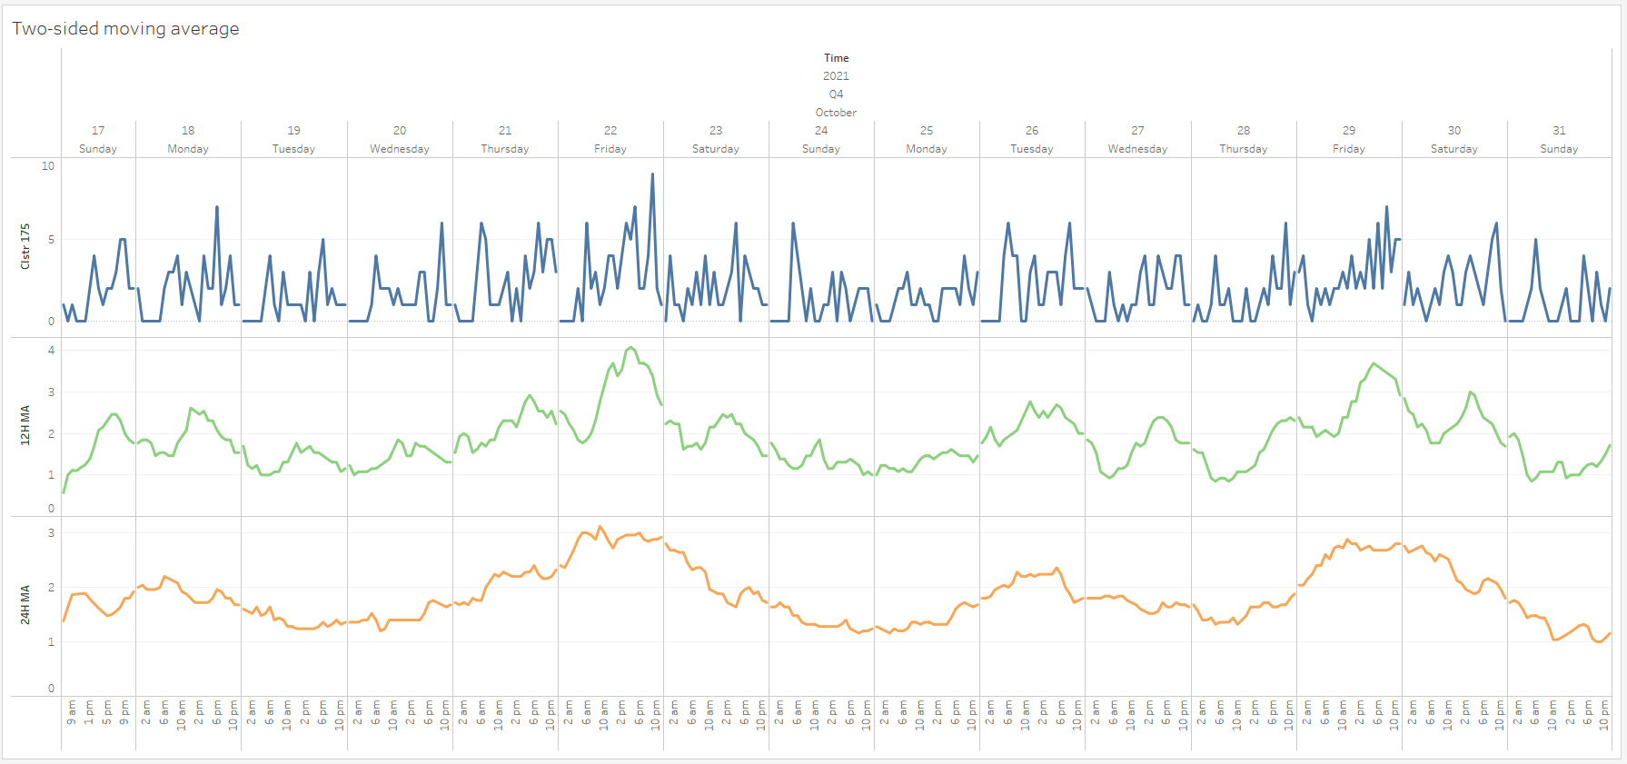

Figure : Daily trend cycle for October

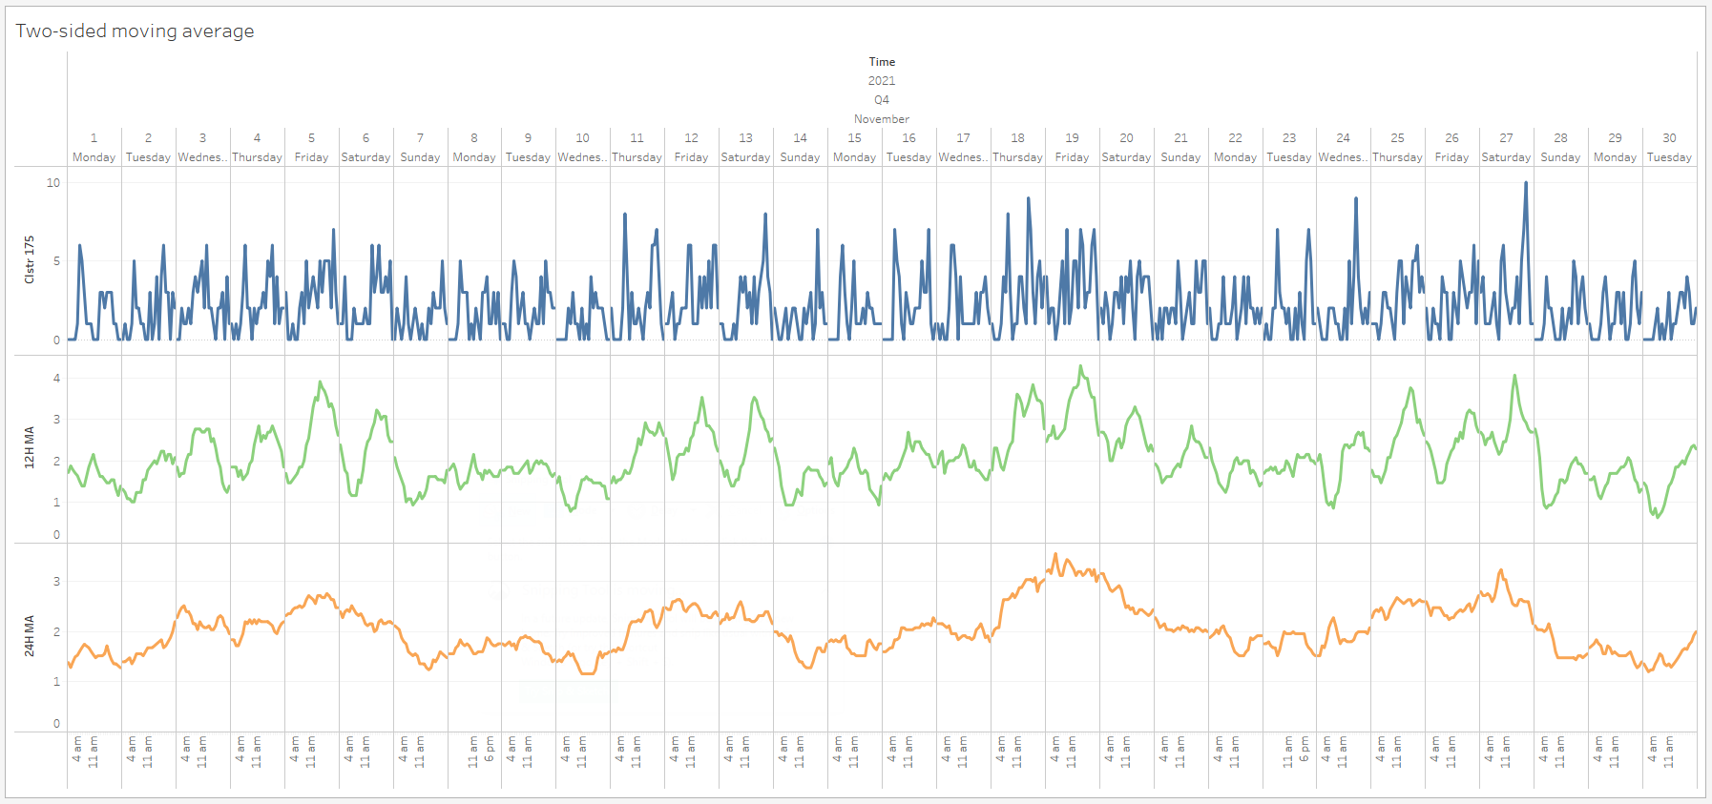

Figure :: Daily trend cycle for November

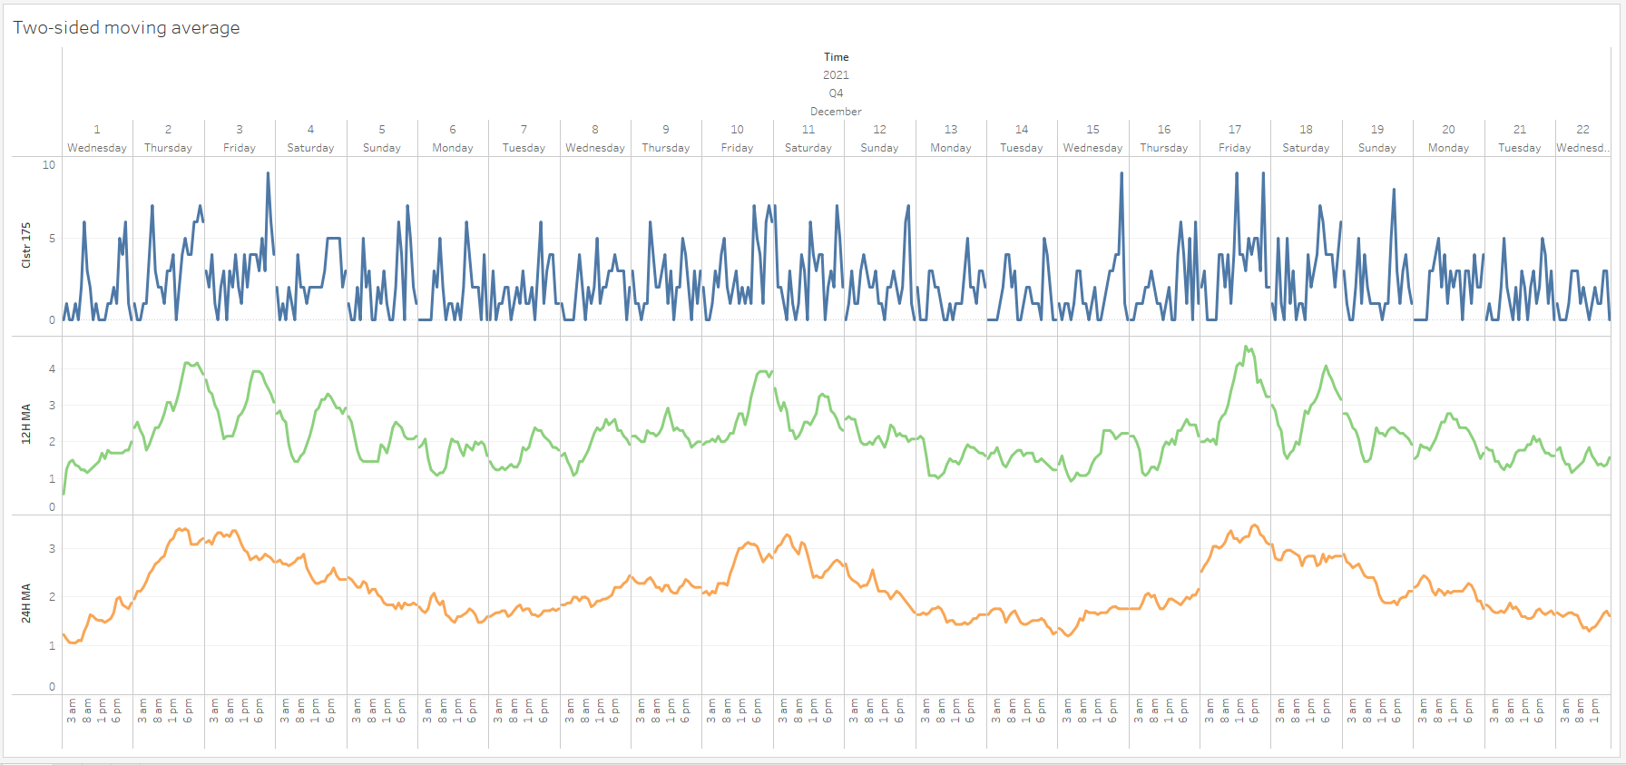

Figure :: Daily trend cycle for December

**Purpose:** Historical trends in data can have cycles which can be analysed using moving/rolling averages (MA) of suitable periods. Cycles show days with peaks and troughs. It gives high level view of days with highest and smallest demand and how demands progress between high and low demand. MA smoothens the original signal to remove the noise and display underlying trends. Two-sided MA do not incur lags. It is favourable to choose a MA period that is same as the periods over which we want to analyse patterns. For example, if we analyse patterns across days then it is favourable to choose 24 hours MA. This shown by the orange plot above over the 3 different months. 12 Hour MA are shown in green.

**Observation:**

* 12Hour MA

|  |  |  |
| --- | --- | --- |
| **Month** | Top 2 Peak days | Top 2 Trough days |
| October | (Thurs, Fri), (Fri, Sat) | (Tues, Wed), (wed, Thurs), (Sun, |
| November | (Fri, Sat), (Fri, Sat), (Thurs, Fri), (Thurs, Sat) | Tues), (Sun, wed), (sun, Mon) (Mon, wed), (sun |
| December | (Thurs, Fri), (Fri, Sat), (Fri, Sat) | wed), (Mon, wed), (Mon, wed), (Tue, wed) |

* 24Hour MA

|  |  |  |
| --- | --- | --- |
| **Month** | Peak days | Trough days |
| October | Fri, Fri | Tues, Mon, Thurs, Sun |
| November | Fri, Fri, Fri, Sat | Sun, wed, Sun, Tue, Tue |
| December | Fri, sat, Fri | Wed, Mon, Wed, Wed |

**Inference:**

* 12H MA
  + Shows that Within every day there is a cycle with trough and peak.
  + (Fri, Sat) are top 2 peak days
  + (Tues, Wed) are top 2 trough days
* 24H MA
  + For every month, generally Fridays have the peak demand over all other days.
  + For every month, generally Monday and Tuesday has the trough demand over all other days.

### 3.2.5 Weekly seasonality

#### 3.2.5.1 Summed daily demand across weeks

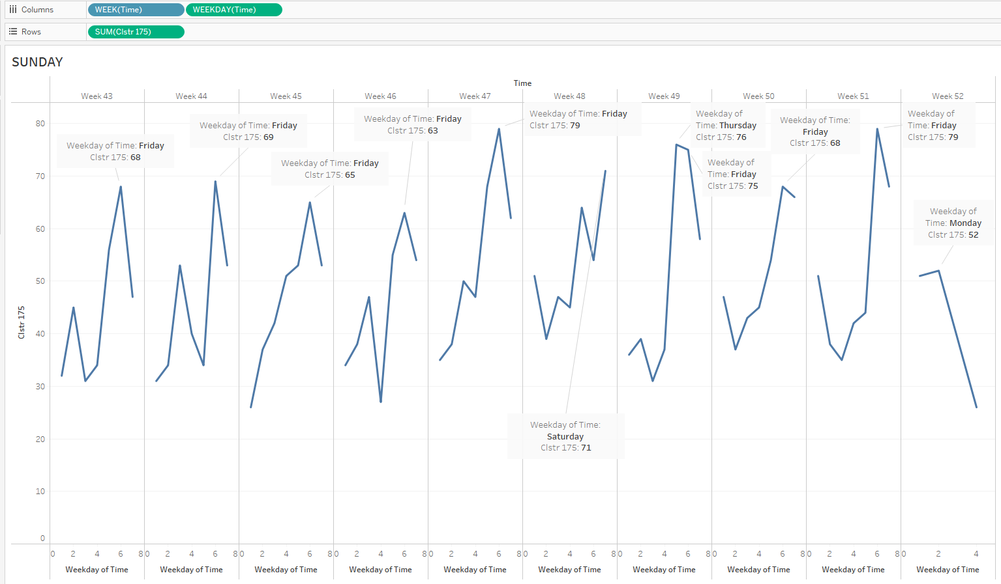

Figure : Plot of summed daily demand across weeks

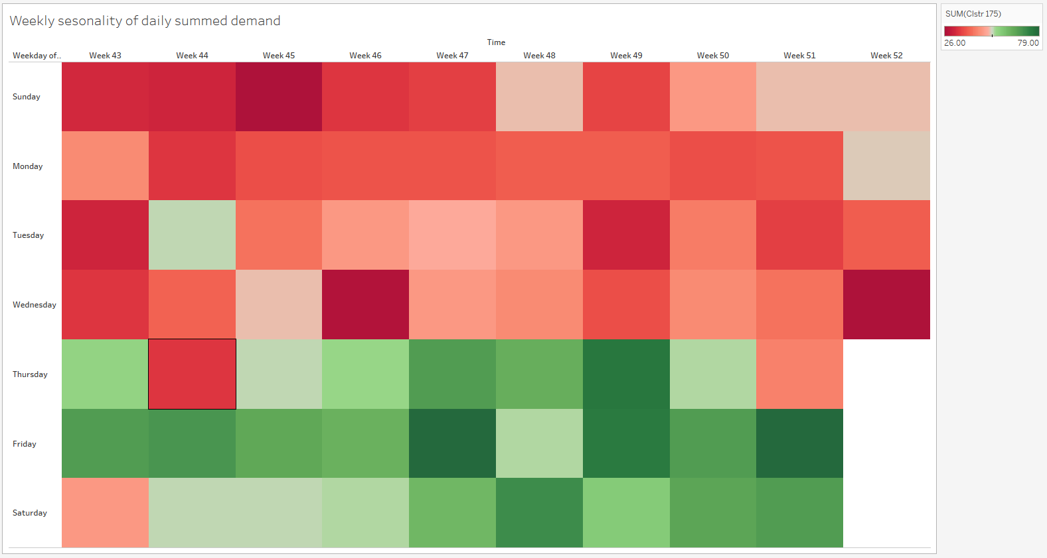

Figure : Heatmap of aggregated daily demand across weeks

**Purpose:** To see similarity in demand across weeks and identify a typical (or average) weekly pattern. The plot in figure x shows the summed demand for each day in a week over 10 weeks. The HEATMAP in figure y shows summed demand of same days over 10 weeks. It is like an accumulation of the plot in figure x.

**Observation and Inference:**

Plot:

* There is a general increasing trend over the days from Sunday to Saturday.
* There is generally a dip on Tuesday or Wednesday
* Demand peaks on Fridays.

HEATMAP:

* There is clearly two periods with lower and higher demand. The lower demand period is days Sunday, Monday, Tuesday and Wednesday. The higher demand period is Thursday, Friday and Saturday.

#### 3.2.5.2 Total demand distribution at each week of the entire data.

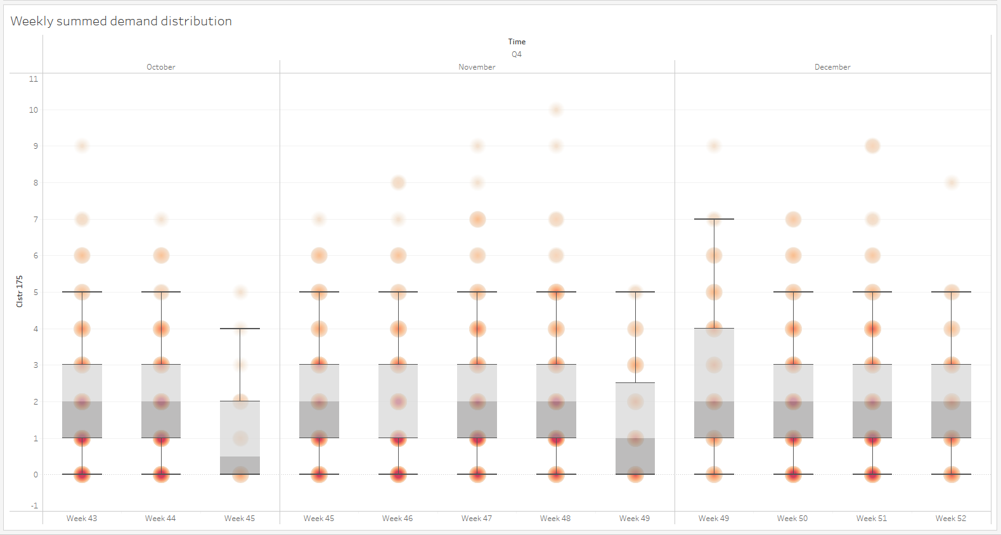

**Purpose:** Check total demand distribution at each week of the entire data.

**Observation and Inference:**

* The demand distribution is very similar across weeks with a median of 2 EVs for each week.
* The mode for each week is either 0 or 1.

### Indirect and direct Correlation due to lags

#### 3.2.6.1 Autocorrelation (ACF) plot

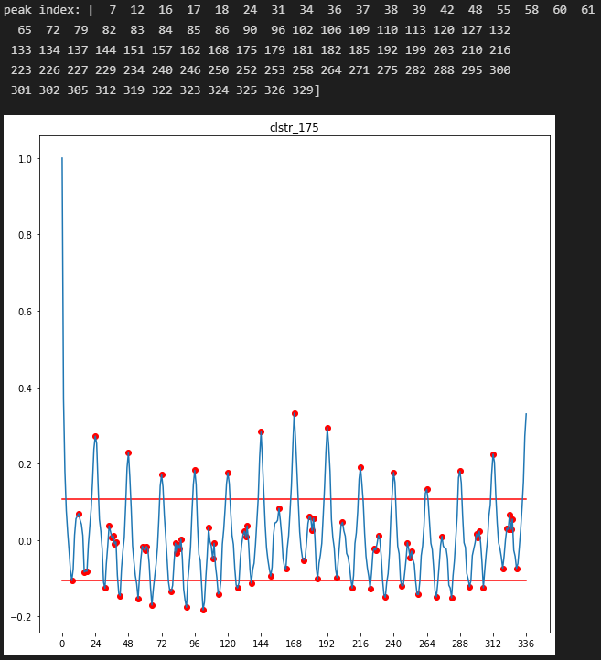

Figure : ACF plot

**Purpose:** Autocorrelation (ACF) plots show lag values that have a direct and indirect effect on present value. ACF indicates positive and negative Pearson correlation between original time series and lagged version of the time series including correlation due to lags in-between. ACF includes both indirect and direct effects of a lag on the present value of the series.

It is not necessary to find autocorrelation for every hour of 24 hour period because for a stationary time series the mean, variance and autocorrelation structure are constant with time.

The reason for including lags of the target with high coefficient is because we expect the proceeding behaviour of the lagged time series (which has already been observed) to also manifest in the proceeding (unobserved) time step of the prediction horizon after the present time step. The unobserved values in the target are learned through supervised learning.

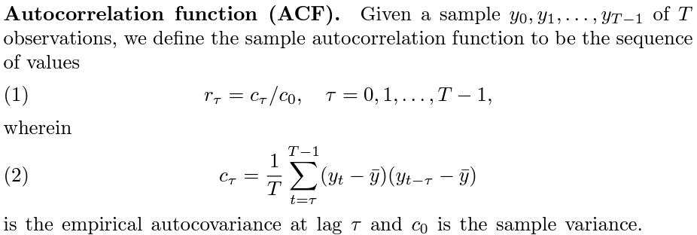

The statistically significant lags are above the limits of ±1.96/√n which are the approximate 95% confidence bounds for the autocorrelations of a white-noise sequence. n is the sample size.

**Observation:** Largest statistically significant lags are 24, 31, 42, 48, 55, 65, 72, 79, 90, 96, 102, 113, 120, 144 and 168 hours.

**Inference:** Including these lagged time series as covariates helps the model to learn its impact on present value and improve prediction accuracy.

#### 3.2.6.2 Partial Autocorrelation (PACF) plot

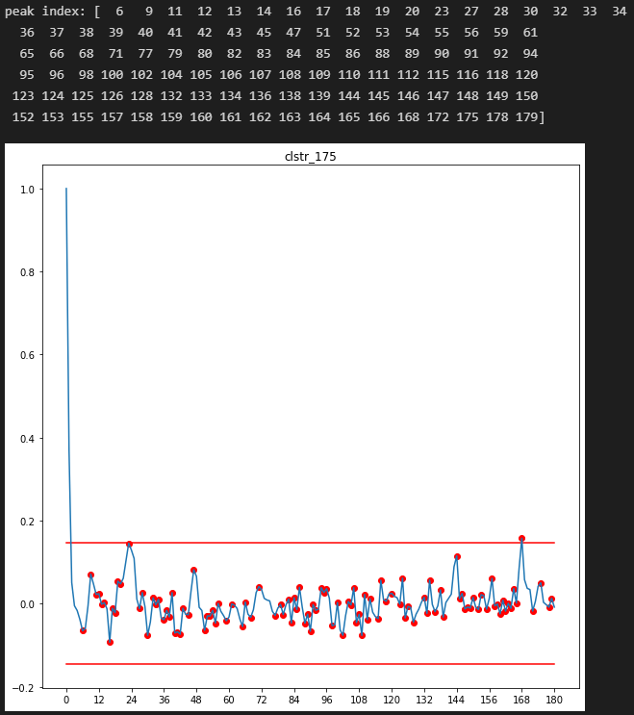

Figure : PACF plot

**Purpose:** PACF plot shows lag values that have a direct effect on present value. Both the ACF and PACF is needed to see how much direct and indirect effect of a lag. At a lag, if ACF is high and the PACF is also high then there is more direct effect. At a lag, if the ACF is High and the PACF is low then there is more indirect effect.

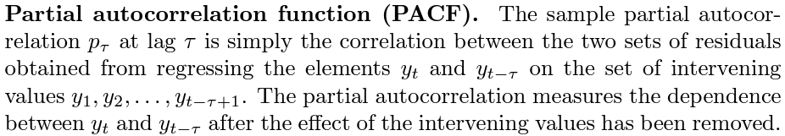

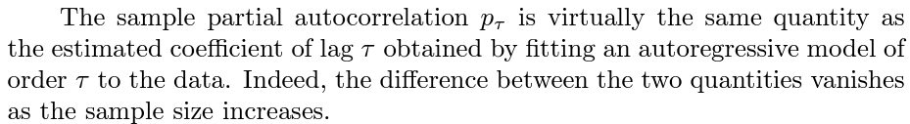

The bounds of ±1.96/√ n are also plotted on the graph of the partial autocorrelation function. n is the sample size.

**Observation:** Thelargest statistically significant lags are 24 and 168 hours.

**Inference:** Including these lagged time series as covariates helps the model to learn its impact on present value. The largest lag is generally used as the encoder length as it directly affects the present value. However, the encoder length is subject to other constraints like availability of data so that the training, validation, and test data distributions have some overlap and are not sparse.

## 3.3 Exploration of Covariate time series

Table x shows the following covariate time series are 2 neighbouring cluster demands, weather data, EV supply of the target cluster.

Table : Covariates and their description

|  |  |
| --- | --- |
| **Covariate Name** | **Description** |
| Temperature | Hourly temperature at target cluster. (Numeric). Good indicator of the effect of sun and rain. |
| Humidity | Hourly humidity at target cluster. (Numeric). Good indicator of the effect of rain and sun. |
| Weather description | Hourly time series of 17 categories indicating different levels of rain and shine. (Categorical). Shown in fig. x |
| Supply at target cluster | Hourly time series of number of EVs entering the target cluster. (Numeric) |
| Lagged neighbouring cluster 1 demand | Hourly time series of lagged EV demand at a neighbouring cluster from the same region having the largest cross-correlation with the target time series. (Numeric). The lag is by the same amount as the prediction horizon window length. |
| Lagged neighbouring cluster 2 demand | Hourly time series of lagged EV demand at a neighbouring cluster from the same region having the second largest cross-correlation with the target time series. (Numeric). The lag is by the same amount as the prediction horizon window length. |

Only any 2 combinations of the above time series are used as covariates at a time. Therefore, this choice of 2 combinations is a hyperparameter that needs to be optimized. Choosing only two covariates ensures that the features provided are relevant and representative. It also results in a Simpler and less overfitting model. The choice of 2 covariates but generally a small number is preferable.

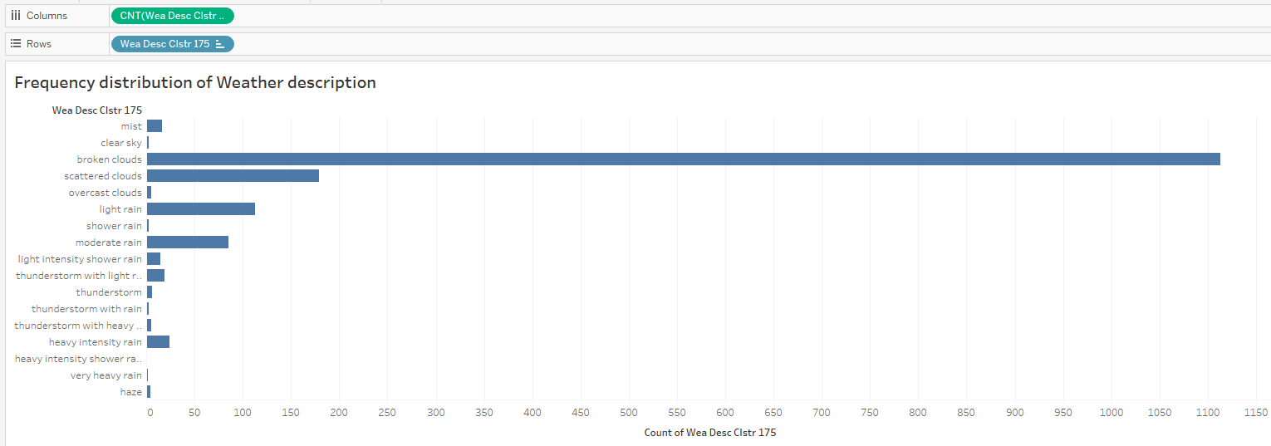

Figure : Frequency distribution of weather description categorical variable

The date information time series are also covariates are they comprise of the following time series.

Table : Date information

|  |
| --- |
| **Date Information** |
| hour-of-the-day |
| day-of-the-week |
| day-of-the-month |
| day-of-the-year |
| week-of-the-year |
| month-of-the-year |
| year |

Covariate time series (predictors) act as features that help to predict the target time series. It is good to investigate the amount of correlation between the individual predictors and the target to assess their level of strength. The correlations of lagged versions of the covariate time series with the target time series can be visualized using a cross-correlation plot. If there exist high correlations of covariate lags on the present target value and if those lags are larger than the encoder length, then they are included as lagged time series covariates.

All these covariates are available in the prediction horizon window. The predicted weather data is available from openweathermap.com, supply arriving at the target cluster is computed using enroute EV information. The neighbouring clusters demand is lagged so it is also available.

All covariate time series are stationary as shown by figure 6.

To visualize correlations and relationships between covariate and target time series the following is performed:

1. Scatter plots are used to see and calculate Pearson correlation between target and covariate time series.
2. Perform similar seasonal analysis and visualization as target time series on covariate time series. And try to explain high demand in target time series that is not associated with seasonality within the target time series.
3. Cross-correlation plots are used to analyse correlation between target time series and lagged covariate time series.
4. Granger causality is used to identify which lags of the covariate time series have a ‘granger causal’ effect on the target time series.

### 3.3.1 Pearson correlation between target and covariate time series

#### 3.3.1.1 Correlation matrix

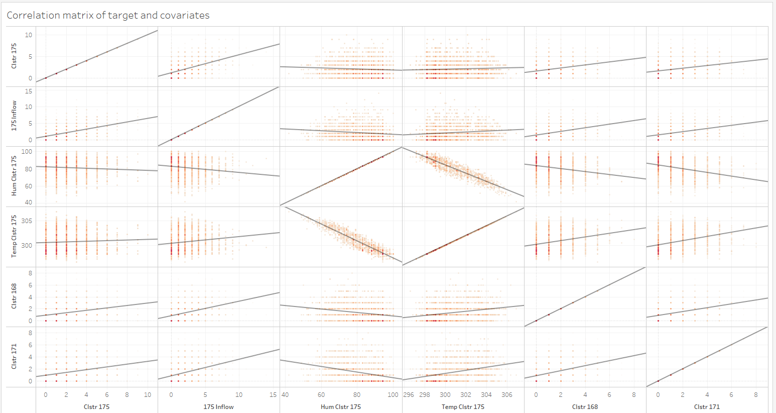

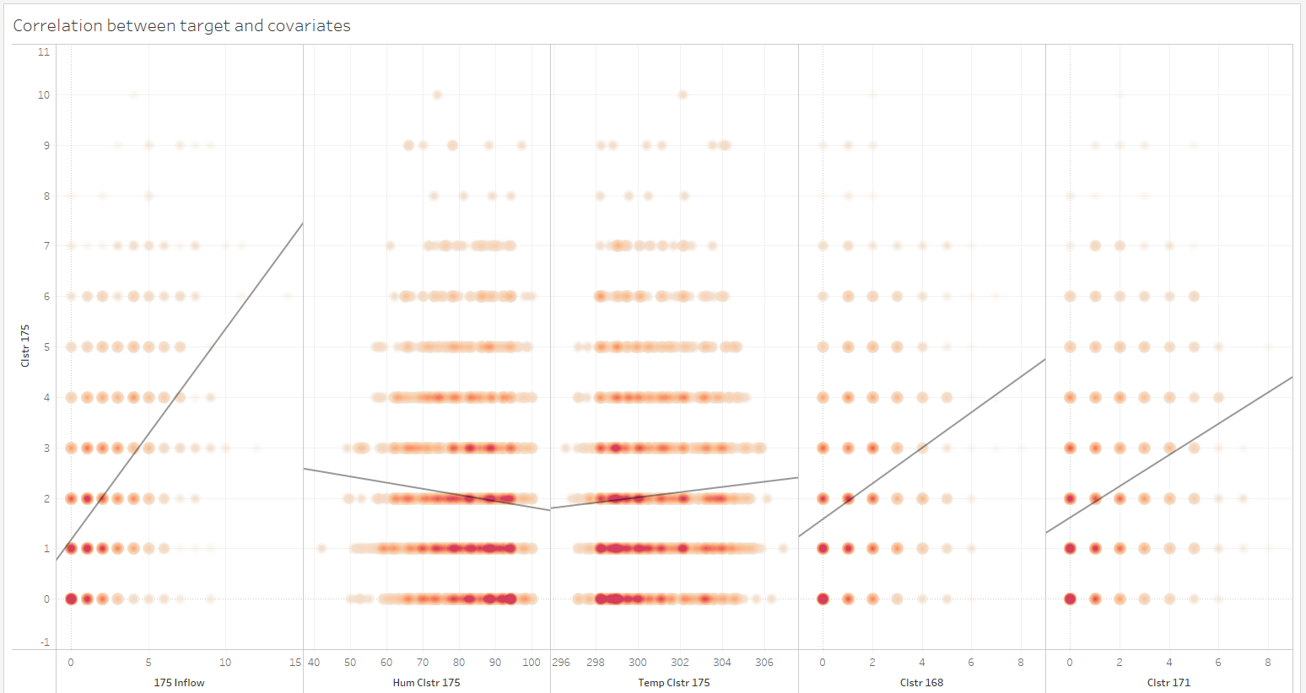

**Observation:**

1. There is a positive correlation between target and clusters 168 and 171. There is low correlation between cluster 168 and 171
2. The highest positive correlation of target is with inflow
3. There is a high negative correlation between temperature and humidity

**Inference:**

1. Both clusters 168 and 171 are necessary covariates.
2. Inflow is a good predictor and puts a bound on the future met demand request.
3. In case of the need for dimensionality reduction, either temperature or humidity but not both can be used due to high negative correlation between them.

#### 3.3.1.2 Correlation between Weather description and target

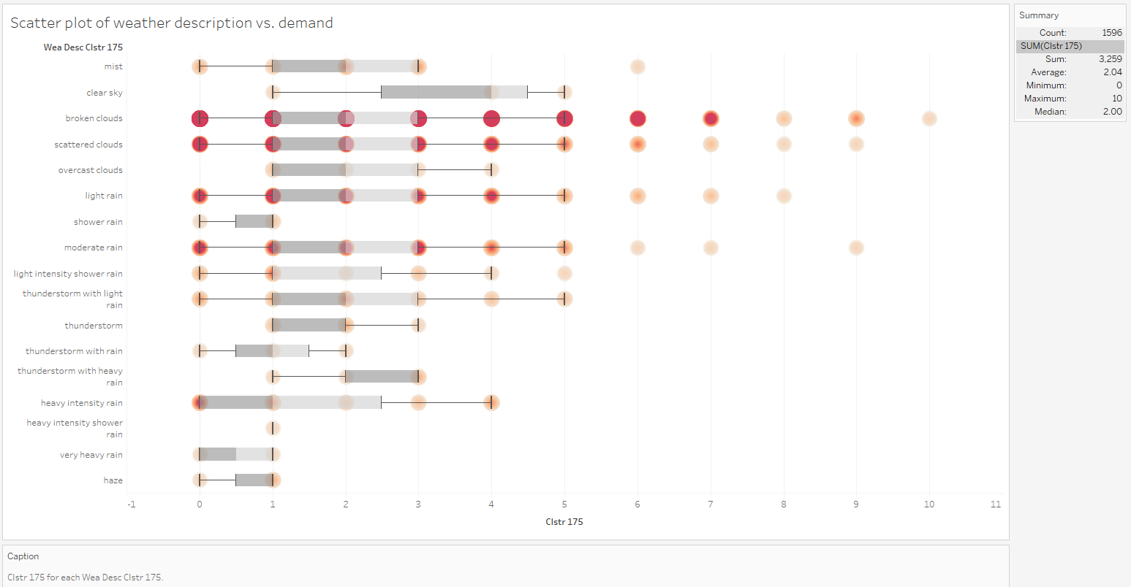

Figure : scatter plot association of weather description and demand

**Observation and Inference:** We would like to establish a correlation/association between weather description and demand through the scatter plot above. It weakly shows that sunny conditions can lead to higher demand while rainy conditions are limited to lower demand. The darker density dots show that sunny conditions are overrepresented.

##### 3.3.1.2.1 Data distribution in individual categories of weather description categorical variable

**Purpose:** To see demand distribution in each category of the weather description covariate.

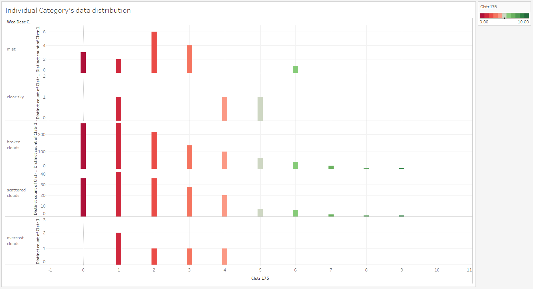

**Observation and Inference:** The categories in figure u above represent sunny conditions. The distribution is negative binomial for the most occurring categories. Smaller requests are more likely than larger requests. The Most frequently occurring weather categories is broken and scattered clouds so it overrepresented compared to other categories.

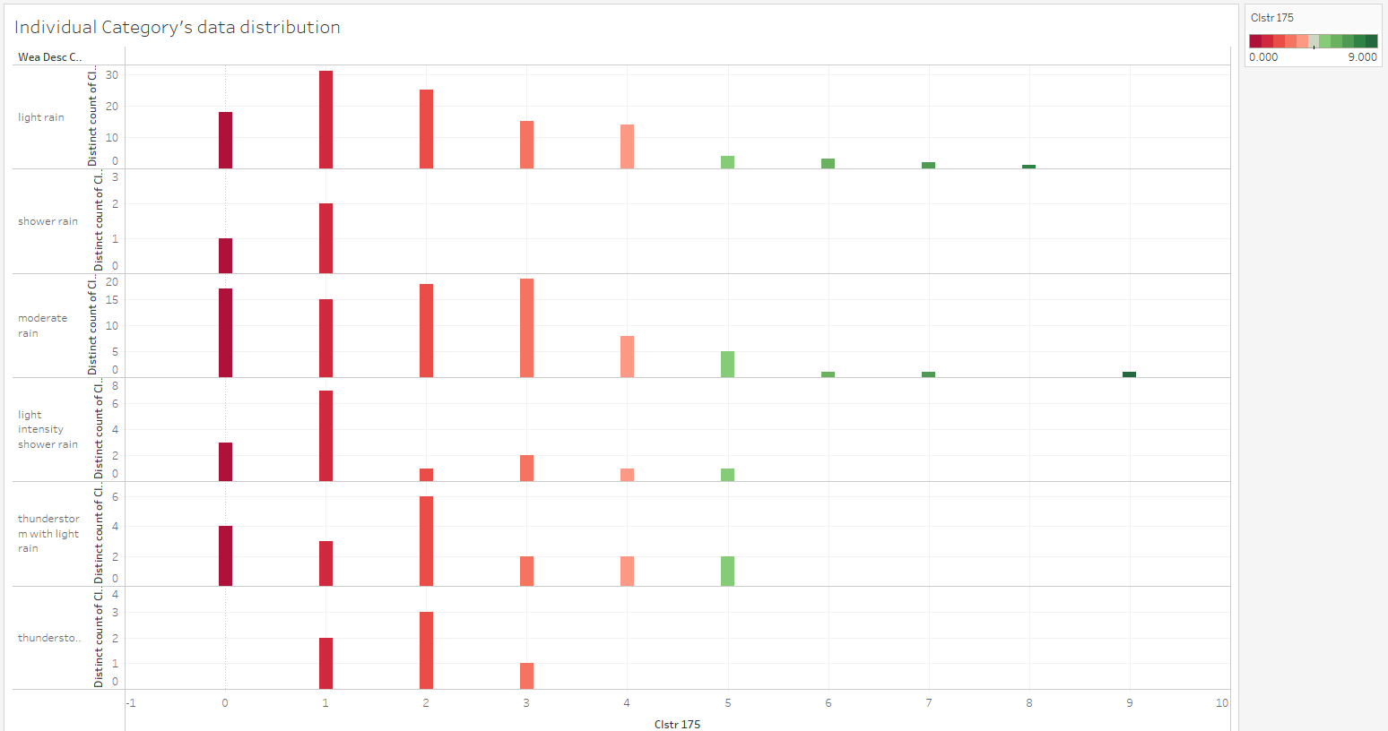

**Observation and Inference:** The categories in figure o above represent light to moderate rain conditions. Light rain and moderate rain show that the negative binomial distribution is still followed.

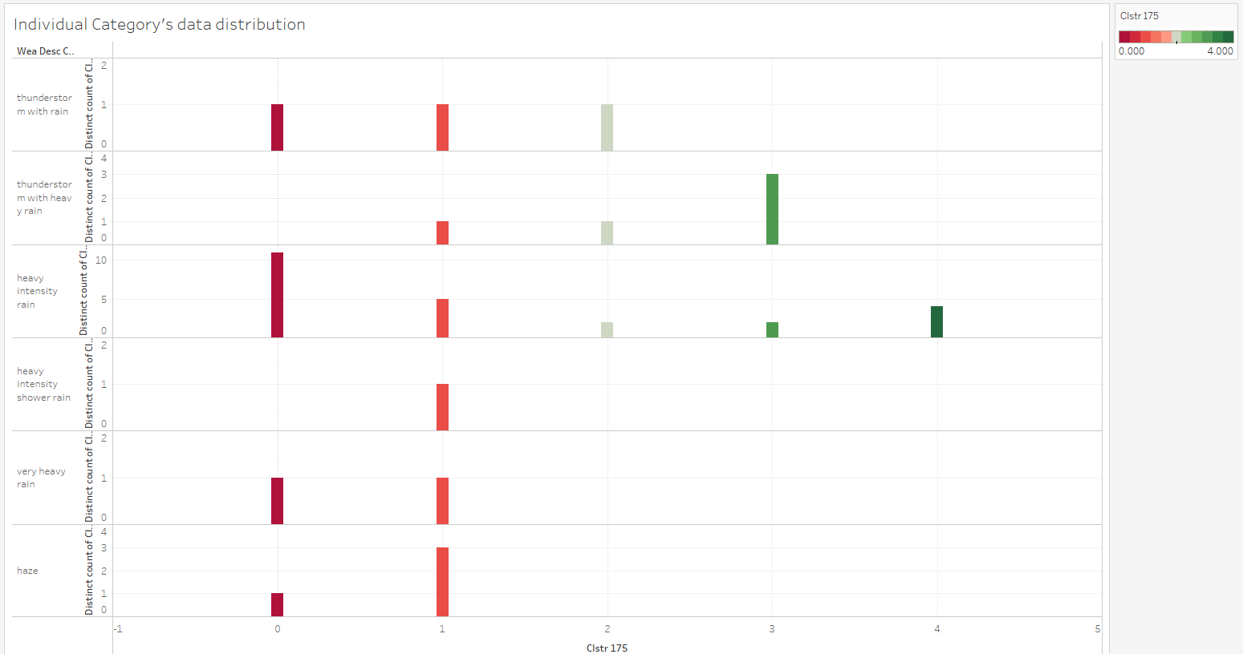

**Observation and Inference:** The categories in figure o above represent heavy rain conditions that might hamper driving ability. Higher demand is more likely than lower demand and there is no occurrence of very high demand.

##### 3.3.1.2.2 Weather description category distribution in individual demand values for the target

**Purpose:** To see weather description category’s distribution for each demand value. This is the complement of the above analysis.

All categories’ distribution

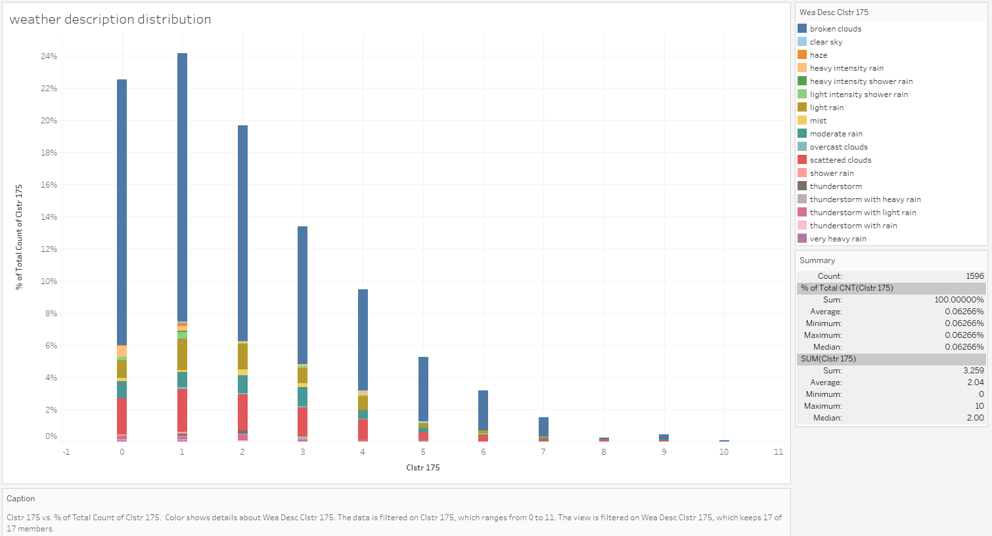

Figure : All categories' distribution

**Observation and Inference:** The data distribution is overrepresented with clear weather condition categories like scattered clouds and broken clouds. Therefore, they need to be separated into sunny and rainy categories to see the distributions within them.

Sunny categories’ distribution

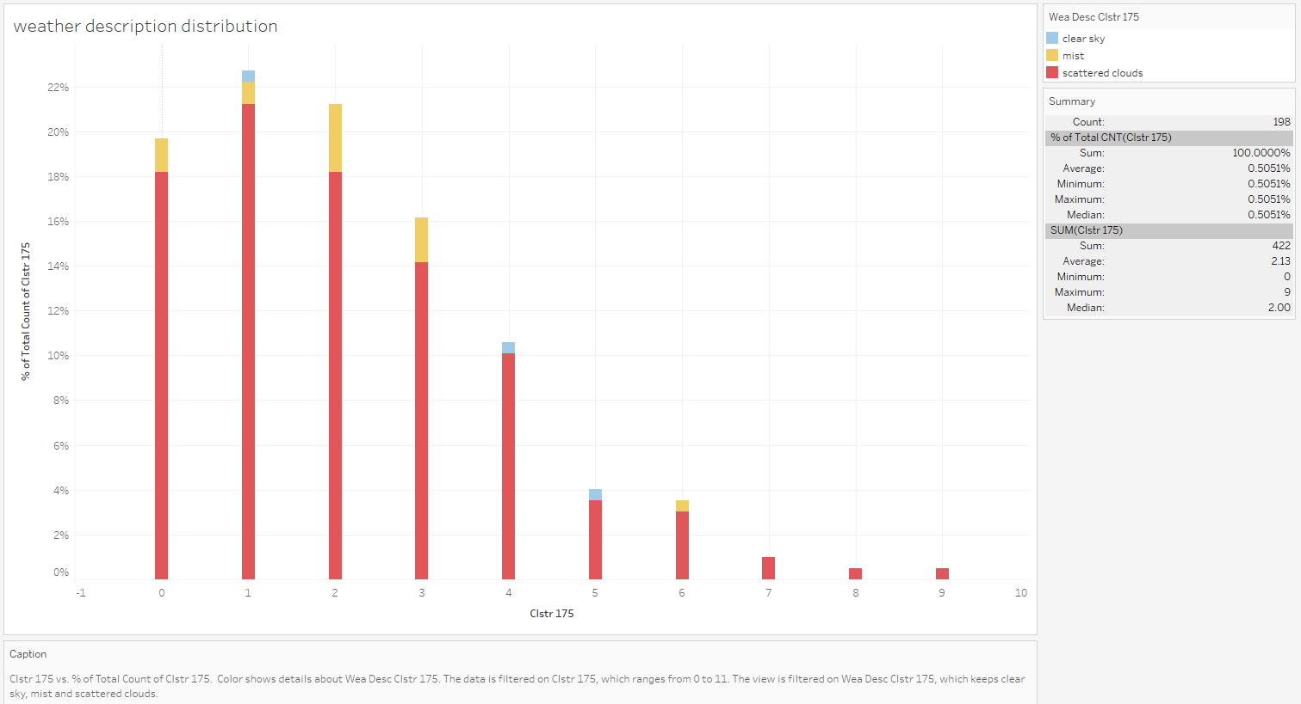

Figure : Sunny categories' distribution

**Observation and Inference:** Broken clouds category is removed. All categories favour lower demand value and are represented less at high demand value.

Light rain categories’ distribution

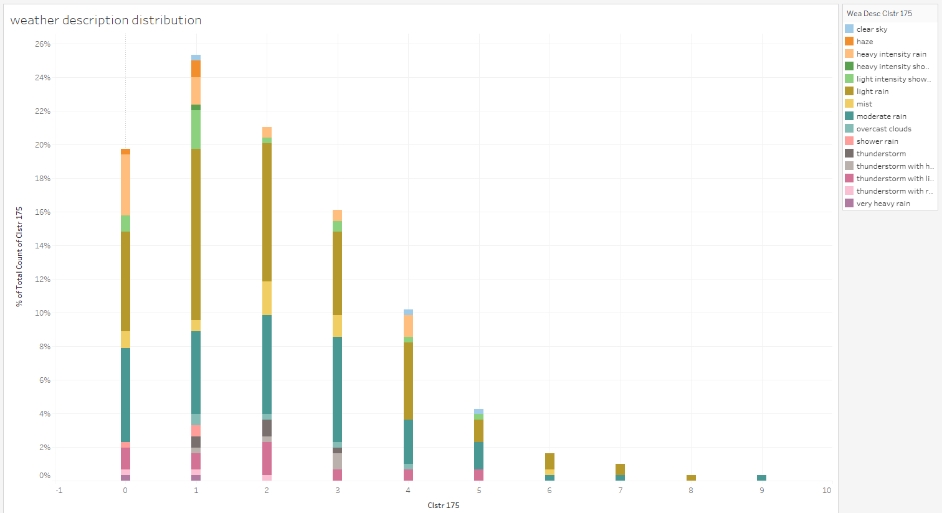

Figure : Light rain categories' distribution

**Observation and Inference:** All categories favour lower demand value and are represented less at high demand value.

Heavy rain categories’ distribution

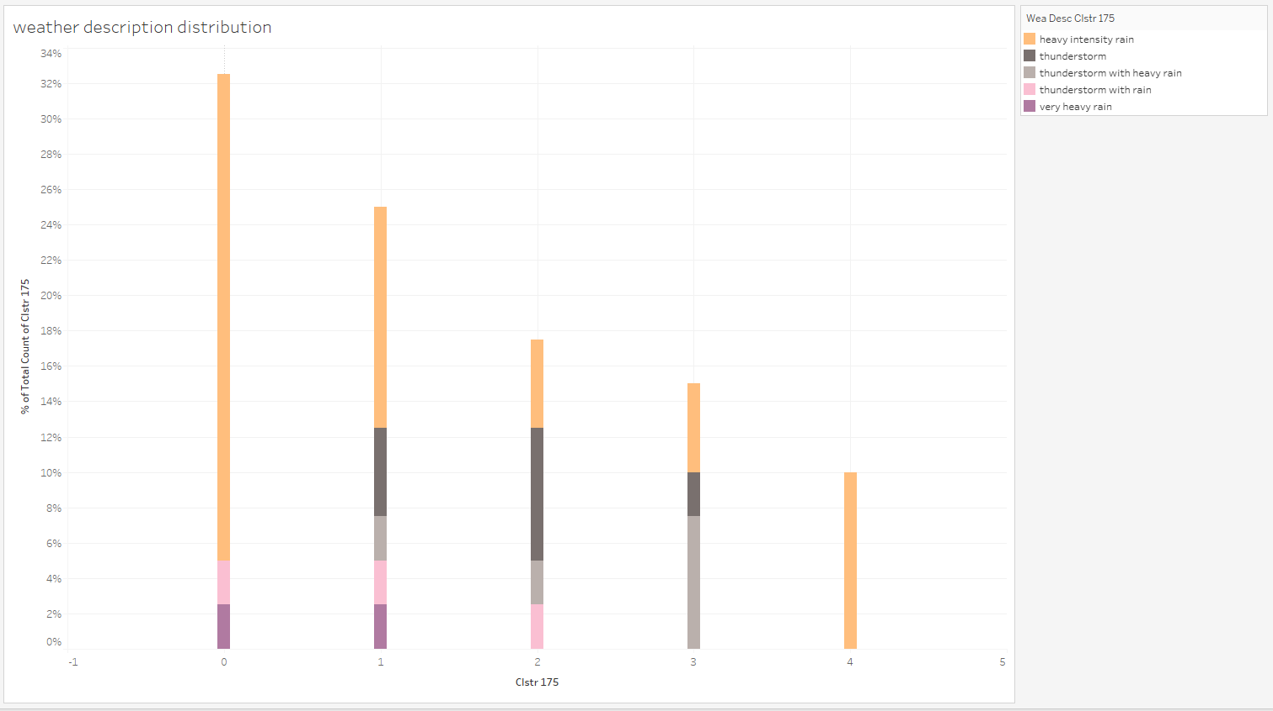

Figure : Heavy rain categories' distribution

**Observation and Inference:** Heavy rain distribution is limited to a maximum demand of 4 EVs. Thunderstorms lead to lower demand compared to heavy intensity rain.

##### 3.3.1.2.3 Association/correlation between weather description and target

**Purpose:** Use Cramer’s V statistic to compute strength of association/correlation. The range of values in the figure below indicates the strength of the association.

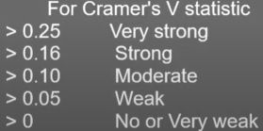

Figure : Strength measurement values

**Observation:**

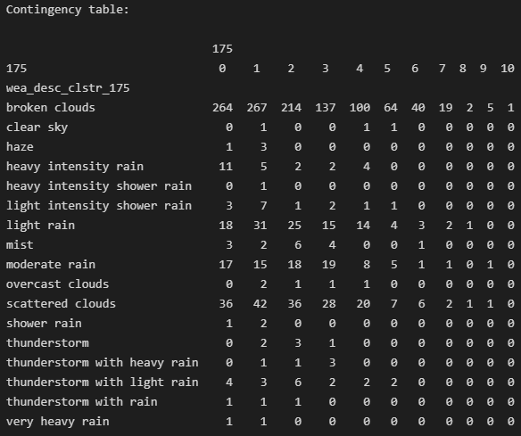

Figure : Contingency table

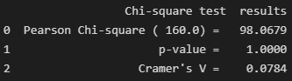

Figure : Cramer V test statistic

**Inference:**

* The Cramer’s V statistic is between a week and moderate association, so it is not possible to say that sunny conditions lead to large demand value and heavy rains lead to lower demand.

### 3.3.2 seasonal analysis of covariate time series

#### 3.3.2.1 Temperature

The plots of the following can be found in the appendix.

**Observation and Inference:**

1. Frequency distribution plot of temperature was plotted and the 4 most frequently occurring temperatures in Singapore for the months of October, November and December are 25.15, 25.55, 25.85, 26.45 degrees Celsius.
2. Hourly temperature boxplot shows that the highest temperatures are between 12pm and 4 pm. Lowest temperatures are between 2am and 6 am.
3. Treemap of weekend temperature seasonality (Friday, Saturday and Sunday) shows that the three highest temperature hours are 10 am, 1 and 2 pm. The three lowest temperatures are 4,5 and 6 am.
4. Treemap for weekdays temperature seasonality (Sunday, Monday, Tuesday and Wednesday) shows that the three highest temperature hours are 12, 1 and 3 pm. The three lowest temperatures are 9,10 and 11 pm.
5. Daily temperature boxplot shows that the daily temperatures are relatively similar. The variance is also similar. The variance is higher for data above 50th percentile compared to data below 50th percentile.

##### 3.3.2.1.1 Trend cycle and correlation plot

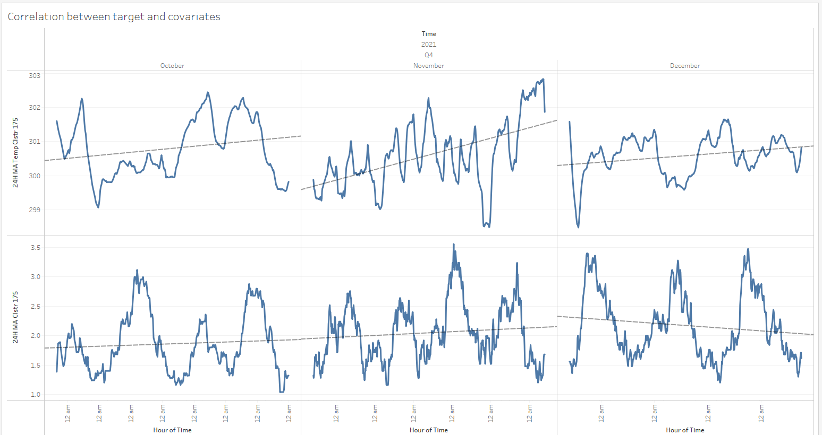

Figure : Trend cycles

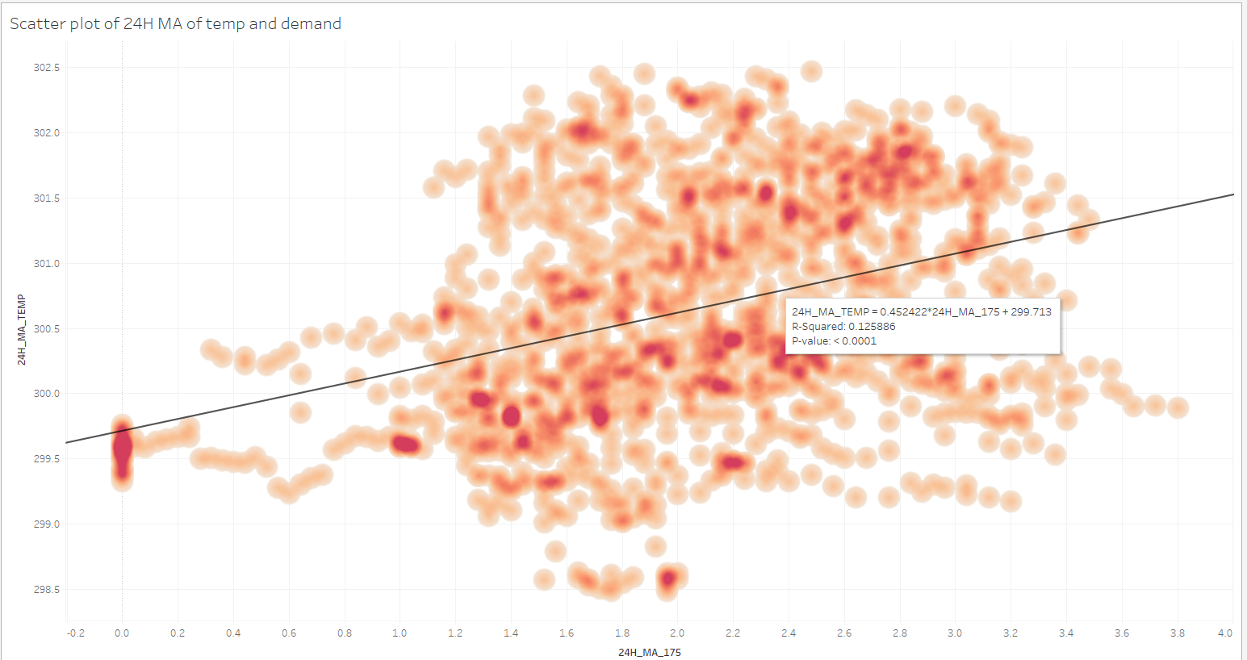

Figure : Scatter plot

**Purpose:**

A smoothed 24-hour MA is used to show the trend cycle in figure x. We want to measure the strength of correlation between temperature and demand of this smoothed time series. The scatter plot in figure y is utilized to identify this correlation.

**Observation and Inference:**

1. Although there is a positive correlation with temperature it is not a strong one. Therefore, we cannot say that a high temperature every time leads to high demand.

#### 3.3.3.2 Humidity

The plots of the following can be found in the appendix.

**Observation and Inference:**

1. The frequency distribution plot of humidity shows that the top 4 most frequent humidity levels are 82, 87, 92 and 94 %.
2. Treemap of weekend seasonality shows that humidity is highest at 12,4,6,7 am. Lowest at 12,1,2,3 pm.
3. Treemap of weekday seasonality shows that humidity is highest at 10, 11 pm 2,7 am. Lowest at 10 am 12,1,2 pm.
4. The hourly boxplot shows highest humidity levels between 2 to 7 am. Lowest levels between 10 am to 5 pm.
5. Weekly Boxplot shows that there is more variability across weeks compared to temperature.
6. Daily boxplot shows that the daily humidity is similar and the variance is small.

##### 3.3.3.2.1 Trend cycle and correlation plot

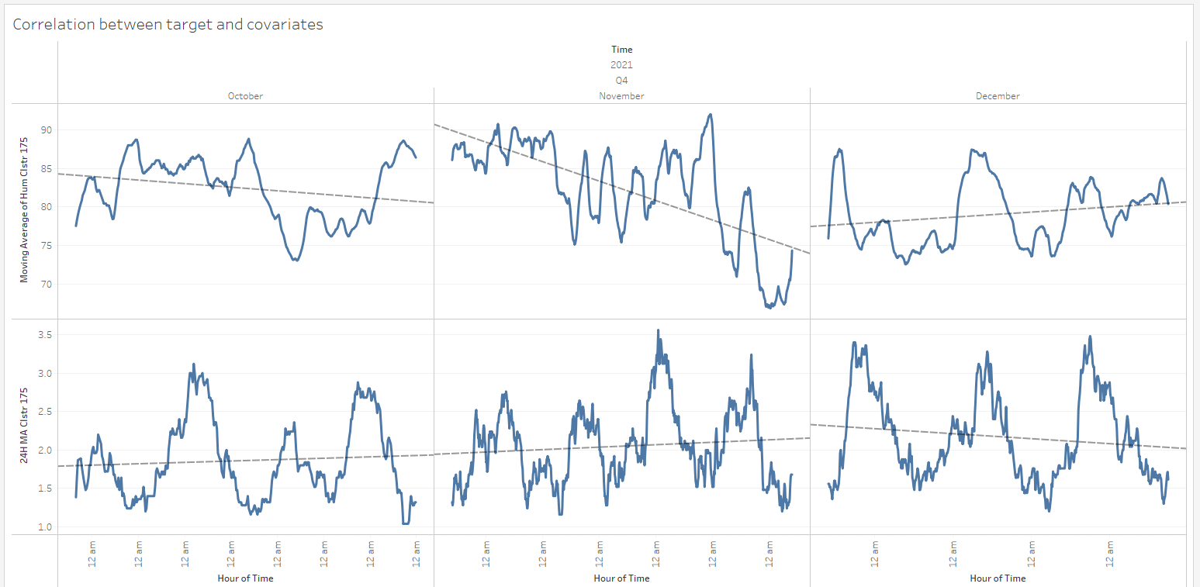

Figure :Trend cycles

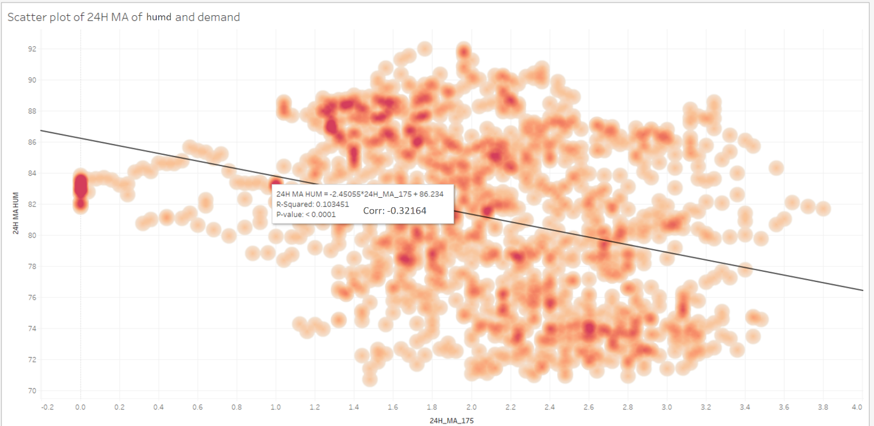

Figure : Scatter plot

**Observation and Inference:**

1. There is a negative correlation between humidity and demand.
2. There is better correlation between temperature and demand compared to humidity and demand. In case of dimensionality reduction, temperature should be preferred over humidity.

#### 3.3.3.3 Supply at target cluster

##### 3.3.3.3.1 Trend cycle and correlation plot

**Purpose:**

The number of EVs inflow into a cluster (and the number of idle standing EVs in the cluster) determines the number of EVs that can outflow (demanded) from that cluster. This can help to predict future demand and put an upper bound on the prediction.

Hence, we expect to see a high correlation between demand and inflow (including lagged inflows). One-sided MA is preferred over 2-sided MA in order to avoid looking into the future to compute the present MA.

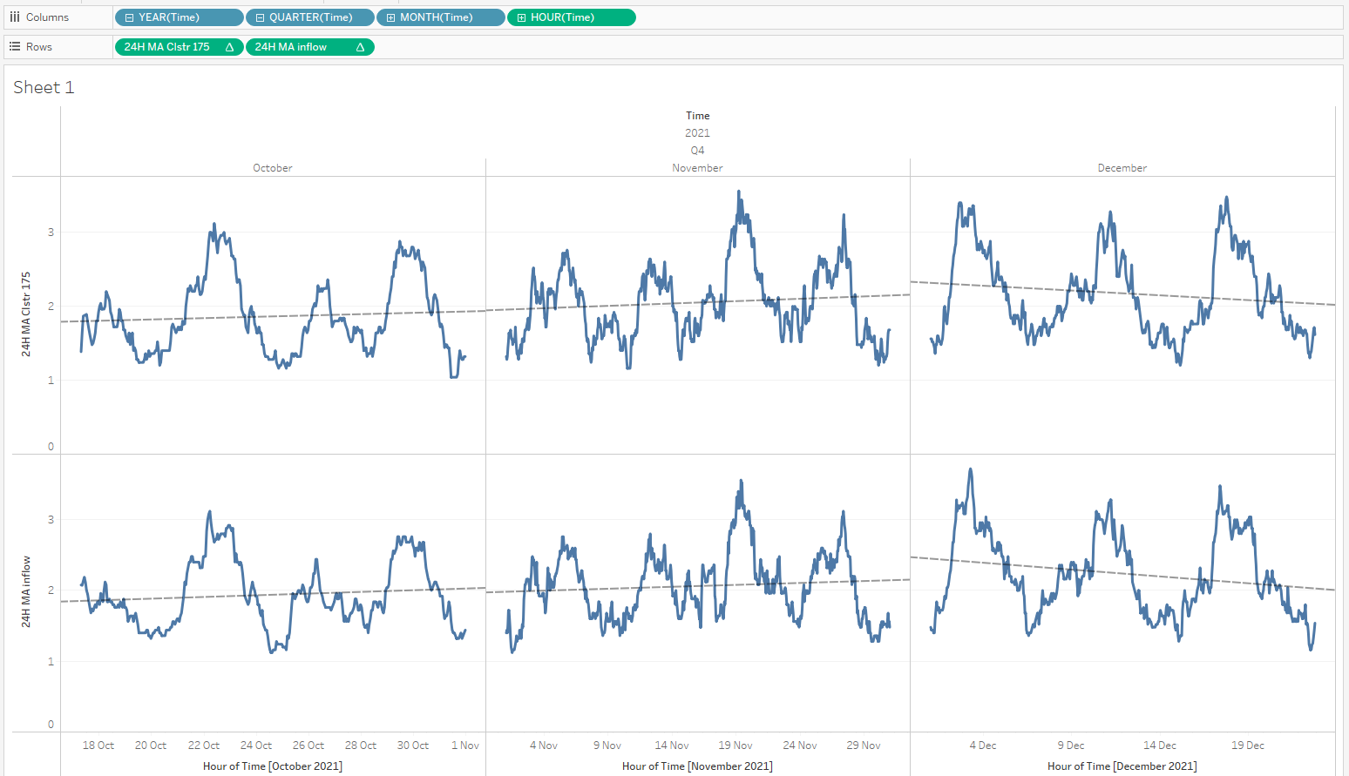

Figure : Trend cycles

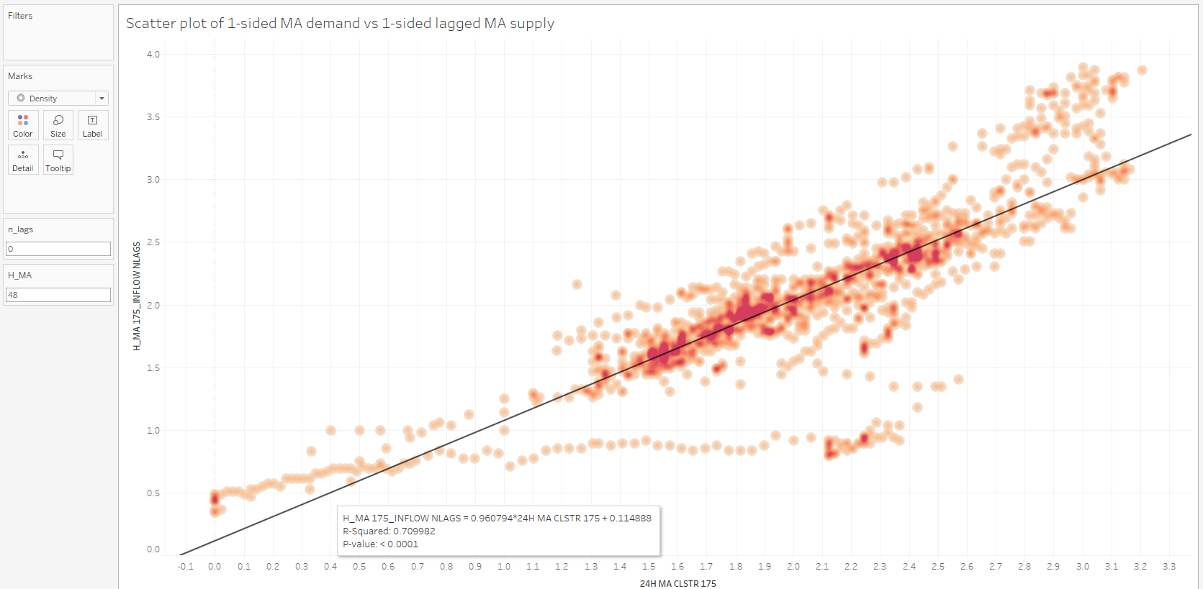

Figure :Scatter plot

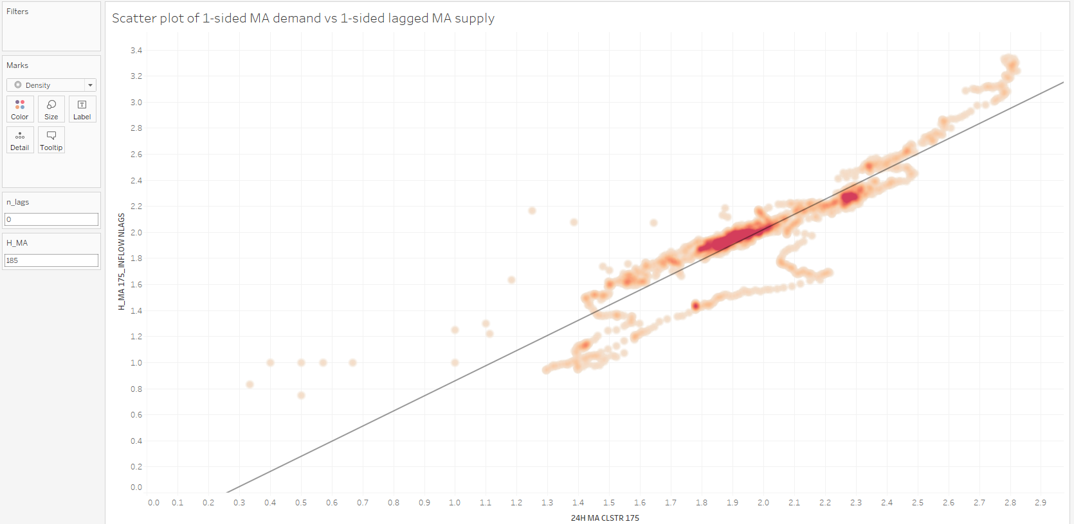

Figure : Scatter plot

**Observation:**

1. The correlation for the original inflow and demand time series is 0.225. For lagged versions of inflow, the correlation decreased. The correlation plot can be seen in figure x below the correlation matrix.
2. Figure y shows the trend cycle of 24-hour moving average for both supply and demand. There appears to be high correlation between the two and this is quantified by the scatter plot in figure z. Increasing lag values only caused lower correlation.
3. Increasing the H_MA parameter seems to increase correlation even more.

Table : Hours of MA Vs. correlation

|  |  |
| --- | --- |
| hours of MA | Correlation |
| 0 | 0.225 |
| 5 | 0.530 |
| 10 | 0.5582 |
| 15 | 0.5915 |
| 20 | 0.6250 |
| 24 | 0.6535 |
| 35 | 0.6919 |
| 48 | 0.7099 |
| 72 | 0.7341 |
| 96 | 0.7649 |
| 168 | 0.8352 |
| 185 | 0.84056 |
| 200 | 0.8371 |
| 250 | 0.8350 |
| 300 | 0.8238 |
| 336 | 0.8052 |

**Inference:**

1. Due to high noise in the original time series of inflow and demand the positive correlation is low for all lags of inflow including 0.
2. After filtering the noise, the trends of supply and demand have a high correlation. As demand reacts to supply the lag 0 of supply gives the largest correlation. The arrived inflow are expended within the hour through demand.

##### 3.3.3.3.2 Creation of a new covariate to bound the demand time series

**Purpose:** Subtract past demand from past inflow to see how many cars are standing in the station recently.

Creation of a new feature (covariate) time series to put an upper bound on the future demand request using the following formula in tableau.

*LOOKUP(SUM([175 Inflow]),1) + SUM([175 Inflow] - [Clstr 175])*

The past time period’s demand is subtracted from the past time period’s inflow and added to the current time periods inflow to put a bound on the possible demand at the current period. However, this does not take into account of the idle standing vehicles therefore it is not a true upper bound.

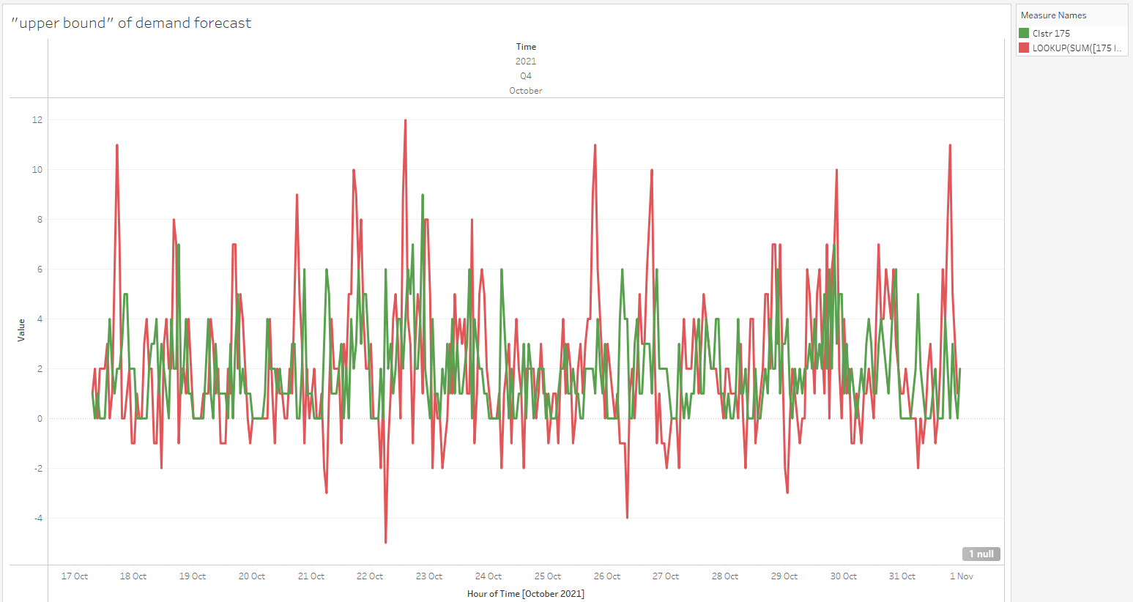

**Observation and Inference:**

1. All demands proceeding a peak value of inflow are either equal or lower than its value.

#### 3.3.3.4 Lagged neighbouring cluster 1 and 2 demand

The neighbouring clusters with the 2 largest cross correlation (in the first 168 lags) are chosen as covariates in predicting the target cluster. The neighbouring cluster demands are lagged by the prediction window length (1 hour) as their future values are not available as covariates in the prediction window. Cluster 171 is neighbouring cluster 1 and cluster 168 is neighbouring cluster 2.

##### 3.3.3.4.1 Trend cycle and correlation plot

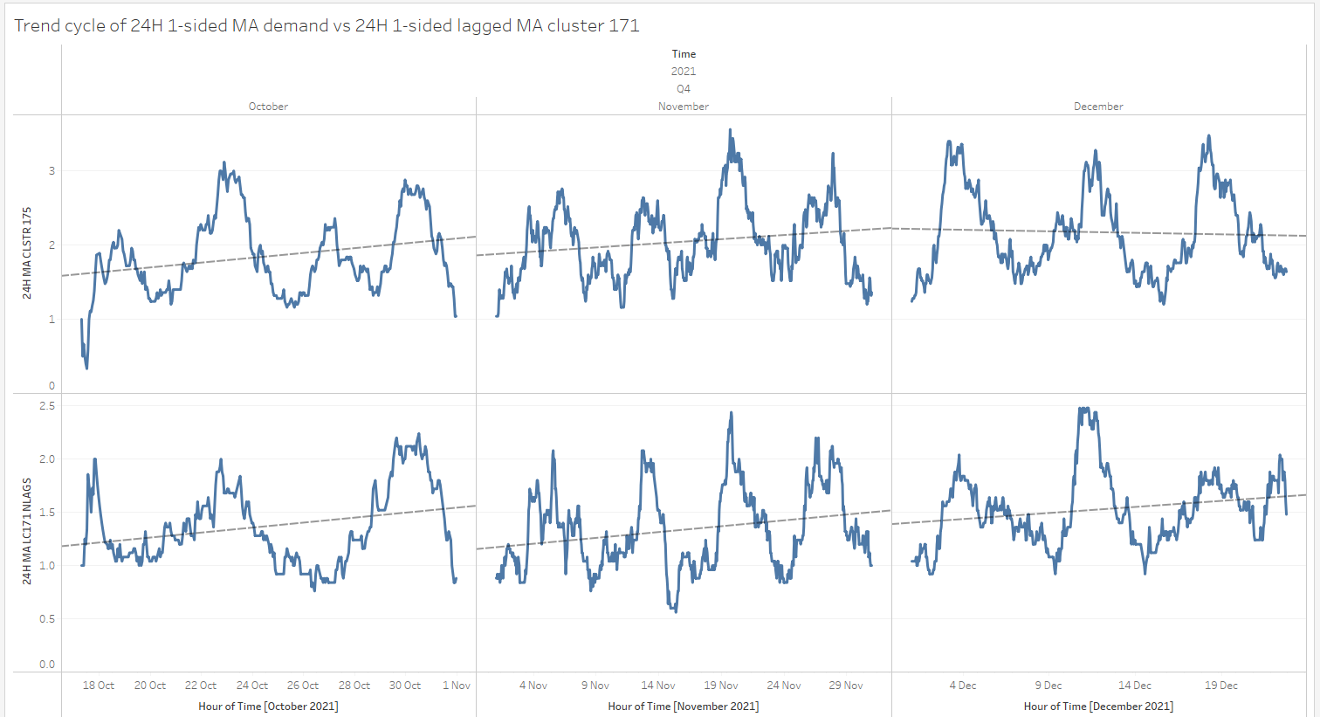

Figure : Trend cycles

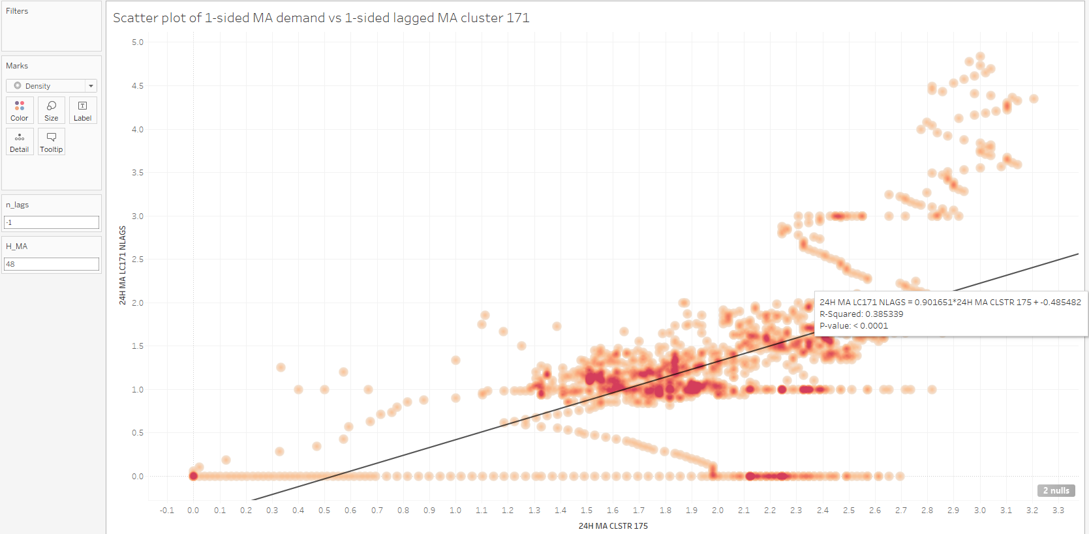

Figure : Scatter plot

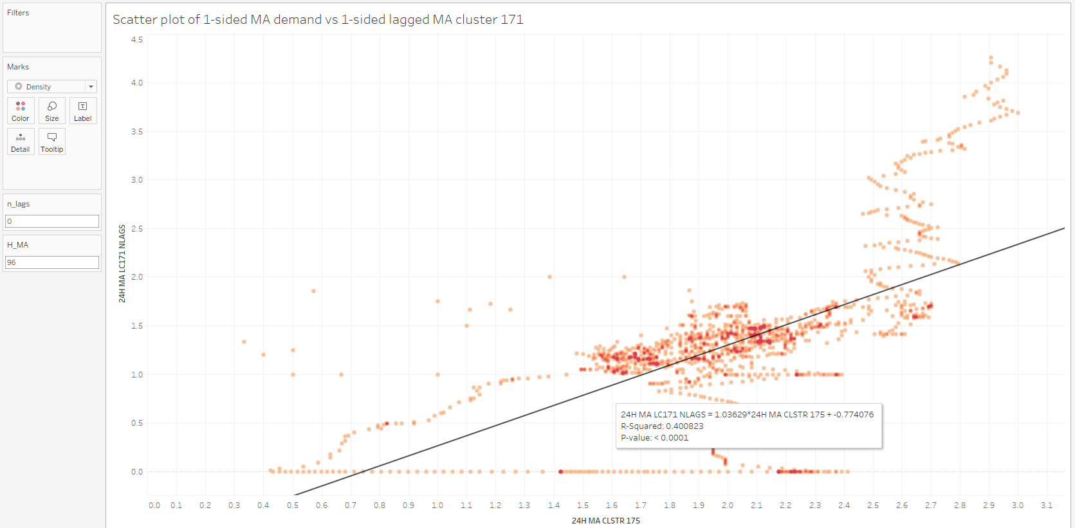

Figure : Scatter plot

Table : Hours of MA Vs. correlation

|  |  |
| --- | --- |
| hours of MA | Correlation |
| 0 | 0.0711 |
| 10 | 0.2431 |
| 20 | 0.2817 |
| 24 | 0.3038 |
| 30 | 0.3360 |
| 48 | 0.3839 |
| 72 | 0.3987 |
| 96 | 0.4008 |
| 100 | 0.3998 |
| 120 | 0.3864 |
| 125 | 0.3851 |

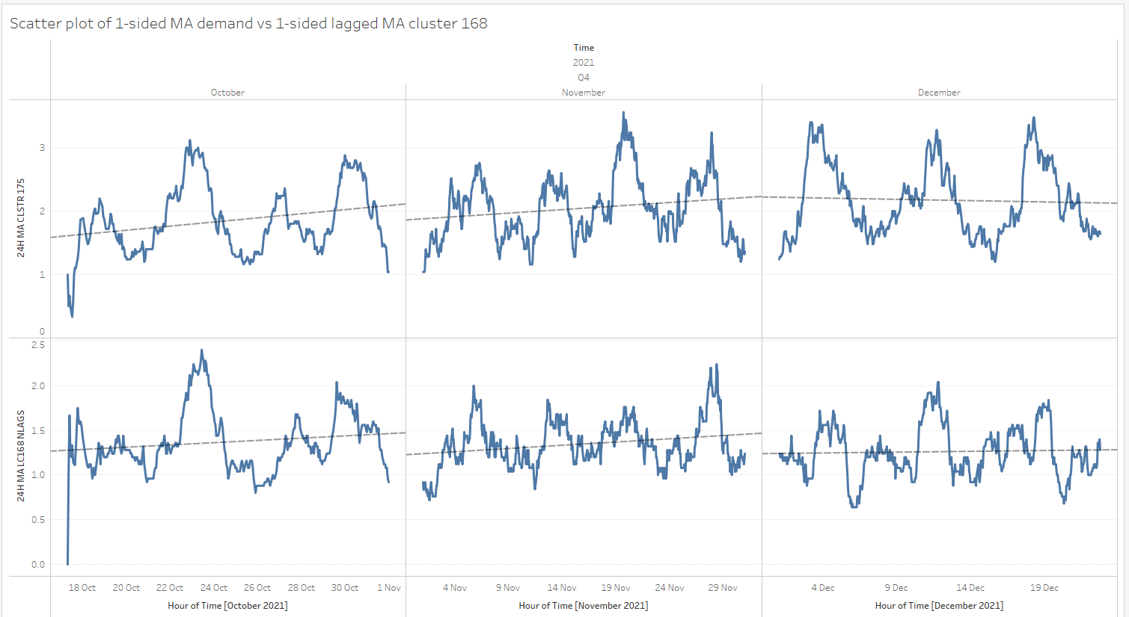

Figure : Trend cycles

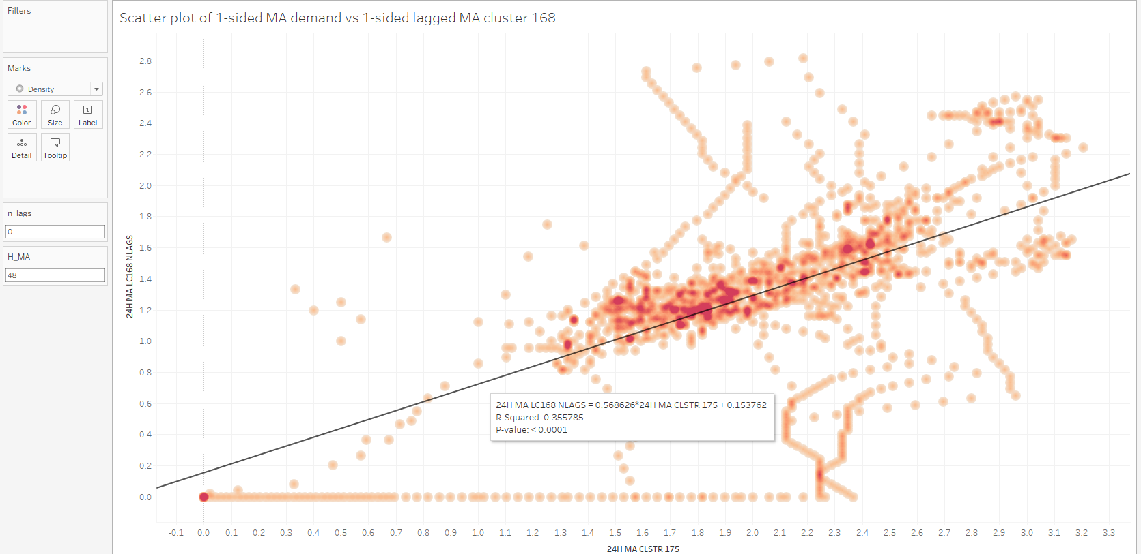

Figure : Scatter plots

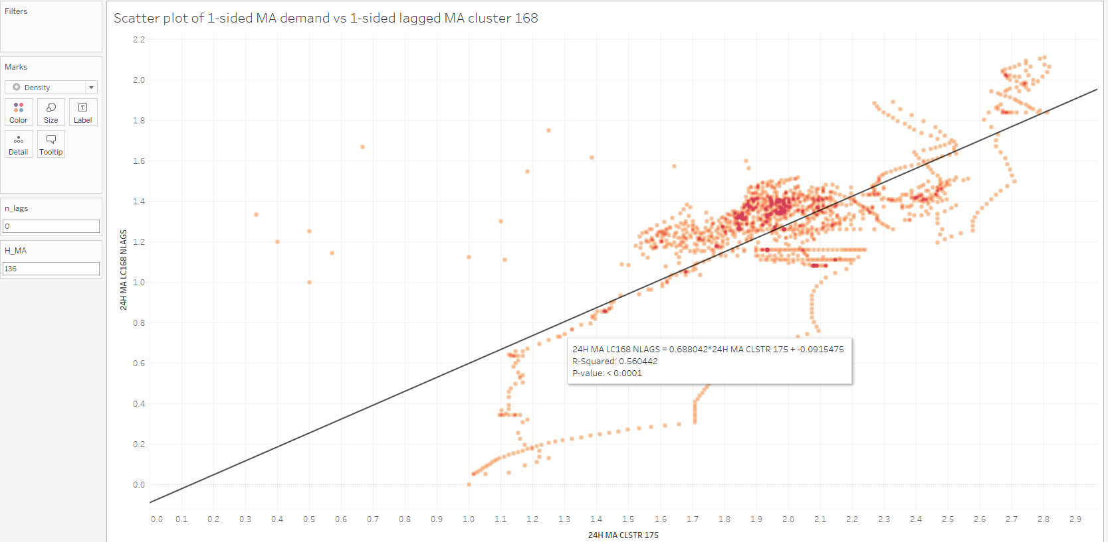

Figure : Scatter plots

Table : Hours of MA Vs. Correlation

|  |  |
| --- | --- |
| hours of MA | Correlation |
| 0 | 0.0714 |
| 24 | 0.2538 |
| 48 | 0.3357 |
| 72 | 0.4277 |
| 96 | 0.4946 |
| 120 | 0.544 |
| 136 | 0.5604 |
| 148 | 0.5597 |
| 172 | 0.5188 |

**Observation and Inference:**

Cluster 171

* The trend cycles show that the peaks of both lagged cluster 171 and target are aligned. There is a decreasing trend on the month of December for the target but not for cluster 171.
* Scatter plots in figure x and y show that increasing MA increases correlation. Table x shows that this increase in correlation is up to a MA value of 96 hours. After this, correlation begins to decrease.
* These higher MA like 48 hours can be used to as a new covariate signal to improve prediction accuracy.

Cluster 168

* The trend cycles show that the peaks of both lagged cluster 168 and target are aligned for most months. There is a decreasing trend on the month of December for both cluster 168 and the target.
* Scatter plots in figure x and y show that increasing MA increases correlation. Table x shows that this increase in correlation is up to a MA value of 136 hours. After this, correlation begins to decrease.
* These higher MA like 48 hours can be used to as a new covariate signal to improve prediction accuracy.

### 3.3.3 Cross-correlation plots and Granger Causality

Cross-correlation is the same as ACF but the lagged time series is not the target but the covariate with which correlation is being calculated.

A lagged time series with the same lag as the lag with largest CCF coefficient can be used as a new covariate to incorporate seasonality in the encoder and improve prediction accuracy when this lag is larger than the encoder length.

The reason for including lags of the covariate time series with high coefficient is because we expect the effect of the time steps of covariate on the target proceeding the lagged time series (which has already been observed) to also affect similarly the proceeding (unobserved) time step of the target in the prediction horizon after the present time step. The unobserved values in the target are learned through supervised training.

Granger causality is a statistical test to quantify the nonzero lags (lags > 0) of the covariate time series that have a unique impact in predicting the present value of the target time series.

#### 3.3.3.1 Temperature

**Observation:**

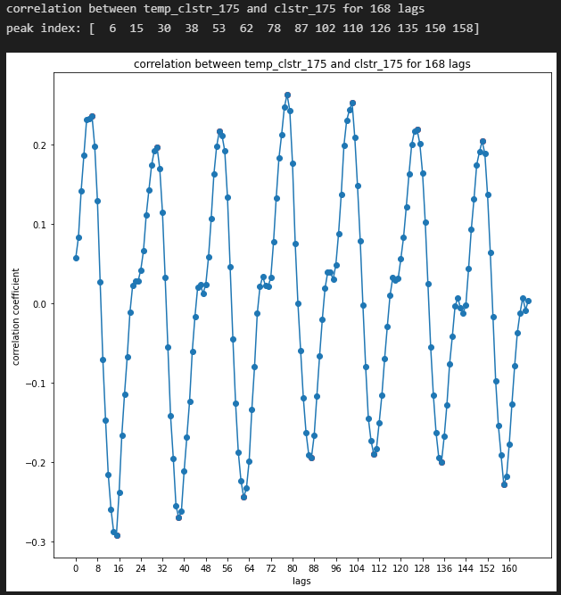

Figure : Cross-correlation plot

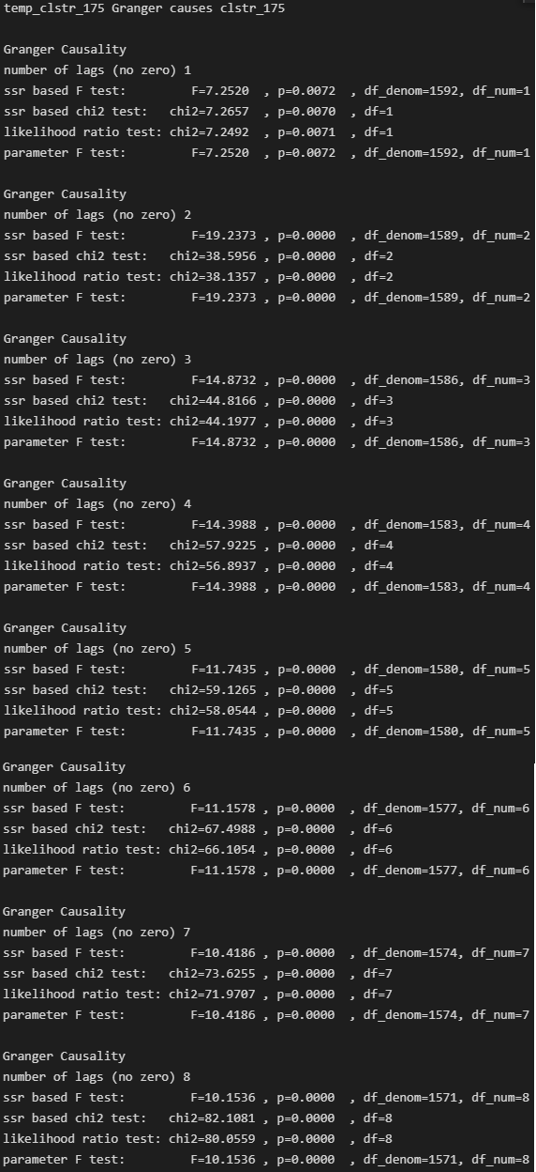

Figure : Granger Causality

**Inference:**

1. Temperature itself has a 24 hour seasonality as the temperature each day follows a similar pattern. The values of the correlation are not significant and the correlation with the past is likely to be a spurious correlation rather than a true relationship because it is highly unlikely that previous days temperature will affect the demand the next day given that the temperature fluctuations are not even large.
2. The results of granger causality shows that all the past 8 lags have some unique impact on the future target.

#### 3.3.3.2 Humidity

**Observation:**

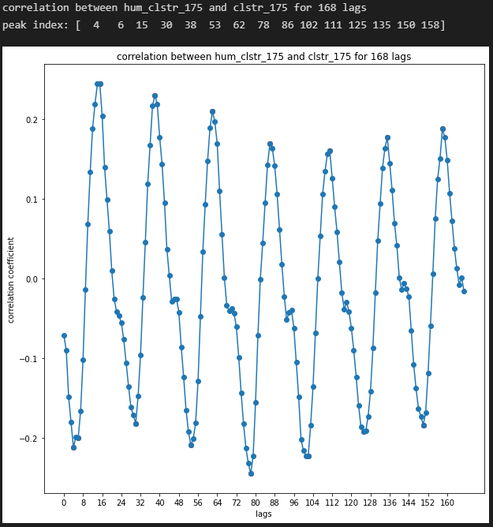

Figure : Cross-correlation plot

**Inference:**

1. Humidity has a high negative correlation with temperature itself so its behaviour is similar to temperature. This is evident from the fact that the peak lags of both temperature and humidty are same. The values of the correlation are not significant and the correlation with the past is likely to be a spurious correlation rather than a true relationship because it is highly unlikely that previous days humidity will affect the demand the next day given that the humdity fluctuations are not even large.
2. The results of granger causality are similar to temperature and all the 8 lags have granger causality with the target.

#### 3.3.3.4 Supply at target cluster

**Observation:**

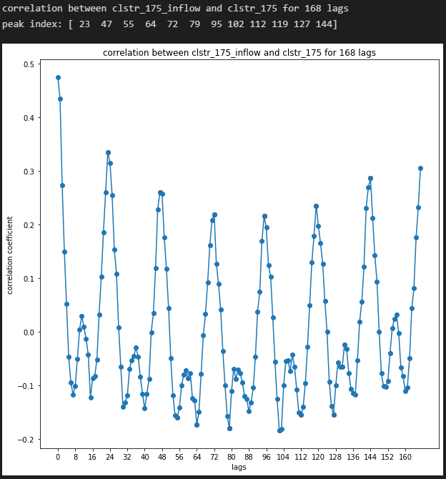

Figure :: Cross-correlation plot

**Inference:**

* The correlation is greatest for a lag of 1. This shows that demand in this cluster responds quickly to supply from the previous time period.
* The peak correlations decrease until 72 (3 days) to 96 hours (4 days) and then begin to increase. This can be attributed to seasonality in weekdays (4 days) and in weekends (3 days)
* Negative correlation is lesser compared to positive correlation.
* The results of granger causality are like temperature and all the 8 lags have granger causality with the target.

#### Lagged neighbouring cluster 1 and 2 demand

**Observation:**

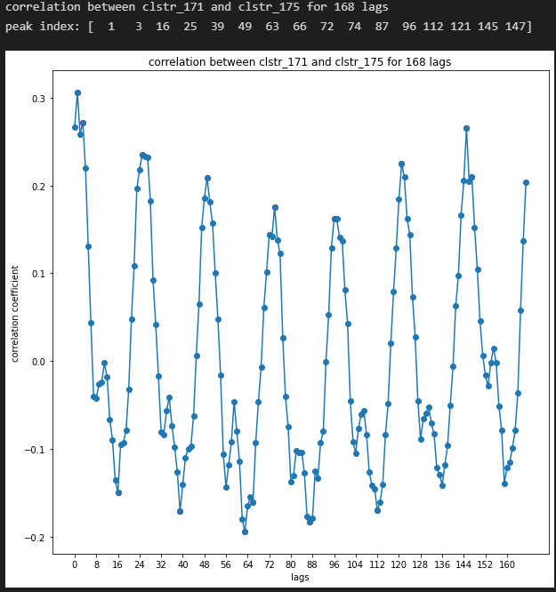

Figure : Cross-correlation plot

**Inference:**

* The correlation is greatest for a lag of 1 compared to other lags but by absolute measure it is still a smaller correlation value. This shows that demand in the target responds to demand in cluster 171 from the previous time period. This could be due to demand overflow from cluster 171 due to lack to supply there.
* The peak correlations decrease until 96 hours (4 days) and then begin to increase to a second peak at 168 hours (1 week). This can be attributed to seasonality in weekdays (4 days) and in weekends (3 days)
* Negative correlation is lesser compared to positive correlation.
* The results of granger causality are similar to temperature and all the 8 lags have granger causality with the target.

**Observation:**

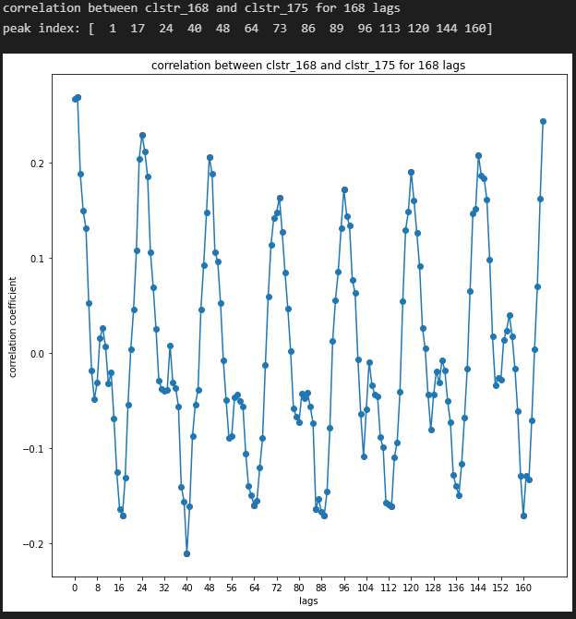

Figure : Cross-correlation plot

**Inference:**

* The correlation is greatest for a lag of 1 compared to other lags but by absolute measure it is still a smaller correlation value. This shows that demand in the target responds to demand in cluster 168 from the previous time period. This could be due to demand overflow from cluster 168 due to lack to supply there.
* The peak correlations decrease until 96 hours (4 days) and then begin to increase to a second peak at 168 hours (1 week). This can be attributed to seasonality in weekdays (4 days) and in weekends (3 days)
* Negative correlation is lesser compared to positive correlation.
* The results of granger causality are similar to temperature and all the 8 lags have granger causality with the target.

# Spatial and Temporal Segregation of predicted cluster demand

The cluster-level demand prediction every hour is segregated/upsampled into 5-minute intervals at every stations.

## 4.1.2.5.1 Persistence model

Due to strong weekly seasonality, the demand after upsampling in same proportion to the demand in the previous week.

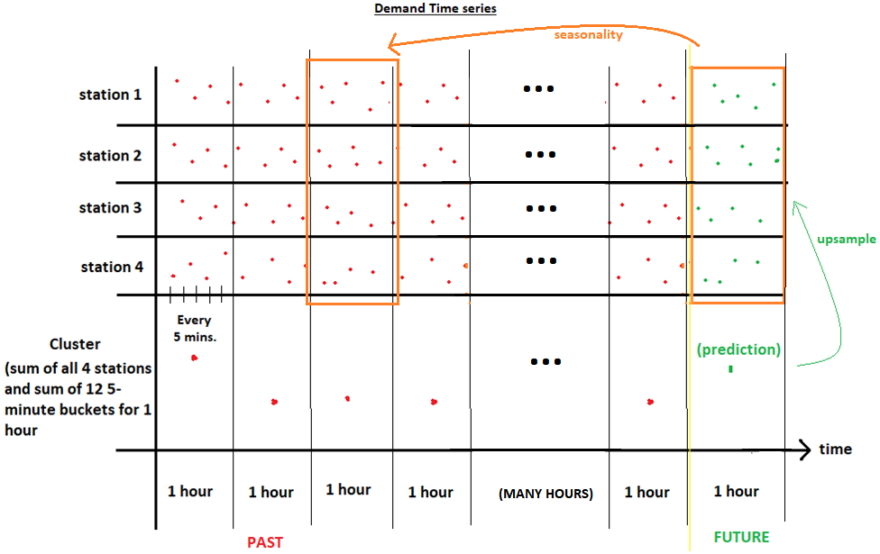

Figure : Illustration of segregation of hourly cluster-level demand prediction

## 4.1.2.5.2 XGBOOST model

# Baselines

After analysing the underlying patterns, simple models can be employed to utilize them to make predictions. Training these models is faster and their prediction accuracy is intermediate.

## 5.1 Persistence Model

This is the simplest model. The past values persist, and they are aggregated to make future predictions. It leverages weakly seasonality to average the same-hour and same day ground-truths of previous weeks to make future predictions. The formula is given below.

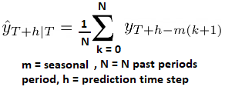

Equation :Historic Average (HA) (persistance model) formula

**Source code files:**

1. *DeepAR_tampines_lag_502_experiment.ipynb*

### Test Results

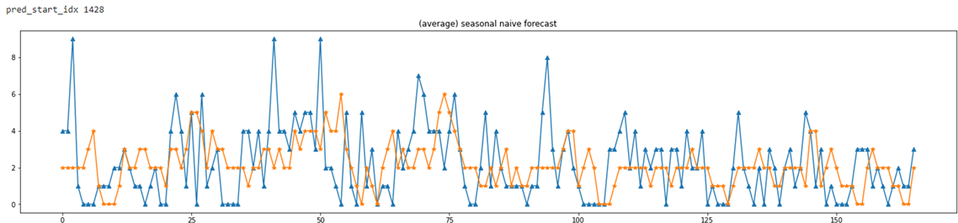

Figure : Historic Average predictions

> MAE

[1] 1.64

> RMSE

[1] 2.13

### 5.1.2 Shortcomings

1. The MAE is given by 1.64 cars/hour and RMSE = 2.13 cars/hour.
2. Solely based on the target time series alone and only one weekly seasonal pattern is used in making this prediction.
3. Does not utilize other covariate information like supply and weather to quantify their impact on prediction.

### 5.1.2 Target time series analysis in the prediction horizon

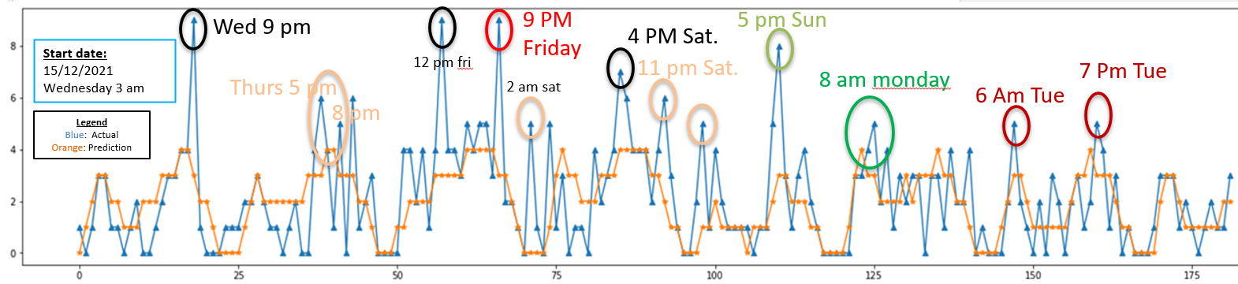

Figure : Target Time Series Analysis in the prediction horizon

The patterns detected in the training data can be observed in the test data as well. The blue plot above is the actual (ground-truth time series). **Ignore the orange plot.**

1. Wednesday 9 pm has a high variance so its weekly seasonality is not strong. This can be viewed in the Heatmap and Treemap given in appendix. A high peak can be better explained using other covariates.
2. Thursday evenings from 4 pm – 8 pm are generally seasonal.
3. Friday 12 pm is not due to weekly seasonality and it has to be explained by other covariates.
4. Friday 9 pm has the strongest weekly seasonality.
5. High peak Saturday 2 Am is an outlier.
6. Saturday 4 pm and 11 pm have weekly seasonality with moderate demand.
7. Sunday 5 am has weekly seasonality with moderate demand.
8. Sunday 5 pm has weekly seasonality with moderate demand.
9. Monday 8 am has moderate weekly seasonality with moderate demand.
10. Tuesday 6 am has strong weekly seasonality with moderate demand.
11. Tuesday 7 pm has strong weekly seasonality with moderate demand.

## Statistical Models

### 5.2.1 SARIMA

Many of the patterns explored in section 3 can be captured by the Autoregressive (AR) Integrated (I or d) Moving Average (MA) model. Serial dependence on past values is captured by the AR terms while detrending is done by the I or d term. Mean reversion characteristics are captured by the MA terms. (Hyndman, n.d.)

The general equation for an ARIMA model is given below.



Equation :ARIMA characteristic polynomial

Where ф1 to фp are the AR coefficient terms, θ1 to θq are the MA coefficient terms. μ is the (global) mean of the process. Bp is the lag operator, yt-p. ɛt is white noise with mean 0 and a constant variance.

To incorporate seasonality into the model, AR and MA seasonal terms Φp and Θq are added as shown below with an example for an ARIMA(1,1,1)(1,1,1)4 process without a constant.

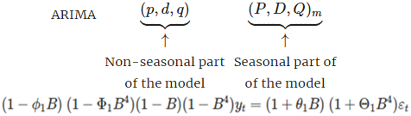

Equation :SARIMA characteristic polynomial

Small m represents seasonal period of 4.

Some of the coefficients in the model can take a value of 0. Generally, the seasonal coefficients tend to have lags around the seasonal period while the non-seasonal terms tend to have relatively smaller values closer to lag of 0.

SARIMA modelling is an iterative process comprising of the three stages of model selection, model estimation and model checking.

**GitHub folder:**

1. DeepAR_demand_prediction\2_freq_nbinom_LSTM\1_cluster_demand_prediction\Statistical TSA Model in R

**Source code files:**

1. *ARIMA.r*
2. *plot_full_ARIMA_prediction.r*

The choice of terms p,P d,D,q and Q in the SARIMA model are determined by analysis of the time series plot, ACF and PACF plots.

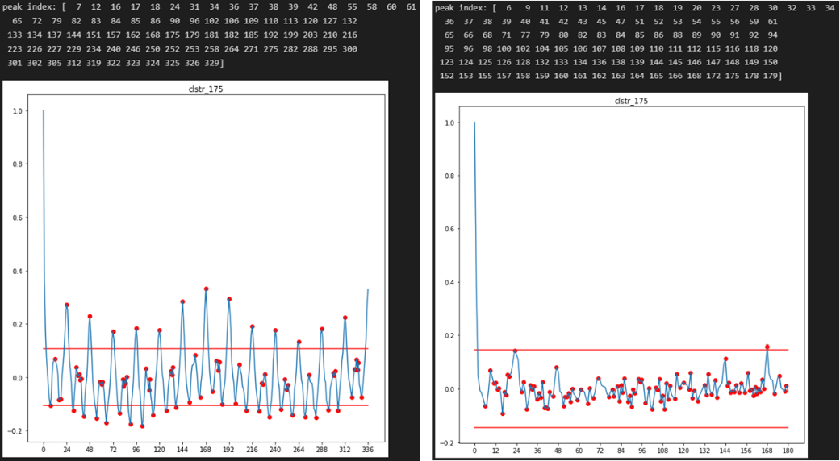

Figure : ACF and PACF plot of Target time series

The time series plot does not seem to have any visible trend as mean is relatively constant around 2 cars. The weak stationarity is indicated by the autocorrelation function exhibiting a smooth pattern of significant values at high lags instead of converging rapidly to zero as the value of the lag increases. This could be a sign of a small hidden trend.

Basically, we need to perform some deterministic transformation on the original times series (detrending or seasonality removal) to simplify the ACF and PACF plots to simplify the SARIMA model with fewer terms to create a parsimonious model. After performing prediction, inverse transformation can be applied to get predictions in the original time series.

* As 168 hours lag has high correlation, we can remove this effect by seasonal differencing 168 hour lagged time series from the original time series. The effect of this in the ACF and PACF plots is shown below. Peaks are mostly only detected for 24 hours, 168 hours. This simplifies the SARIMA model.

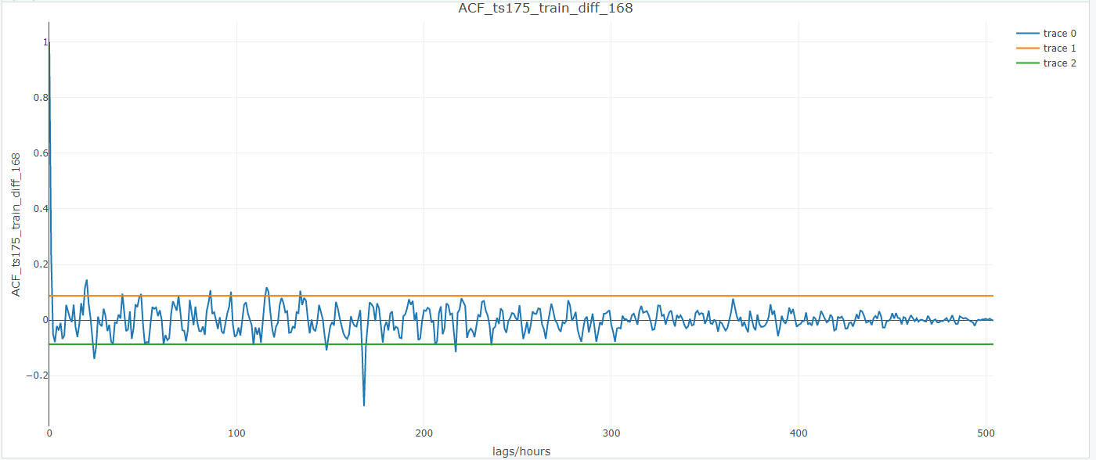

Figure : ACF plot after 168-hour differencing

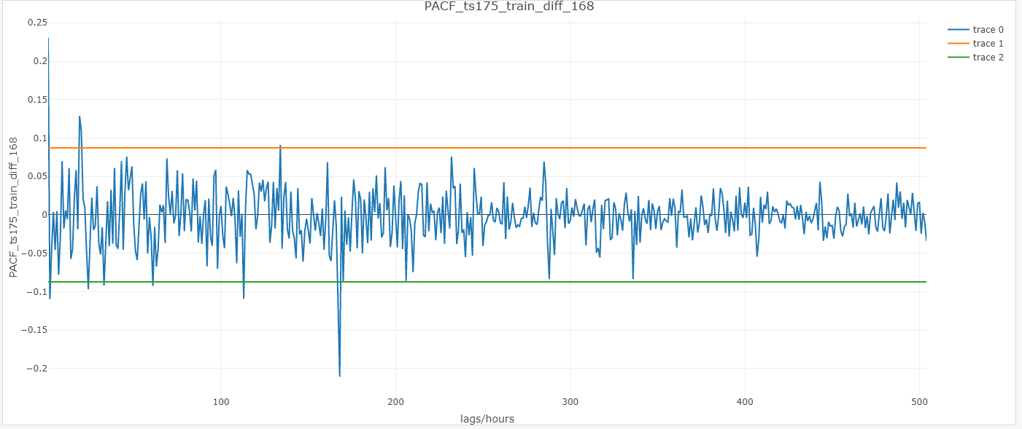

Figure :PACF plot after 168-hour differencing

Generally, the order of the non-seasonal Autoregressive terms are inferred from the PACF plot. Non-seasonal Moving Average terms are inferred from the ACF plot. The order of the seasonal AR and MA terms is similarly inferred from the ACF and PACF plot around the same lag as the seasonal period.

#### 5.2.1.1 Model Fitting and Test Results

A SARIMA model is trained on the last 4 weeks of the data to predict the following 24-hour segment. After this prediction, the observed ground truth 24 hours is appended to the training data and retrained. This trained model is used to predict the following 24-hour segment. This process repeats for future predictions.

This way short horizons of distinct 24-hour segments are predicted consecutively. There are 6 segments of predictions in total in the test set.

The ARIMA model is fitted automatically using the “auto.arima()” function to predict the 6 segments is given below:

Best model: ARIMA(2,0,0) with zero mean

> autofit

Series: ts175_train_diff_168

ARIMA(2,0,0) with zero mean

Coefficients:

ar1 ar2

0.2574 -0.1096

s.e. 0.0443 0.0443

sigma^2 = 3.968: log likelihood = -1063.62

AIC=2133.23 AICc=2133.28 BIC=2145.91

Best model: ARIMA(2,0,0) with zero mean

> autofit

Series: ts175_train_diff_168

ARIMA(2,0,0) with zero mean

Coefficients:

ar1 ar2

0.2230 -0.0771

s.e. 0.0434 0.0436

sigma^2 = 4.079: log likelihood = -1121.51

AIC=2249.02 AICc=2249.07 BIC=2261.84

Best model: ARIMA(0,0,1) with zero mean

> autofit

Series: ts175_train_diff_168

ARIMA(0,0,1) with zero mean

Coefficients:

ma1

0.2195

s.e. 0.0406

sigma^2 = 4.236: log likelihood = -1183.33

AIC=2370.67 AICc=2370.69 BIC=2379.3

Best model: ARIMA(2,0,1) with zero mean

> autofit

Series: ts175_train_diff_168

ARIMA(2,0,1) with zero mean

Coefficients:

ar1 ar2 ma1

0.9635 -0.2275 -0.7365

s.e. 0.1670 0.0447 0.1679

sigma^2 = 4.323: log likelihood = -1239.58

AIC=2487.17 AICc=2487.24 BIC=2504.6

Best model: ARIMA(2,0,1) with zero mean

> autofit

Series: ts175_train_diff_168

ARIMA(2,0,1) with zero mean

Coefficients:

ar1 ar2 ma1

0.9610 -0.2318 -0.7283

s.e. 0.1767 0.0441 0.1787

sigma^2 = 4.291: log likelihood = -1340.51

AIC=2689.02 AICc=2689.08 BIC=2706.77

Best model: ARIMA(2,0,1) with zero mean

> autofit

Series: ts175_train_diff_168

ARIMA(2,0,1) with zero mean

Coefficients:

ar1 ar2 ma1

0.9642 -0.2271 -0.7383

s.e. 0.1675 0.0424 0.1688

sigma^2 = 4.215: log likelihood = -1386.24

AIC=2780.49 AICc=2780.55 BIC=2798.39

The 168-hour differencing causes the SARIMA model to remain ARIMA without any SARIMA terms. The full prediction length is shown in figure x for the outputs to be comparable to other models.

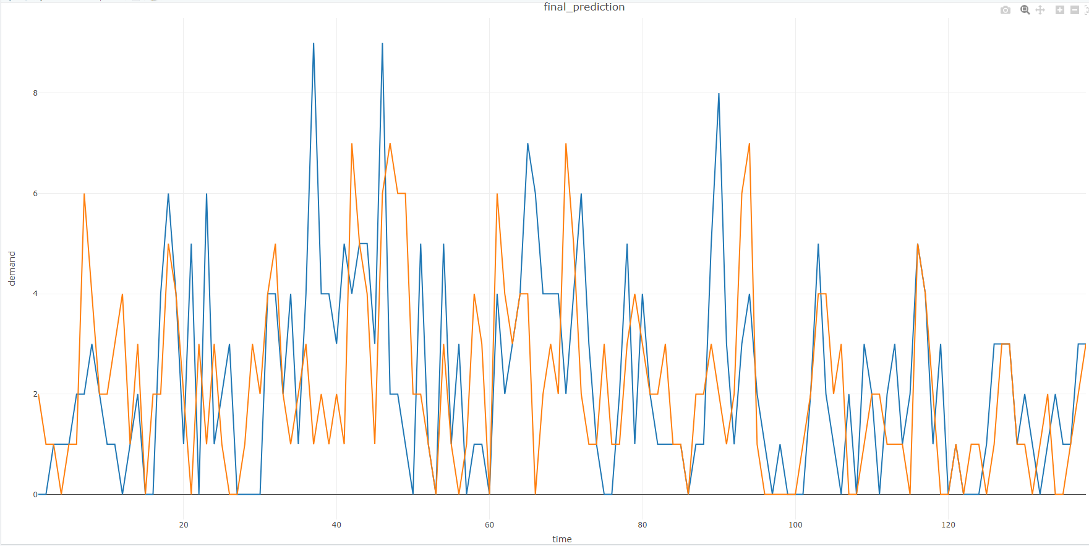

Figure : SARIMA predictions

> MAE

[1] 1.550725

> RMSE

[1] 2.166945

##### 5.2.1.1.1 Observation

* Not all peaks of ground truth and predictions overlay each other.
* The Mean Absolute Error (MAE) metrics are better than historical average and Root Mean Squared Error (RMSE) metrics are very close to historic average.
* On average peak detection is lagging by 1-2 hours.

##### 5.2.1.1.2 Shortcomings

1. seasonality is not captured, or it is predicted at wrong times as misalignment of peaks indicate. The model is not utilizing the 168-hour correlation through the SARIMA terms even when the peaks of ACF and PACF plot indicate this.
2. Some peaks are over or under predicted. The peak below 40th hour in figure 58 is not due to seasonality so it is not detected. It could have been detected if covariates were included.

### 5.2.2 Autoregressive conditional Negative-binomial model (ARCNBM)

The demand time series is stochastic in nature. The marginal (overall) distribution comes from a negative binomial distribution as shown by the target frequency distribution in 3.2.2.

The conditional distribution of the time series given past observations is also a negative binomial distribution with time-varying parameters, λt and σt2 = λt + λt2/ф where ф is the over-dispersion parameter that is time invariant. λt and σt2 are time-varying mean and variance. (Liboschik, n.d.)

#### Model formulation

The model is based on the linear regression model but includes autoregressive terms. The Link function models how mean of the chosen distribution varies with time. The mean is always non-negative.

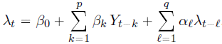

Equation :Linear Link function

The log-linear link function below allows for both negative and positive correlation to be modelled.

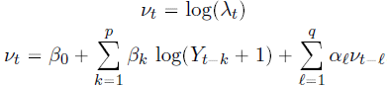



Equation :Log-Linear Link function

The chosen conditional distribution is the negative binomial distribution due to its ability to model overdispersion (variance larger than the mean).

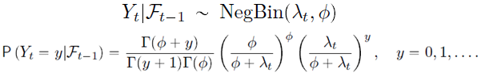

Equation :Target time series is modelled as Negative-Binomial process with time-varying parameters

The domain of the parameters in the model is given below. During model fitting these parameters are identified using quasi-maximum likelihood estimation for mixed Poisson process.

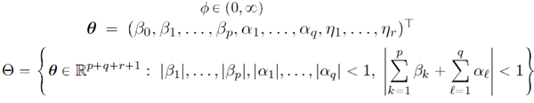

Equation :Domain of parameters in the model

Although, the probabilistic distribution can be sampled at any time instant, the mean squared error is reduced by using the conditional mean which is the output of the link function.

#### 5.2.2.1.1 Model Assessment

Given several different models, we want to assess the model fit and its predictive performance to facilitate the selection of an adequate model for a given data set.

A simultaneous assessment of calibration and sharpness summarized in a single numerical score can be calculated by proper scoring rules like the ranked probability score (RPS). RPS can be easily compared with MAE from a deterministic prediction. It can also assess the results of two different model’s probabilistic forecasts with a single metric. (pierre, n.d.)

A model’s prediction should strive to maximize the sharpness of the predictive distribution

subject to calibration. Calibration refers to the statistical consistency between the predictive distribution and the observations, and it is a joint property of the forecasts and the values that it utilizes. The notion of sharpness refers to the concentration of the predictive distribution and is a property of the forecasts only. It follows that if the predictive distribution is more concentrated, then the forecasts obtained are sharper. Therefore, this will yield better predictions subject to calibration. (Gneiting)

A list of proper scoring rules is given in the table below:

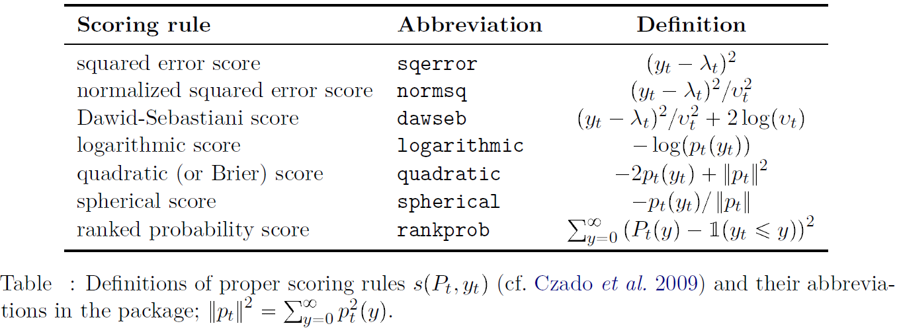

Table : Proper Scoring Rules

$S=\left(P_{t}, y_{t}\right)$ is the score at a time step/period. The mean score, $S=\sum_{t=1}^{n}{\frac{1}{n}}\left(P_{t}, y_{t}\right)$ is for a prediction horizon. The score measures a distance between the observed data, $y_{t}$ and the prediction from the predictive distribution, $P_{t}$.

Other popular model selection criterions include the Akaike and Bayesian Information Criterion, (AIC and BIC). BIC generally yields more parsimonious models than the AIC.

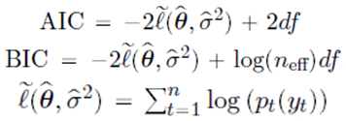

Equation :Information Criterion

$df$ is the total number of parameters (including the dispersion coefficient), and $n_{eff}$ is the number of effective observations in the training data.

#### 5.2.2.2 Model fitting and Test Results

**GitHub folder:**

1. DeepAR_demand_prediction\2_freq_nbinom_LSTM\1_cluster_demand_prediction\Statistical TSA Model in R

**Source code files:**

1. ARCNBM.r
2. plot_full_ARCNBM_prediction.r

The number of peaks of the ACF and PACF plot determine the order of the Autoregressive terms. These numbers are used to experiment different combinations of terms for the conditional mean and past observations in the link function.

To achieve high accuracy, an ensemble approach is used. 6 models are trained. Each model uses a validation set from one of the 6 different weeks of the historic data. The validation sets are the same 24-hour period used in the testing set. E.g., if test set is 24 hours of Saturday, then Validation sets are also 24 hours of Saturday from previous observed weeks.

Model fitting is performed using the following function:

tscount::tsglm(ts = ts175_train, model = list(past_obs = reg_lags,

past_mean = reg_lags), link = "log", distr = "nbinom")

Coefficients:

Estimate Std.Error CI(lower) CI(upper)

(Intercept) 0.0698 0.0425 -0.0136 1.53e-01

beta_1 0.2602 0.0392 0.1833 3.37e-01

beta_16 -0.0729 0.0372 -0.1459 6.93e-05

beta_24 0.0505 0.0394 -0.0268 1.28e-01

beta_48 0.0591 0.0398 -0.0189 1.37e-01

beta_91 -0.0478 0.0381 -0.1225 2.68e-02

beta_168 0.2188 0.0391 0.1421 2.95e-01

alpha_1 -0.0582 0.0573 -0.1705 5.41e-02

alpha_16 -0.0413 0.0465 -0.1323 4.98e-02

alpha_24 0.2731 0.0795 0.1173 4.29e-01

alpha_48 -0.2151 0.0605 -0.3336 -9.66e-02

alpha_91 -0.0592 0.0499 -0.1571 3.87e-02

alpha_168 0.3929 0.0734 0.2490 5.37e-01

sigmasq 0.1122 NA NA NA

Standard errors and confidence intervals (level = 95 %) obtained

by normal approximation.

Link function: log

Distribution family: nbinom (with overdispersion coefficient 'sigmasq')

Number of coefficients: 14

Log-likelihood: -2008.226

AIC: 4044.453

BIC: 4115.154

QIC: 4070.956

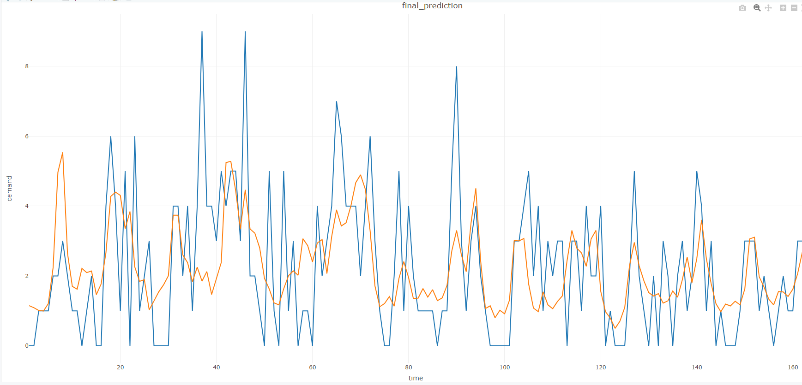

Figure : ARCNBM predictions

> MAE

[1] 1.367033

> RMSE

[1] 1.848611

##### 5.2.2.1.2 Observation

1. The model achieves a lower MAE and RMSE but at the expense of detecting peak demands.
2. It does not predict any 0 demand periods.

##### 5.2.2.1.3 Shortcomings

1. Longer training times
2. Need to choose the number of terms in the process.
3. No long-term memory
4. Large number of parameters leads to overfitting.
5. Not good for predicting peaks, as it only detects average seasonality.
6. Prediction is averaged out.

# 6. DeepAR

Although, ARCNBM captures the visible and discernible underlying patters in exploratory data analysis there may still be indiscernible underlying patterns that elude the human notion of patterns like seasonality. These can be captured by a deep learning model that can learn latent features in data. Specifically, Recurrent neural networks (RNN) are used to detect patterns in sequential data and make future predictions. Multi-variate probabilistic forecast is needed to quantify uncertainty and get bounds on the demand forecast. This is helpful for the downstream task of vehicle rebalancing.

## 6.1 Introduction

**RNN**

In a sequence, each element is dependent on the past element to a certain degree depending on the inputs in the past elements. Each element is processed by a cell. The cell state vector carries pattern detected in the input elements and the states prior to a cell. This cell state is propagated through the cells to the cell where prediction is required. The weights and biases learned in each cell shared as they are all identical.

Traditional Feed Forward Networks (FFN) are different from RNNs as different parts of the FFN learn different features of the data. RNNs are suitable for input and output sequences of any arbitrary length. These are possible due to weights sharing.

RNN architecture:

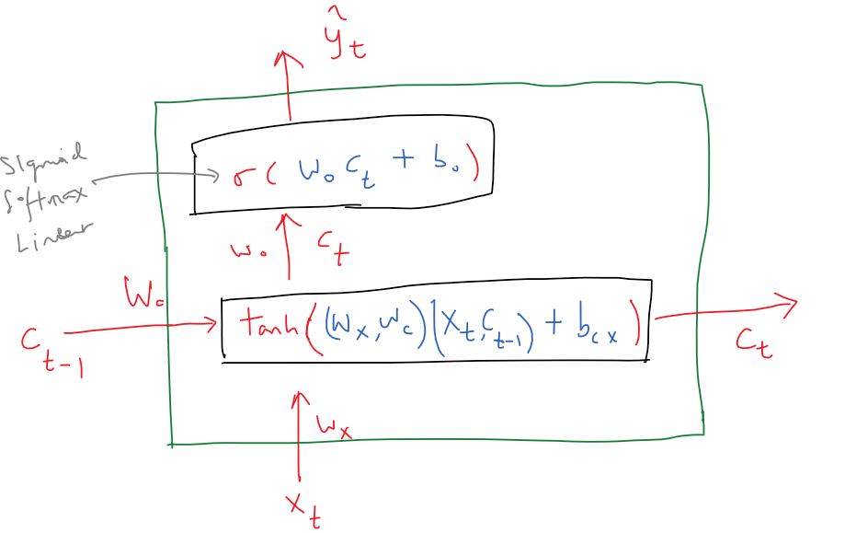

Figure :RNN cell

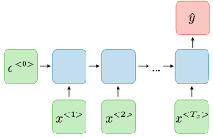

Figure :RNN network

In a many-to-one model, many inputs in a sequence are used to predict a single output. The RNN architecture consists of cells forming a network to represent the many-to-one model. Each of the blue squares is a RNN cell represented in figure x. The green squares with a letter c and x is the cell state and input vectors respectively. X is a vector of inputs at time, t consisting of the target and features that are standardized to ensure that they have similar scale. The red square with letter y is the output vector. To make more than one prediction the output and the cell state from the previous cell can be fed into the next cell and so on to get the next predictions. This will form a many-to-many model.

Figure x depicts an RNN cell. For the first cell/element, the cell state vector is a 0 vector. The longer the sequence of inputs and the greater the number of patterns, the longer the length of the state vector is. The length of the cell state vector is the same as the number of neurons in the first network. The RNN cell has two networks. The first network has a $\tanh\left( \right)$ activation function to squash the inputs to -1 and 1. It allows the cell states to take on both positive and negative values. This network detects existence of any of the learned patterns in the concatenated vector of the previous cell state and the current input. The detection of this updated pattern is passed on as the next cell state. In the current cell, an output is generated for the detected pattern using the second network. The second network has a $sigmoid\left( \right)$ activation function to ensure positivity of output results. This is the forward propagation step during training and testing.

$$c_{t}=\tanh\left(\left[w_{x},w_{c}\right]\left[x_{t},c_{t-1}\right]+b_{cx}\right)$$

$${\hat{y}}_{t}=σ\left(w_{0}c_{t}+b_{0}\right)$$

During training, learning occurs by backward propagation through time (Mustafa, n.d.) which involves gradient descent. The errors from the current RNN cell are backpropagated through the state, back through time, to previos RNN cells. This allows the RNN to learn to capture long term time dependencies. i.e., how a past cell’s state affects a future cell’s output.

The Loss function specifies the amount of error making predictions and the gradient can be used to correct the errors by updating the weights and biases.

From a set of possible sequences, $x^{1},x^{2},x^{3},x^{4},…x^{t}.$ where $x^{t} ϵ W$, $t ϵ N$

$W = whole number$, $N = Natural number$

We want to find the sequence that has the highest joint probability for that sequence. The joint probability can be expanded into conditional probabilities where probability of the future forecast is conditioned on the past observations. Maximizing the individual conditional probabilities leads to a high value of the joint probability.

$$P\left(x^{3},x^{4} | x^{1}, x^{2}\right)=P\left(x^{3} | x^{1},x^{2}\right)∙ P\left(x^{4} | x^{1},x^{2},x^{3}\right)$$

$x^{1}, x^{2}=known inputs$, $x^{3},x^{4}=unknown outputs$

The loss function for a sequence is given by the following formula.

$$L\left(x_{i}^{t},x_{i}^{t}\right)=-\sum_{t=1}^{n}{\sum_{i=0}^{m}{I\left(x_{i}^{t}\right)∙}\log{P\left(y_{i}^{t} | x^{t-1},x^{t-2}, ….\right)}}$$

Where $x_{i}^{t}$ is the true value of element at time, t and $y_{i}^{t}$ is the predicted value of the element at t. The inner summation iterates all the values of $x^{t}$ using $ⅈ$. $I\left(x_{i}^{t}\right)$ is the indicator function that results in 1 when $x_{i}^{t}$ is the correct value and 0 when it is wrong. It is one-hot-encoding.

we need to calculate the gradient of the loss function with respect to each time step separately and then add them up. The current cell state is recursively dependent on the previous cell state. So, we need to correct for the previous cells states that contributes to the prediction at the current time step. The gradient of the first network looks like the following:

$$\frac{∂L_{t}}{∂W_{c}}=\sum_{k=1}^{t}{\frac{∂L_{t}}{∂y_{t}}∙}\frac{∂y_{t}}{∂c_{t}}∙\left(\prod_{j=k}^{t-1}{\frac{∂c_{j}}{∂c_{j-1}}}\right)∙\frac{∂c_{k}}{∂W_{c}}$$

Each of the terms inside the pi notation can be written as below:

$$\frac{∂c_{j}}{∂c_{j-1}}=ⅆiag\left(\tanh^{'}\left(W_{x}∙x_{j}+W_{c}{∙c}_{j-1}+b_{cx}\right)\right)W_{c}$$

It is clear from the above that the two factors that affect the magnitude of the gradient are the weights $W_{c}$ and the derivative of the $\tanh\left( \right)$ activation function. The derivative of the $\tanh\left( \right)$ activation function can only range between 0 and 1. RNNs are susceptible to vanishing and exploding gradients. The longer the inputs the more repeated application of the recurrent connections that can result in either exploding or vanishing gradients.

If the dominant eigenvalue of the matrix $W_{c}$ is greater than 1, the gradient explodes. If it is less than 1, the gradient vanishes. Vanishing and exploding gradients can be minimized by using Xavier-Glorot initialization and clipping gradients respectively.

Basically, vanishing gradients prevents the RNNs ability to learn to detect correct patterns in the earlier cells in order to make correct predictions in the later cells. This problem can be solved by replacing RNN cells with LSTM cells.

**LSTM**

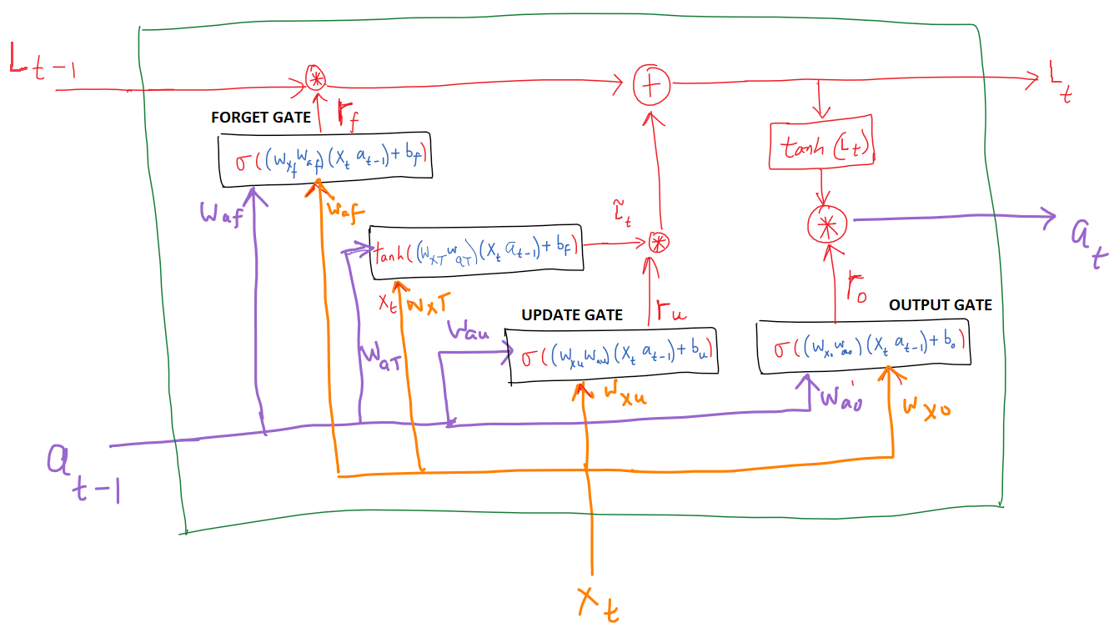

Figure :LSTM cells

Errors associated with the later time steps to affect weight updates of the earlier time steps in backpropagation through time. It must learn to (detect a particular pattern) and memorize it in the cell state as the state is propagated through the cells in order to predict the correct value in a cell at a later time step. Basic RNN cell states have local influences but difficult to influence far away time steps. LSTM lengthens the existence of important and useful short-term memory in the cell states as the states propagate through cells. It does this by preserving some state information in the state vector though the use of gates.

The equations governing LSTM are given below. Forget, update and output gates are the three gates given in equation 2,3 and 4 that perform this operation. Basically, the gates output a vector with elements between 0-1. An element value close to 0 means to forget while an element value close to 1 means to retain/remember. The gates affect the retention/discarding of elements of a cell state by element-wise multiplying with them. There are also two cell states called long-term state, $L_{t}$ and short-term state, $a_{t}$. Note that the short-term state, $a_{t}$ is like the $c_{t}$ state in RNN.

$${\tilde{L}}_{t}=\tanh\left(\left[W_{x}T,W_{aT}\right]\left[X_{t},a_{t-1}\right]+b_{T}\right.$$

$$Γ_{f}=σ\left(\left[w_{x_{f}},w_{af}\right]\left[x_{t},a_{t-1}\right]+b_{f}\right)$$

$$Γ_{u}=σ\left(\left[w_{x_{u}},w_{au}\right]\left[x_{t},a_{t-1}\right]+b_{u}\right)$$

$$Γ_{o}=σ\left(\left[w_{xo},w_{ao}\right]\left[x_{t},a_{t-1}\right]+b_{o}\right)$$

$$L_{t}=Γ_{u}*{\tilde{L}}_{t}+Γ_{f}*L_{t-1}$$

$$a_{t}=Γ_{o}*{tanh⁡(L}_{t})$$

Note that the first equation is like the first equation of the RNN cell. The vector ${\tilde{L}}_{t}$ detects any patterns found in the current input and the previous cell state. Basically, a summary of past observations. It contains patterns detected a few time steps back (short-term memory). The decision to selectively keep or remove some of the elements of this vector, ${\tilde{L}}_{t}$ is performed by the update gate. At the same time, the remember or forget gate retains some of the elements of pervious time step’s long-term state $L_{t-1}.$ This vector contains patterns detected a many time steps back (long-term memory). This gate ensures that the elements in the long-term state, $L_{t-1}$ are not modified in the current cell. Finally, the new long-term state for the current cell, $L_{t}$ is squashed by $\tanh\left( \right)$ activation function and multiplied with the output gate. This gates selectively remembers or forgets patterns that are useful for the output at the current time step. Finally, the $a_{t}$ state is passed linear layer or a SoftMax layer to produce the final output for that time step.

LSTMs are less susceptible to the vanishing gradient problem because small gradients are enough to cause the gamma function to change its value.

## 6.2 Sequence to Sequence Model

**Deep Autoregressive Recurrent Network (DeepAR)**

DeepAR (David Salinas, 2020) is a sequence to sequence model (either a many-to-one or many-to-many model) that summarizes the context information in the inputs to produce appropriate multi-step outputs. DeepAR uses LSTM networks to output probabilistic forecasts including quantile estimates by training them to learn parameters of probabilistic distributions, namely the negative binomial distribution. Beyond univariate time series forecasting, DeepAR can also perform multivariate time series forecasting where it learns local and global patterns in the data across all the related target time series.

### 6.2.1 Working Principle

#### 6.2.1.1 Training

The architecture of DeepAR is shown in figure x below. The encoder and decoder networks are identical. The decoder network proceeds the encoder network. The inputs to the networks are the target, $z_{\text{I,t-2}}$ and its covarites, $x_{\text{I,t-2}}$. Grey rectangles with ${\text{h}}_{\text{I,t-1}}$ represents the cells states of the LSTM cells of the network. ${l(z}_{\text{I,t-1}}\left|θ_{\text{I,t-1}}\right)$ represents the likelihood distribution given the parameters of the distribution output from the LSTM cells as shown by equation x below. $z_{\text{I,t-1}}$ represents the mode of the likelihood distribution. During training, the target’s ground truth is known and it is compared with $z_{\text{I,t-1}}$ which is also the next element of the sequence to calculate the loss for both the encoder and decoder networks. In the encoder network $z_{\text{I,t-1}}$. The subscripts i and t represent a particular target at a particular time step for multi-variate forecasting.

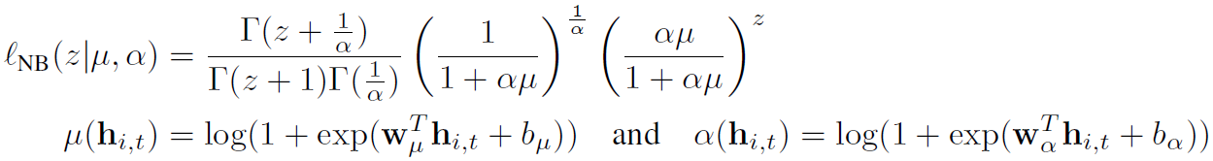

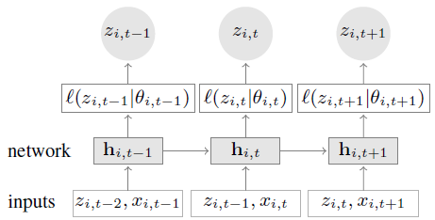 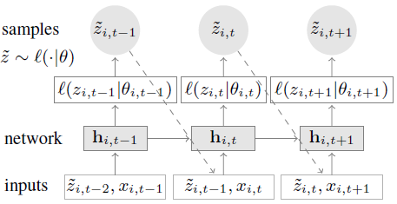

Figure : DeepAR encoder network Figure : DeepAR decoder network

During training, some combination of inputs in the encoder will be correlated to the output in the decoder. The weights are trained to identify this combination. The network outputs the mean, μ and the shape, α parameters. $θ(μ ,α)$. The r and p parameters of the negative binomial distribution are calculated using the formulas below:

$$r=\frac{1}{α}$$

$$p = \frac{μ}{μ+r}$$

The mode of the distribution is then:

$\left\lfloor \frac{\left(r-1\right)\left(1-p\right)}{p}\right\rfloor if r>1$,

$0 if r≤1$

The output must be the mode because it minimizes the negative log-likelihood distribution that is used as the loss function during training. At a particular time step, each possible output values, $z_{\text{I,t}}$ are learnt differently and individually using different combinations of inputs. For example, for an encoder with 8 cells and decoder with 1 cell, the decoder values can range between 0 to 11 cars depending on the input values of the 8 encoder cells. A value of 0 cars in the output has different parameter values, μ and α compared to say a value of 5 cars. The network will detect a different combination of inputs for a value of 0 and 5 to produce μ and α that results in a mode of 0 and 5.

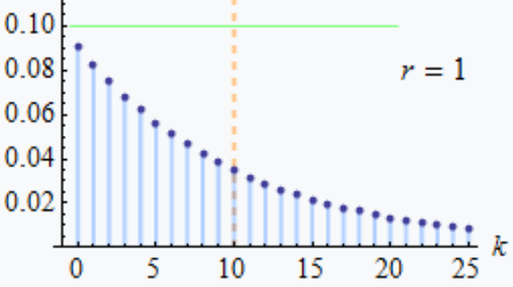 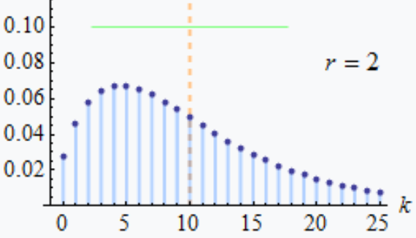

The likelihood loss is aggregated by taking a product of individual likelihood distributions over all the time steps of the decoder network. This is represented by ${\text{Q}}_{Θ}$ () below.



Where





Past time steps are between 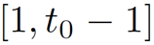 and future time steps are between 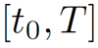.

The cell state is a function of the past cell state, current inputs including the target and covariates and the weights learnt by the neural network.

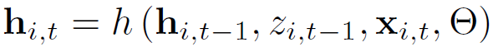

The log likelihood is further aggregated over all the targets, $i$ of multivariate forecasting.

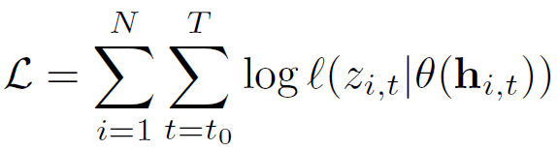

Stochastic gradient descent with Adam optimizer is used to learn the weights, $Θ$ of the LSTM network.

#### 6.2.1.2 Prediction

The encoder inputs and covariates are known but the decoder inputs are not known into the future, but covariates are known. For multi-step prediction during testing, $z_{\text{I,t-1}}$ represents the mode of the likelihood distribution in the decoder network and it is used as the input to the next LSTM cell.

During testing, when a particular combination of inputs learned during training is detected in the cell state, ${\text{h}}_{t}$ will result in the corresponding output.

# 7. DeepAR Code Development

This section describes the development and implementation of the DeepAR forecasting model.

## 7.1 Codebase specifications

**GitHub repository:**

1. DeepAR_demand_prediction

**GitHub folder:**

1. DeepAR_demand_prediction\2_freq_nbinom_LSTM\1_cluster_demand_prediction

**\*** The folders outside this folder contains supporting libraries like pytorch_forecasting with errata and tutorial code for feasibility testing of the DeepAR model.

**Library dependencies list file:**

1. 1_cluster_demand_prediction\requirements.txt
2. DeepAR_vir_env.yml

**Framework:**

1. Pytorch_forecasting version xxxxx

## 7.2 Reproducibility

The following code ensures that identical training runs result in the same output behaviour.

torch.use_deterministic_algorithms(True)

"""

Set Random seed

"""

random.seed(0)

torch.manual_seed(0)

np.random.seed(0)

## additional seeding to ensure reproduciblility.

pl.seed_everything(0)

## 7.3 Data Pre-processing

### 7.3.1 Weather data

**GitHub folder:**

1. 1_cluster_demand_prediction\data

**Raw data inputs:**

1. API calls to openweathermap.org

**Source code files:**

1. collect_weather.py

In this file, API calls are made to openweathermap.org to extract data over a specified period for all the clusters of a region. These data are saved into a csv file like ‘tampines_clstr_175_weather_medium_dataset.csv’. The meta data is shown below.

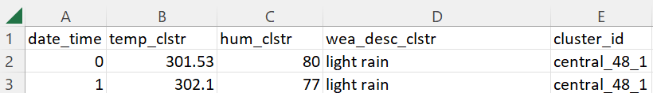

**Raw data file output:**

1. data\weather_data\\tampines_clstr_175_weather_medium_dataset.csv'

### 7.3.2 Demand data

**GitHub folder:**

1. 1_cluster_demand_prediction\data\Data-preprocessing_data_generation

**Raw data file inputs:**

1. transaction_logs.csv

* The raw input file contains all the logs of cars entering and leaving stations at different minutes of the hour in the past 9 weeks. This file is obtained from the fleet operator, BlueSG.

1. \data\demand_data\tampines_region_demand2.csv
2. \data\demand_data\tampines_region_inflow2.csv

*The file contains only the pertinent clusters demand from inflow_clstr_dem.csv and outflow_clstr_dem.csv

1. inflow_clstr_dem.csv

*The cc_id column is used to identify the cluster id of the stations.

**Raw data file output:**

1. inflow_clstr_dem.csv
2. outflow_clstr_dem.csv

*These file contain hourly inflow and outflow from a cluster every hour.

1. tampines_all_clstr_train_dem_data.csv
2. tampines_all_clstr_val_dem_data.csv
3. tampines_all_clstr_test_dem_data.csv

*These files contain region-wise clusters demand and inflow every hour.

**Source code files:**

1. Clstr_inflow_outflow_data_generator_new.ipynb

* This file performs spatial and temporal clustering in order to aggregate the transactions into every hour and cluster. A cluster consists of a few stations within the region. A cluster centre is formed so that the maximum distance between two stations within a cluster is less than 0.5 KM. Outliers such as cancelled bookings (demanded station and inflow station being same within a few minutes) are also removed.

1. 1_cluster_demand_prediction \create_region_demand_inflow_data.ipynb

*The file creates demand and inflow files with the following meta data. Group refers to the cluster id. dem_lag_168 refers to 168 hours lagged version of demand/target time series. These lags are chosen from the autocorrelation plots. This is an example of feature engineering.

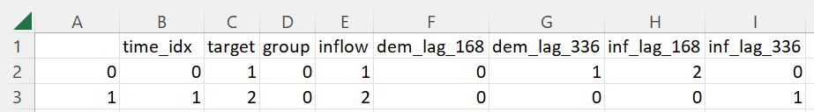

### 7.3.3 Data visualization and Feature Engineering

**GitHub folder:**

1. 1_cluster_demand_prediction

**Raw data file inputs:**

1. \data\demand_data\\tampines_region_demand_medium_dataset_lag_502.csv

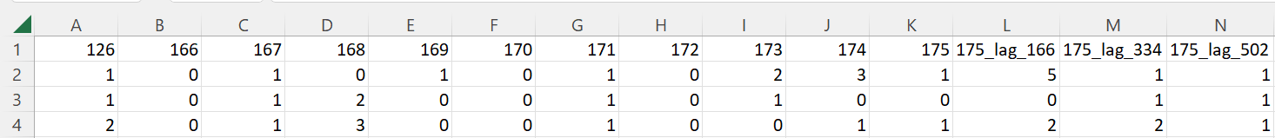

1. \data\demand_data\\tampines_region_inflow_medium_dataset_lag_502

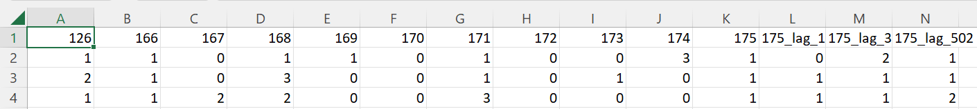

1. \data\weather_data\\tampines_clstr_175_weather_medium_dataset.csv'

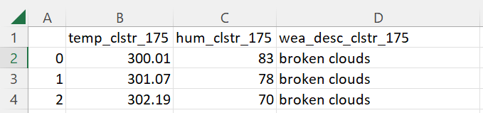

**Raw data file outputs:**

1. final_response_ts_tampines_medium_dataset_lag_502.pkl

*demand at clstr_175

1. final_num_covariate_ts_tampines_medium_dataset_lag_502.pkl

*'temp_clstr_175', 'hum_clstr_175', 'clstr_171', 'clstr_168', 'clstr_175_lag_502', 'clstr_175_lag_166', 'clstr_175_lag_334', '175_inflow', '175_lag_502_inflow', '175_lag_166_inflow', '175_lag_334_inflow'

1. final_cat_covariate_ts_tampines_medium_dataset_lag_502.pkl

*wea_desc_clstr_175

**Source code files:**

1. data_viz_analysis_3_lags.ipynb

*Each bullet point below refers to a cell in the notebook.

* This file only performs preliminary data visualization and data analysis. Detailed analysis is performed in section 3 above using the Tableau software.
* The time series of demand, inflow and their lagged versions are plotted to visualize any visible patterns.
* The time series are decomposed into trend, seasonality, and residuals.
* Typically, 1 week of data (168 hrs) is used as the length of the encoder. However, when data is scarce like 6 weeks of training data for a single cluster or a few clusters it can lead to overfitting. There may not be significant overlap in the data distribution of the training, validation, and test set.

For example, At each time step there can be 0-11 cars demand at a station. With 168 hours of time steps. There can be ${\left(11\right)}^{186}$ unique sequences. This reduces the chance of two similar sequences in the training and test set. This is not an issue if there are enormous number of time series to train on. However, our application deals with less than 50 time series at a time. Therefore, the encoder length must be shortened. The shortening cannot be too small that it leads to one-to-many mapping where the same encoder sequence occurs more than once in the training set with different decoder sequences. A compromise must be reached when determining the encoder length.

For a particular training set, different lengths of encoder is tried and a histogram of encoder decoder sequence is plotted. The decoder length is kept constant at 1. The number of same and unique encoder-decoder sequences are calculated for each encoder length by sliding a string of encoder-decoder length across the entire time series one time step at a time. The number of same encoder but different decoder sequences is also calculated to identify the existence of one to many mapping problem. The results are summarized in the figures below.

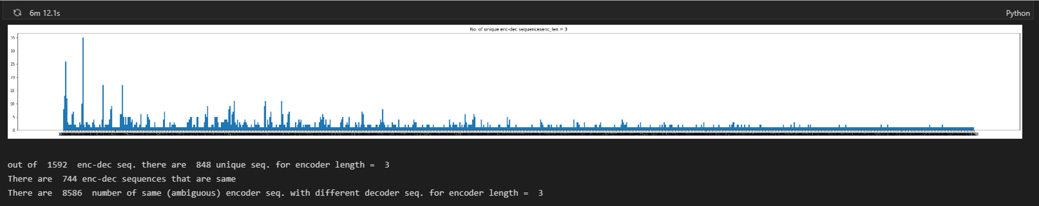

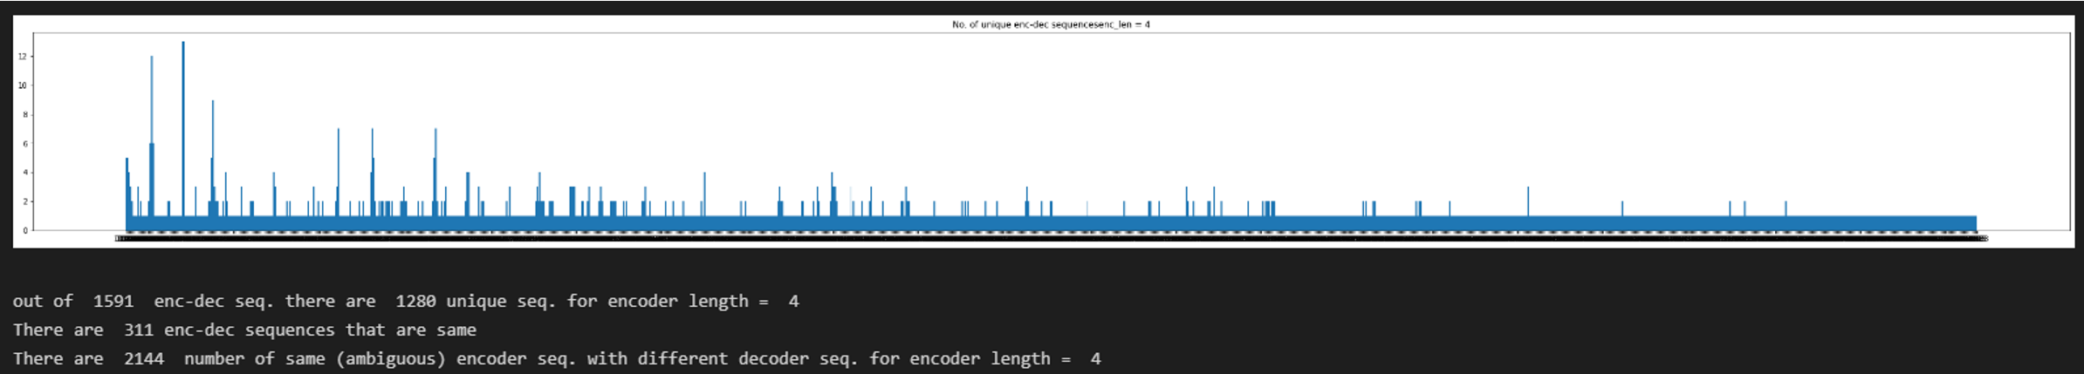

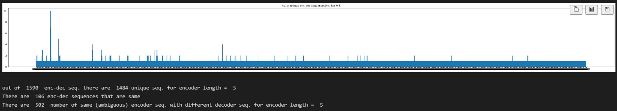

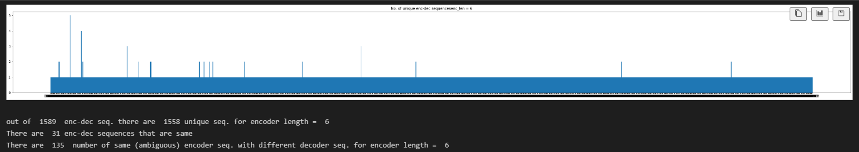

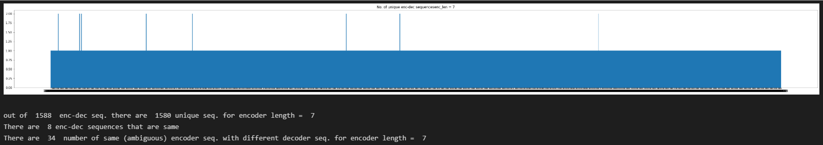

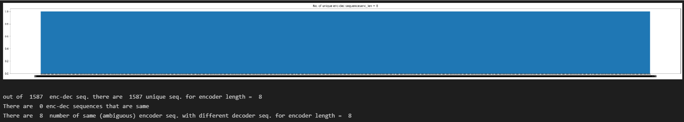

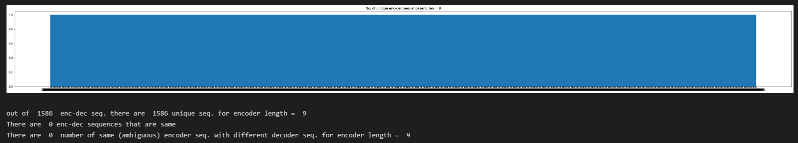

For this training data, encoder length of 8 or 9 is suitable.

* The histogram of the time series is plotted to visualize the distribution of time series and the parameters of the negative binomial distribution is calculated.
* The time series of weather information such as temperature, humidity and weather description are plotted to visualize any visible patterns.
* The stationarity of all the time series is tested using the augmented dickey fuller test.
* Time series decomposition of time series is carried out.
* Weekly boxplot of all numerical time series is performed to see existence of seasonality across weeks. Detailed analysis of seasonality is performed in section 3 using the Tableau software tool.
* ACF and PACF plot of all numerical time series is performed to identify highly correlated lags. These lags are used to create new lagged time series as covariates.
* Seasonal plots of 24-hour periods across different weeks is performed to see patterns across weeks.
* Seasonal plots of 24-hour periods across different weeks is performed to see patterns across weeks.
* Seasonal plots of 24-hour periods across different days of each week is performed to see patterns across days of a week.
* Inverse Fast Fourier Transform (IFFT)F plot of the target time series is performed to identify major periods and peaks of these major periods. This is to identify the times that indicate peak activity with high probability. This helps to improve certainty about demand and it is advantageous to ensure presence of vehicles during these times through rebalancing.
* Fast Fourier Transform (FFT) plot of the other numerical covariate time series is performed.
* FFT plot of a time series every week is performed to see common major periods across weeks.
* Cross-correlation plot of all the cluster’s demand time series is performed to identify the two most correlated cluster’s demand time series from the same region.
* All the numerical covariate time series and the target (response) time series are dumped into 2 different pickle files.
* Granger causality of the numerical covariate time series from different lags on the target time series is checked.
* The categorical covariate time series is also dumped into a pickle file.
* The correlation between categorical time series and the target time series is examined. The contingency table is printed to show a 2d histogram between weather description and the target time series. The Cramer’s V score is also computed. There is only a very week correlation between the categorical and target time series.

### 7.3.4 Train, Validation and Test dataset creation

**GitHub folder:**

1. 1_cluster_demand_prediction\model

**Raw data file inputs:**

1. final_response_ts_tampines_medium_dataset_lag_502.pkl
2. final_num_covariate_ts_tampines_medium_dataset_lag_502.pkl
3. final_cat_covariate_ts_tampines_medium_dataset_lag_502.pkl

**Outputs:**

1. train-validation-test split of the entire dataset

**Source code files:**

1. DeepAR_tampines_lag_502_optuna_local.ipynb
2. DeepAR_tampines_lag_502_experiment.ipynb

*Both files perform the same train-validation-test split.

* The response (target) time series, numerical covariates and categorical covariates are concatenated into a single dataset data frame.
* Date information time series such as hour-of-the-day, day-of-the-week, day-of-the-month, day-of-the-year, week-of-the-year, month-of-the-year and year are concatenated to the single dataset data frame.
* A 70-20-10 split is applied to train-validation-test split of the entire dataset
* For the Tampines cluster, all the covariate time series include 'wea_desc_clstr_175', 'temp_clstr_175', 'hum_clstr_175', 'clstr_171', 'clstr_168', 'clstr_175_lag_502', 'clstr_175_lag_166', 'clstr_175_lag_334', '175_inflow', '175_lag_502_inflow', '175_lag_166_inflow' and '175_lag_334_inflow'.
* However, only two covariates from the following list are used as covariates at any one training run. This list includes 'wea_desc_clstr_175', 'temp_clstr_175', 'hum_clstr_175', 'clstr_171', 'clstr_168'. This is feature selection. It is a hyperparameter. If all the features are used in one go, it can lead to longer times for learning and the model may have a higher bias due to underfit. This can lead to poor convergence due to not all the features having a high correlation with the targe and ultimately this will lead to poor results.
* Examples of covariate pairs list include:
  1. [('wea_desc_clstr_175', 'temp_clstr_175'),
  2. ('wea_desc_clstr_175', 'hum_clstr_175'),
  3. ('wea_desc_clstr_175', 'clstr_171'),
  4. ('wea_desc_clstr_175', 'clstr_168'),
  5. ('temp_clstr_175', 'hum_clstr_175'),
  6. ('temp_clstr_175', 'clstr_171'),
  7. ('temp_clstr_175', 'clstr_168'),
  8. ('hum_clstr_175', 'clstr_171'),
  9. ('hum_clstr_175', 'clstr_168'),
  10. ('clstr_171', 'clstr_168')]
* Finally, all the possible columns used for training include the following: 'time_idx', 'group', 'clstr_175', 'wea_desc_clstr_175', 'temp_clstr_175', 'hum_clstr_175', 'clstr_171', 'clstr_168', 'clstr_175_lag_502', 'clstr_175_lag_166', 'clstr_175_lag_334', '175_inflow', 'date', '_hour_of_day', '_day_of_week', '_day_of_month', '_day_of_year', '_week_of_year', '_month_of_year' and '_year'.

## 7.4 Training, Validation and Testing using Pytorch-forecasting

**GitHub folder:**

1. 1_cluster_demand_prediction\model

**Raw data file inputs:**

1. final_response_ts_tampines_medium_dataset_lag_502.pkl
2. final_num_covariate_ts_tampines_medium_dataset_lag_502.pkl
3. final_cat_covariate_ts_tampines_medium_dataset_lag_502.pkl

**Outputs:**

1. Demand predictions

**Source code files:**

1. DeepAR_tampines_lag_502_experiment.ipynb

* After splitting the dataset into train, validation, and test sets, the optimal hyperparameter is selected from the results of Optuna below and the training routine is initiated.
* The categorical variables are first one-hot-encoded and goes through an embedding layer to reduce dimensionality.
* The ‘train_dataset’ object is created specifying the different columns of the data frame like the target, numerical and categorical covariates.
* Three data loaders called are created. train_dataloader, val_dataloader, and test_dataloader are created to combines a dataset and a sampler to provides an iterable over the given dataset.
* A ‘trainer’ object is initialized specifying the details of the training routine like maximum number of epochs, use of GPUs, gradient clipping and so on.
* DeepAR neural network architecture is defined through the ‘deepar’ object. Specifications like training dataset, learning rate, number of neurons to use in the LSTM cells, the number of LSTM layers, dropout and the negative binomial likelihood loss are specified.
* ‘trainer.fit’ is applied to fit the model to training data and validate on the validation set.
* Prediction is made on the test set using ‘deepar.predict()’
* Prediction is made one time step at a time as this gives the greatest accuracy. The MAE and RMSE for the entire test set is calculated. The plot of ground-truth versus DeepAR predictions are also created.
* History average calculation and plot of the demand is performed to use as baseline to compare with DeepAR predictions.

## 7.5 Automatic Hyperparameter Tuning

### 7.5.1 Optuna

Optuna is a hyperparameter optimization framework with visualizations for interpretability. It can efficiently search large spaces and prune unpromising trials for faster results compared to grid search.

**GitHub folder:**

1. 1_cluster_demand_prediction\model

**Raw data file inputs:**

1. final_response_ts_tampines_medium_dataset_lag_502.pkl
2. final_num_covariate_ts_tampines_medium_dataset_lag_502.pkl
3. final_cat_covariate_ts_tampines_medium_dataset_lag_502.pkl

**Outputs:**

1. Optimal hyperparameters
2. Parallel coordinate plot
3. Optimization history plot
4. Slice plot
5. Hyperparameter importances
6. Contour plot
7. Empirical distribution function plot
8. Intermediate values plot

**Source code files:**

1. DeepAR_tampines_lag_502_optuna_local.ipynb

* Basically, the range of all the hyperparameters is specified together with the RMSE of the validation dataset as the objective function to minimize. Optuna finds the optimal hyperparameter combination an intelligent way without trying out all the possible combination as in grid search.
* The Optimal hyperparameters are shown below:

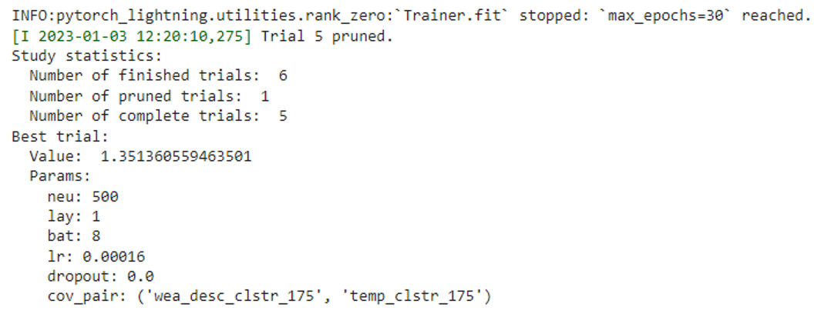

* Visualizations of objective function values (RMSE of the validation dataset) for different combinations tried and pruned are also shown below:

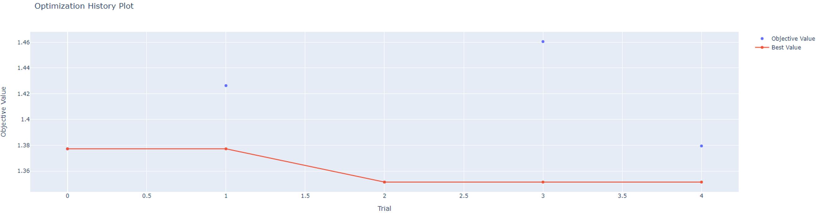

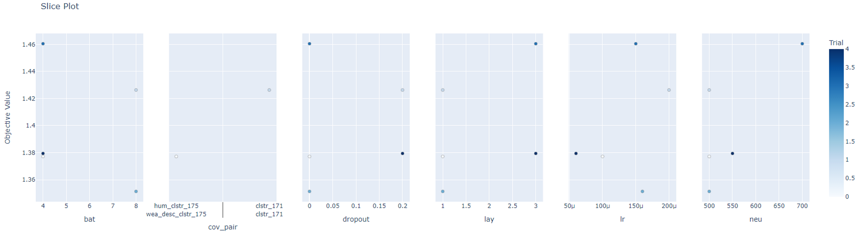

* The importance of each hyperparameter in reducing the objective function value is given below. Covariate pairs and learning rates have the greatest importance.

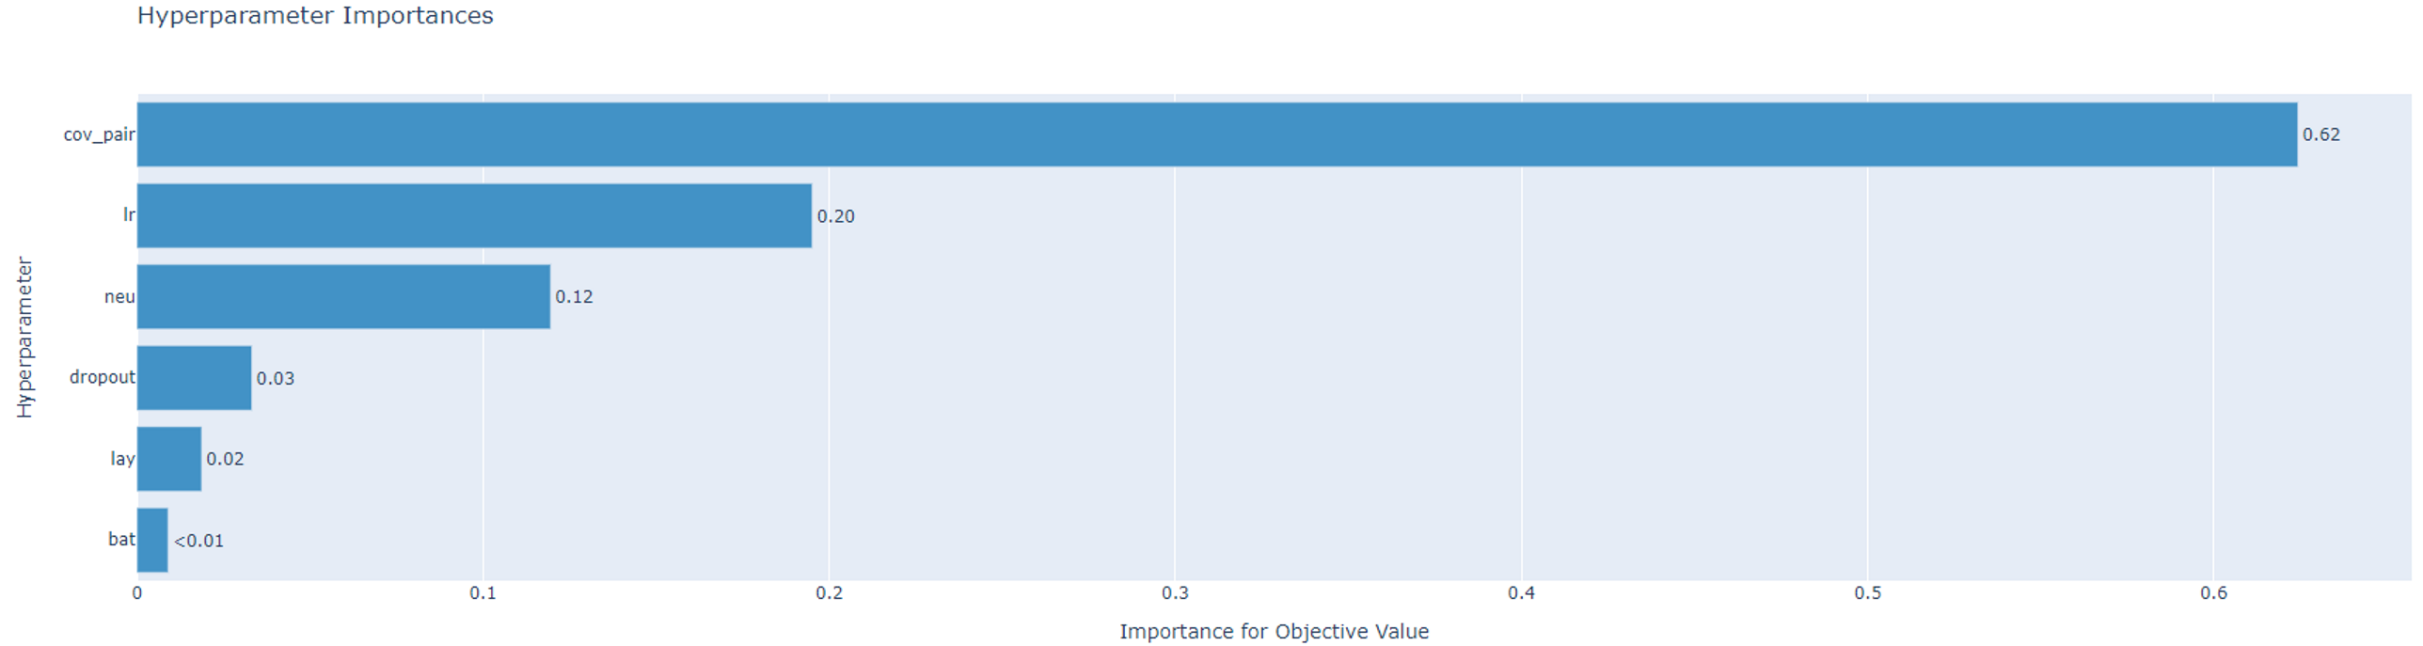

#### 7.5.1.1 Feature Importance

* Within the covariate pairs the importance of individual pairs can be seen from the parallel coordinates plot below based on the lower objective function value. The order of importance from highest is as follows: (wea_desc_clstr_175, temp_clstr_175) , (wea_desc_clstr_175, clstr_171), (hum_clstr_175, clstr_171), (temp_clstr_175, clstr_171),

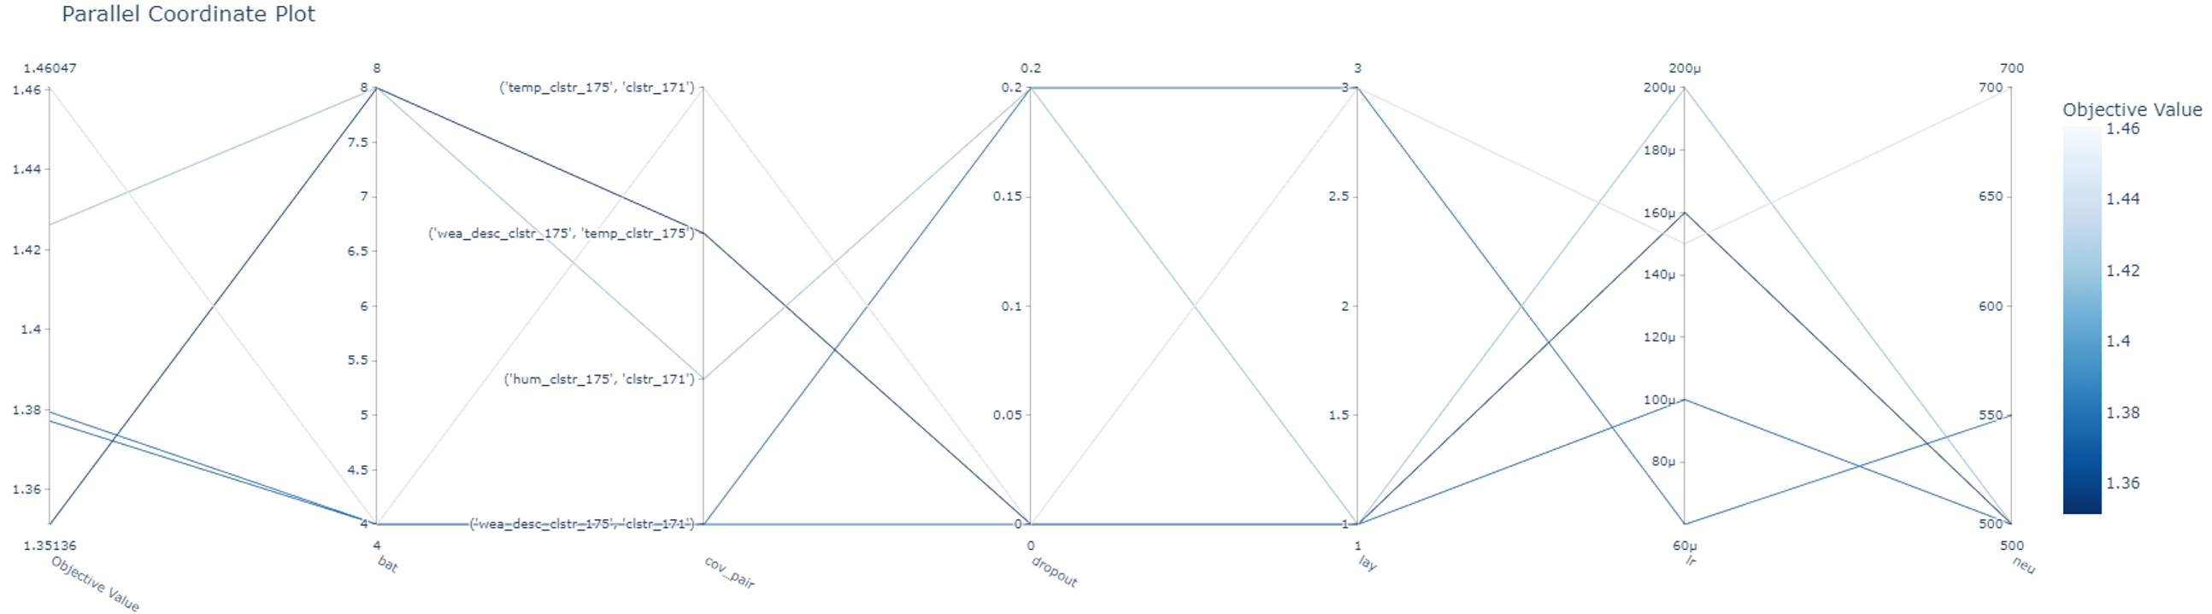

* The learning rate and covariate pairs have the steepest contours to reduce the objective function value.

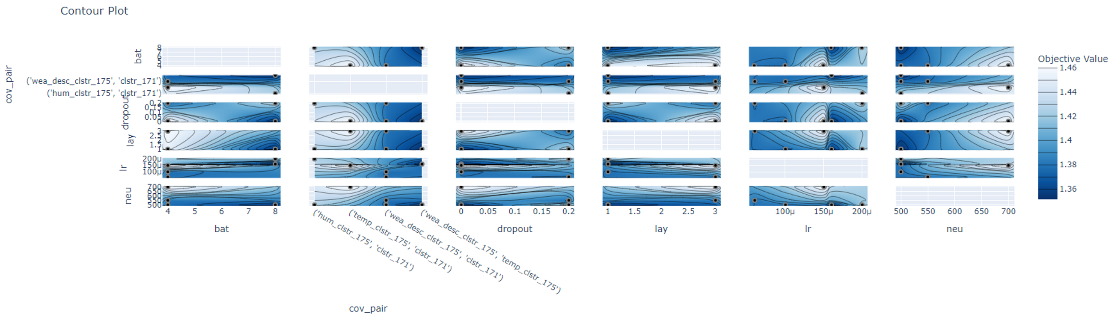

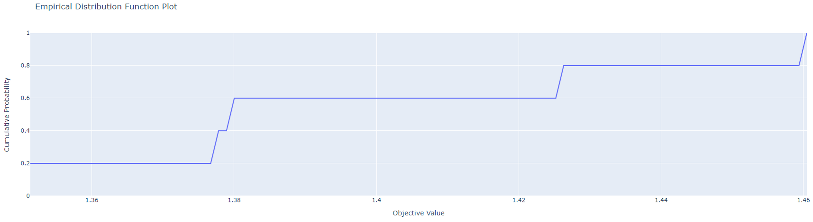

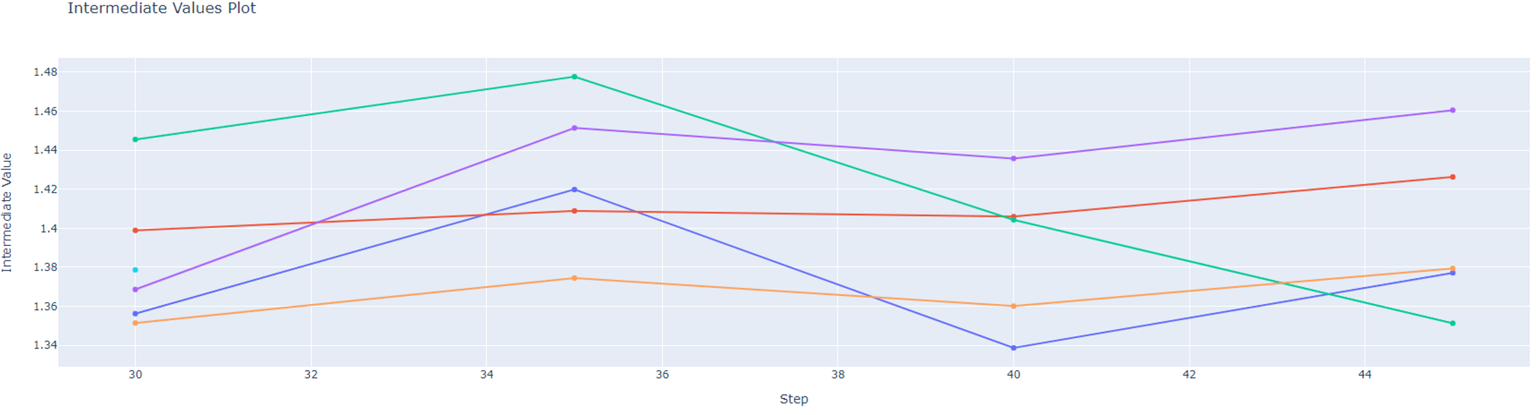

### 7.5.2 Loss curves

Tensorboard was used to log the metrics during training and validation. The cyan coloured loss curve indicates the result of using the optimal hyperparameter combination. It achieves the lowest validation loss which is indicative of the expected loss on the test set. After identifying the optimal and nearly optimal hyperparameter combinations, training is performed and their loss curves are plotted as shown below.

#### 7.5.2.1 Training loss

The training RMSE loss is shown in figure x below. Beyond 10K steps the loss plateaus and do not decrease any longer.

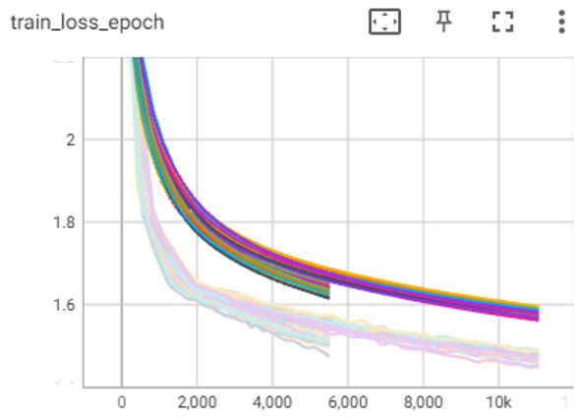

#### 7.5.2.2 Validation loss

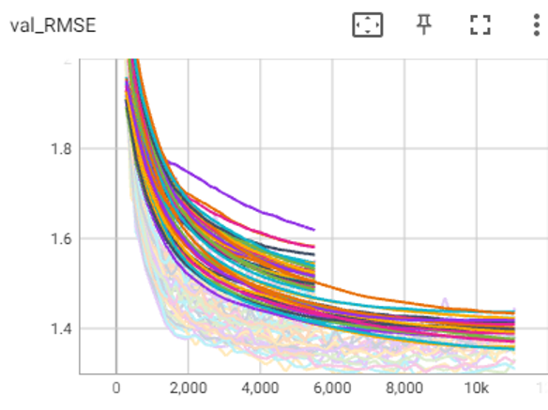

The minimum value of the validation RMSE loss is 1.35 for the optimal hyperparameter combination. Beyond 10K steps, the validation RMSE starts to increase indicating overfitting, so training is halted at around 10K steps.

## 7.6 DeepAR Test results

### 7.6.1 Cluster-wise Results

*7.6.1.1 Tampines*

7.6.1.2 DeepAR prediction:

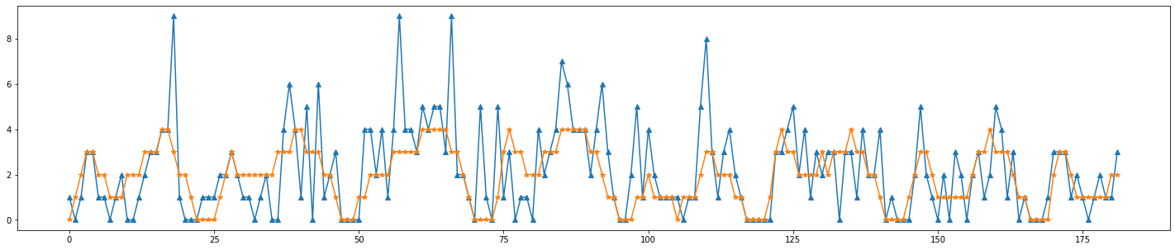

|  |  |
| --- | --- |
| MAE | 1.1926579826478562 |
| RMSE | 1.797340568759467 |

Optimal Hyperparameter combination (from Optuna above):

|  |  |
| --- | --- |
| LSTM Neuron size | 500 |
| Number of layers | 1 |
| Batch size | 8 |
| Learning Rate | 0.000160 |
| Encoder Length | 8 |
| Prediction Length | 1 |
| Dropout | 0.0 |
| Number of Epochs | 45 |
| Covariate 1 | wea_desc_clstr_175 |
| Covariate 2 | temp_clstr_175 |

7.6.1.3 Historic Average (HA) prediction



|  |  |
| --- | --- |
| MAE | 1.63 |
| RMSE | 2.13 |

##### 7.6.1.4 Error analysis

* MAE and RMSE of DeepAR predictions are the best amongst all the prediction models considered here.
* The missing peaks in DeepAR are corrected in the error troubleshooting section, 8.x.x.x below.
* Some peaks such as the one near 125 hours (in DeepAR prediction) and 106 hours (in HA prediction) are not present in the past so they are explained through the covariate information instead of serial dependence. DeepAR correctly uses this covariate information to predict a peak while HA is unable to do so.

###### 7.6.1.4.1 Residual Analysis

The residual time series is the difference between predictions and ground-truth.The empirical autocorrelation function of these residuals is useful for diagnosing serial dependence which has not been explained by the fitted model. The small negative peak at 52 hours has to be accounted for through the use of a lagged covariate feature as the encoder size is only 8-time steps. The small positive peak at 5 hours maybe due to it not being present in the training dataset. A more representative training dataset maybe required.

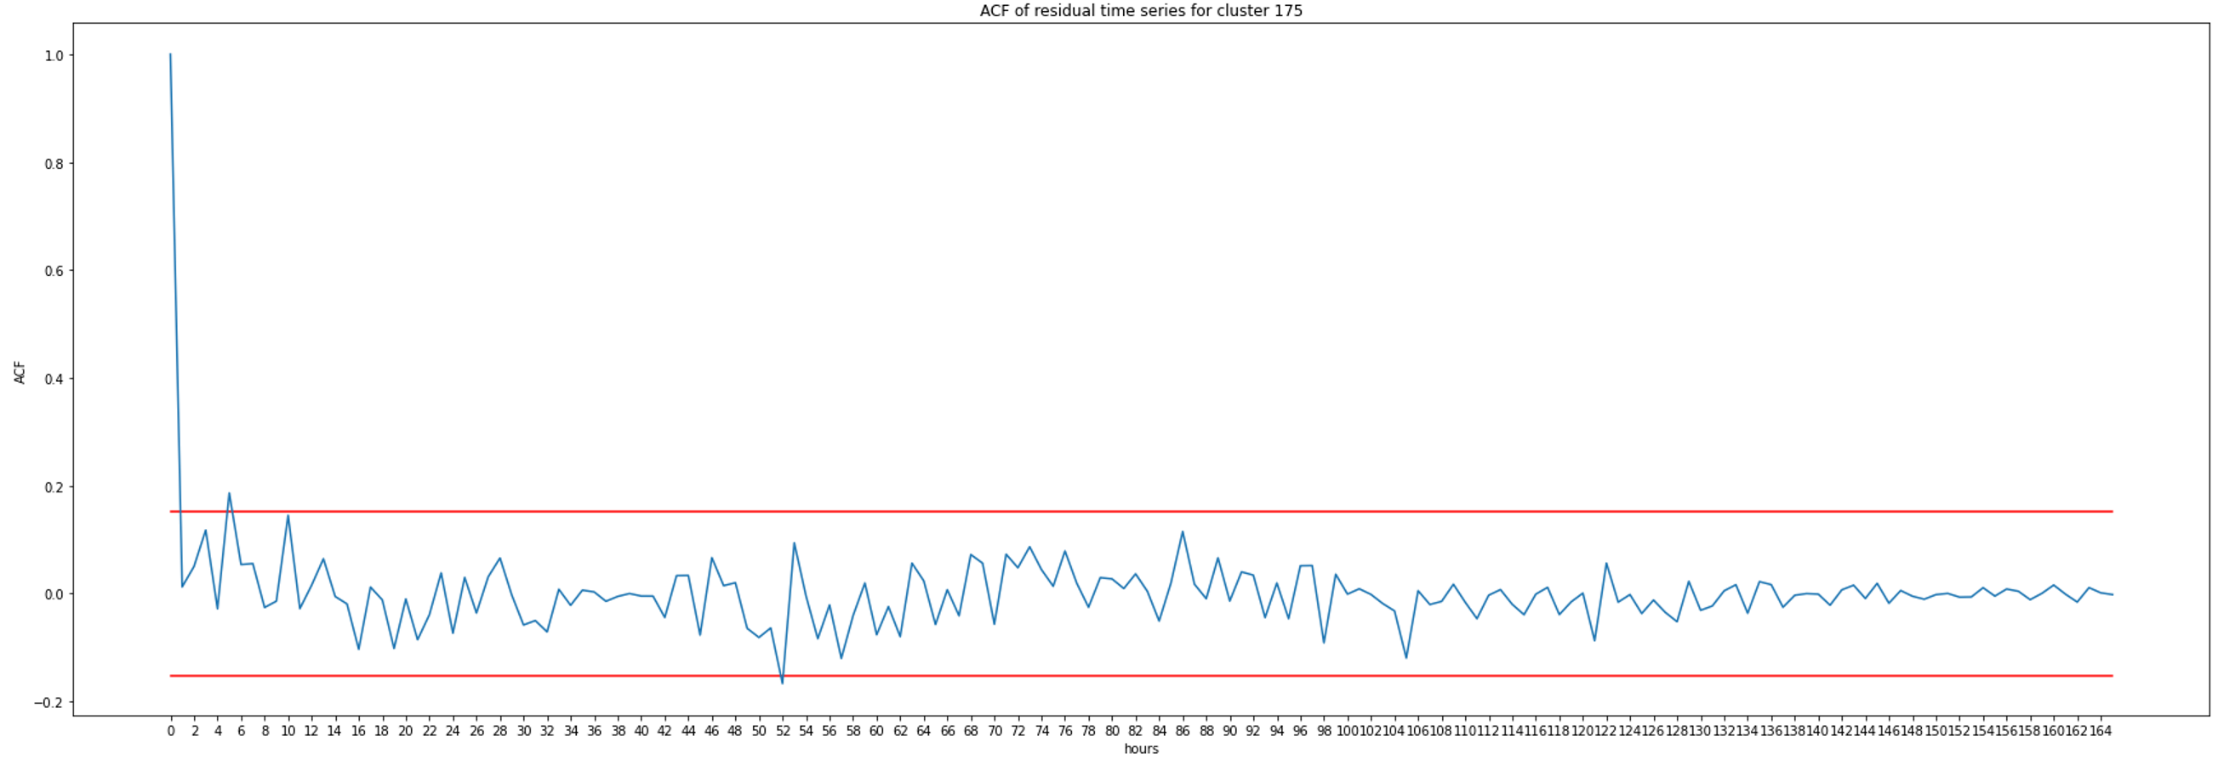

Include scatter analysis.

##### 7.6.1.5 Probabilistic forecast

Confidence levels of (95%, 75% and 50%) demand prediction for horizon window of 4 hours into the future.

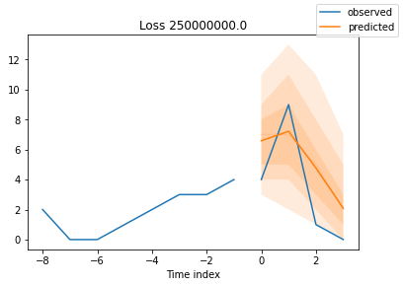

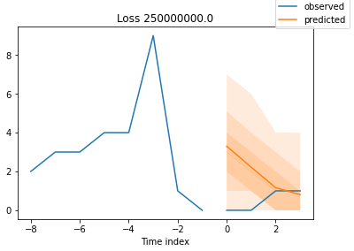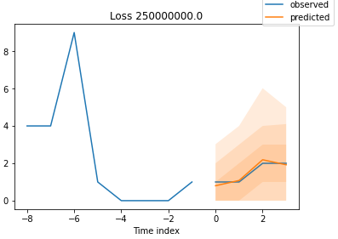

All predictions are observed to lie within the 75 and 95% confidence levels. The predictions are mostly sharp. Need to get the RPS for these probabilistic forecasts.

#### 7.6.1.2 Central

Tune for better result

##### 7.6.1.2.1 DeepAR prediction:

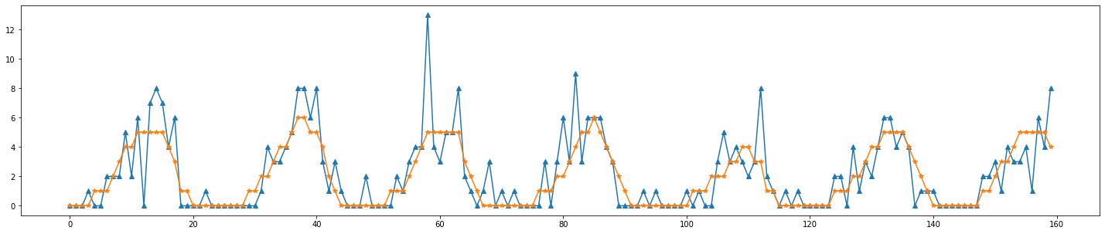

|  |  |
| --- | --- |
| RMSE | 0.96875 |

Optimal Hyperparameter combination:

|  |  |
| --- | --- |
| LSTM Neuron size | 168 |
| Number of layers | 3 |
| Batch size | 8 |
| Learning Rate | 0.0001 |
| Encoder Length | 24 |
| Prediction Length | 1 |
| Dropout | 0.2 |
| Number of Epochs | 24 |
| Covariate 1 | temp_clstr_52 |
| Covariate 2 | hum_clstr_52 |

##### 7.6.1.2.2 Historic average

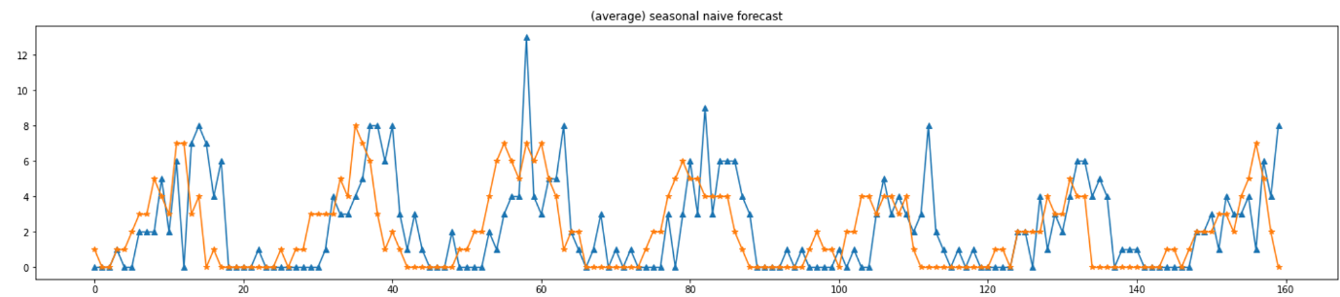

|  |  |
| --- | --- |
| RMSE | 1.7125 |

##### 7.6.1.2.3 Error analysis

* These DeepAR predictions appear like the average of the time series. The model architecture has to be improved (increase complexity) to capture the peaks as this has worked for Tampines cluster after error correction in section 8.x.x.x below.

#### 7.6.1.3 Woodlands

Tune for better result

##### 7.6.1.3.1 DeepAR prediction:

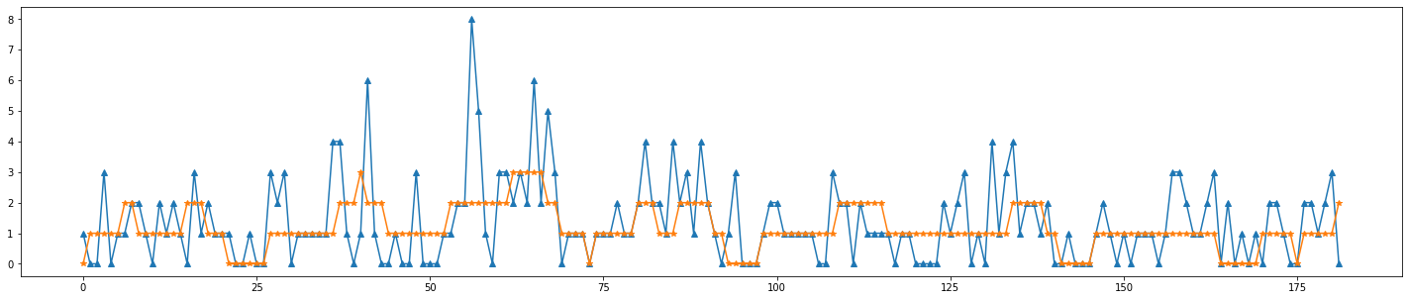

|  |  |
| --- | --- |
| RMSE | 1.1779 |

Optimal Hyperparameter combination:

|  |  |
| --- | --- |
| LSTM Neuron size | 672 |
| Number of layers | 3 |
| Batch size | 8 |
| Learning Rate | 0.0001 |
| Encoder Length | 24 |
| Prediction Length | 6 |
| Dropout | 0.2 |
| Number of Epochs | 18 |
| Covariate 1 | wea_desc_clstr_190 |
| Covariate 2 | clstr_192 |

##### 7.6.1.3.2 Historic average

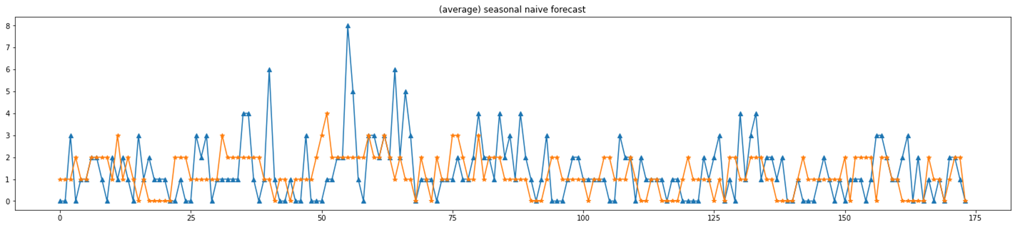

|  |  |
| --- | --- |
| RMSE | 1.434 |

##### 7.6.1.3.3 Error analysis

* These DeepAR predictions appear like the average of the time series. The model architecture has to be improved (increase complexity) to capture the peaks as this has worked for Tampines cluster after error correction in section 8.x.x.x below.

### 7.6.2 Region-wise Results



Figure :cluster naming in plots below

Instead of training a separate model for each cluster, all clusters within the same region are trained using the same model. Tampines region is selected and it includes 11 clusters in total.

#### 7.6.2.1 Tampines

Tune for better result

##### 7.6.2.1.1 DeepAR prediction (cluster 126):

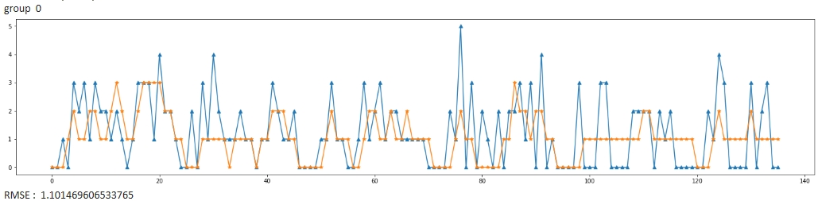

|  |  |
| --- | --- |
| RMSE | 1.01146 |

Optimal Hyperparameter combination:

|  |  |
| --- | --- |
| LSTM Neuron size | 84 |
| Number of layers | 2 |
| Batch size | 16 |
| Learning Rate | 0.0001 |
| Encoder Length | 24 |
| Prediction Length | 1 |
| Dropout | 0 |
| Number of Epochs | 24 |
| Covariate 1 | wea_desc_clstr |
| Covariate 2 | temp_clstr |

##### 7.6.2.1.2 Historic average

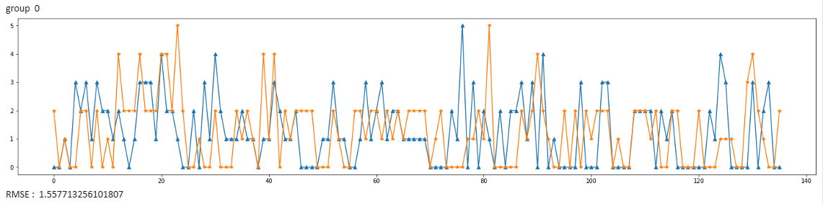

|  |  |
| --- | --- |
| RMSE | 1.5577 |

##### 7.6.2.1.3 Error analysis

* Further tuning is required to capture the peaks more accurately.
* HA has overprediction problems while DeepAR does not have.

###### 7.6.2.1.3.1 Scatter analysis

Remove this scatter analysis.

Scatter plots to see how good the correlation between prediction is and actual (ground-truth).

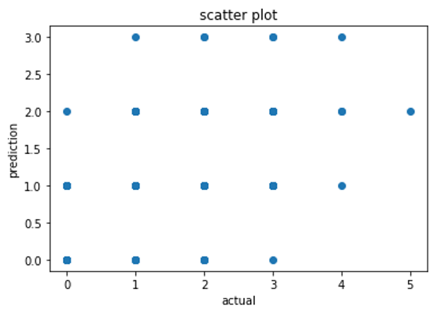

* This type of error being made here is underprediction. Tuning is required to improve prediction accuracy.

##### 7.6.2.1.4 DeepAR prediction (cluster 166):

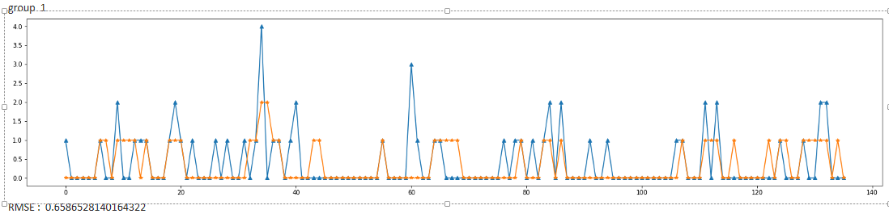

|  |  |
| --- | --- |
| RMSE | 0.65865 |

##### 7.6.2.1.5 Historic average

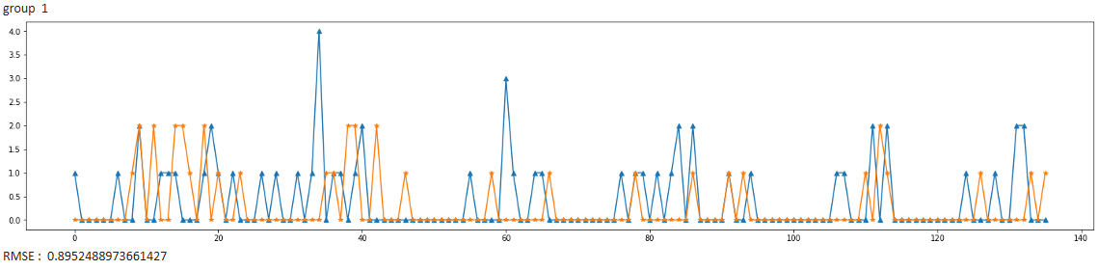

|  |  |
| --- | --- |
| RMSE | 0.89524 |

7.6.2.1.6 DeepAR prediction (cluster 175):

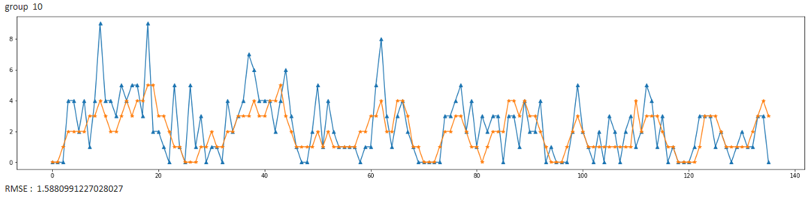

|  |  |
| --- | --- |
| RMSE | 1.588099 |

##### 7.6.2.1.7 Historic average

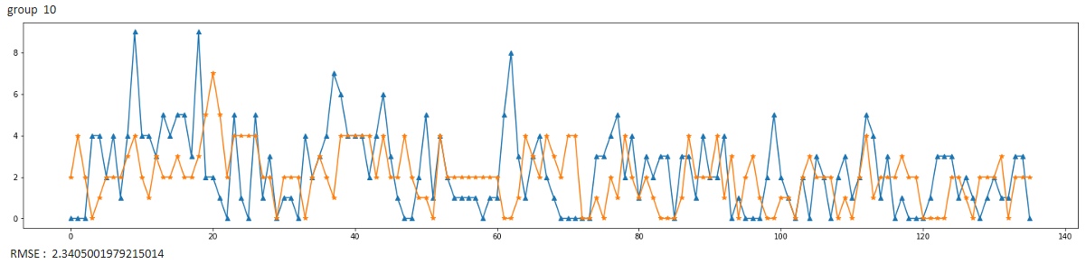

|  |  |
| --- | --- |
| RMSE | 2.340500 |

# 8. Troubleshooting and debugging

## 8.1 Model Troubleshooting

### 8.1.1 Error Troubleshooting example

#### 8.1.1.1 Error: Missing seasonality



**Problem:** Although the RMSE is lower for DeepAR predictions, the predictions appear to be like average of the ground truth. It does not capture seasonal peaks. Red peaks are weekly seasonal patterns. Cream and black peaks are not seasonal.

#### 8.1.1.2 Error correction

**Solution approaches:**

1. Reduced embedding dimension so that there are fewer parameters to learn. This is because of a lack of data available during training. This is also difficult for convergence to optimal weights. Fewer weights lead to better convergence.
2. Increased number of neurons to capture more seasonal patterns as each neuron is responsible for detecting a pattern.

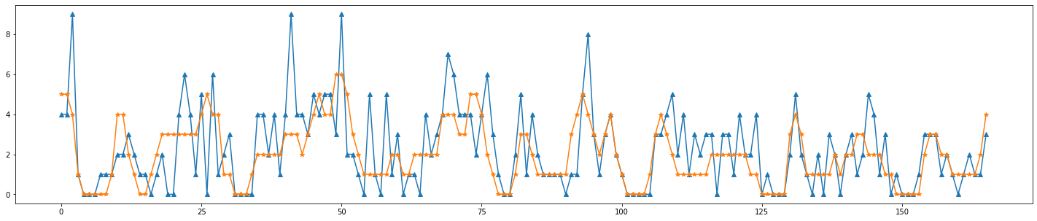

|  |  |
| --- | --- |
| MAE | 1.1686746987951808 |
| RMSE | 1.6391299484640647 |

* The seasonal peaks and non-seasonal peaks captured are shown in green circles.

Optimal Hyperparameter combination:

|  |  |
| --- | --- |
| LSTM Neuron size | 620 |
| Number of layers | 1 |
| Batch size | 4 |
| Learning Rate | 0.00016 |
| Encoder Length | 8 |
| Prediction Length | 1 |
| Dropout | 0.2 |
| Number of Epochs | 40 |
| Covariate 1 | wea_desc_clstr_175 |
| Covariate 2 | temp_clstr_175 |

**Percentage improvement in MAE of DeepAR predictions compared to HA:**

1.6386 - 1.1686=0.47/1.6386 = 0.2868 (29%)

**Percentage improvement in RMSE of DeepAR predictions compared to HA:**

2.1312 - 1.63 = 0.5012/2.1312 = 0.2352 (24%)

**Percentage improvement in MAE of DeepAR predictions compared to ARCNB:**

1.36 - 1.1686 = 0.1914/1.36 = 0.141 (14%)

**Percentage improvement in RMSE of DeepAR predictions compared to ARCNB:**

1.84 - 1.63 = 0.21/1.84 = 0.114 (11%)

Include result of adding 52-hour lagged time series to solve residual error.

Include better scatter analysis after troubleshooting.

### 8.1.2 Comparison between cluster-wise and Region-wise DeepAR prediction

#### 8.1.2.1 Tampines cluster 175

##### 8.1.2.1.1 Cluster-wise prediction plot



|  |  |
| --- | --- |
| RMSE | 1.63 |

##### 8.1.2.1.2 Region-wise prediction plot (same cluster)



|  |  |
| --- | --- |
| RMSE | 1.588 |

##### 8.1.2.1.3 Comparison

* RMSE of region-wise prediction is slightly lower. Seasonal and non-seasonal Peak detection can be improved further. More tuning of region-wise prediction is required to better capture the peaks.

## 8.2 Code errata and bug fixes

Please refer to the following forums to see errors encountered during development

1. <https://discuss.pytorch.org/u/jose_peeterson/activity>
2. <https://github.com/Guanghan/lighttrack/issues/46>
3. <https://github.com/jdb78/pytorch-forecasting/issues/1110>
4. <https://github.com/Guanghan/lighttrack/issues/46>
5. <https://stackoverflow.com/questions/73453444/runtimeerror-index-put-requires-the-source-and-destination-dtypes-match-got-fl/74323261#74323261>

# 9 Gaps and Improvement suggestions

1. Include holidays as categorical time series. Include rebalancing signal time series.
2. Perform Hypothesis Testing to establish relationships between covariates and target.
3. ~~Cramer’s V statistic for categories within the categorical variable to see an increase in association between certain categories.~~
4. Can differencing 168 hours **once more** help to reduce the peaks of ACF/PACF at 168 lags? Can we change the period to 24 hours so that after this 168 hour differencing the SARIMA model can model AR/MA terms around the 24 seasonal period instead of 168 hours.
5. How to decide the similarity in distribution between the training, validation, and test set? How to select the correct hyperparameter combination the minimize the validation error AND the test error.
   1. How to ensure validation set is representative of the test set? Take multiple validation sets which are same historic period as the testing period instead of the previous consecutive week of the test set.
6. Increase dataset size by SYNTHETICALLY generating new time series from the Autoregressive conditional Negative-binomial model. The model incorporates the underlying patterns that was analysed in exploratory data analysis.
7. Use EWMA (exponential weighted moving average instead of one-sided simple moving average)
8. Cross-correlation plots could also include inflows from other cluster’s of the same region and could also be used as covariates.
9. Currently, we are doing cluster-wise and region-wise predictions in order to speed-up training by parallelizing each training cluster/region’s training on a different machine. Try to compare the performance with a country-wise prediction training. Performance here refers to prediction accuracy and training time.
10. Use AIC and BIC for each hyperparameter combination useful for model selection from optuna. This compared with AIC and BIC from statistical models as the likelihood functions are the same.
11. Include density scatter analysis of prediction vs actual to see the type of errors being made. Also include residual analysis for all DeepAR predictions. These are part of error analysis.
12. Include a section on model explainability.
13. Include AIC/BIC score which ensures model simplicity and avoids overfitting. Does extra parAMeters justify the improvement? This can be used for model selection.
14. When the encoder length is small and the dataset size is small we could try using GRU instead of LSTM as it has fewer weight parameters to tune.

# 10 Github Code repository

All the code used above are available from the following repository:

* [Github Repository](https://github.com/JosePeeterson/DeepAR_demand_prediction)

# 11 Production

## 11.1 Deployment

The following block diagram illustrates the pipeline implemented in Amazon sagemaker.

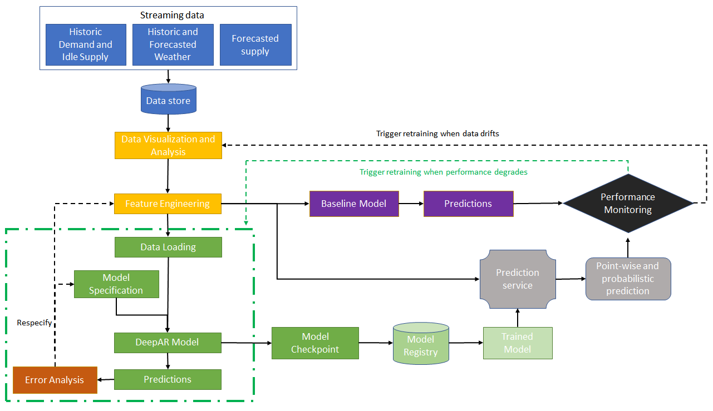

Figure :Machine Learning implementation block diagram

Refer to Detailed block diagram in appendix.

# 12 Appendix

## FFT of weekly demand time series (10 weeks)

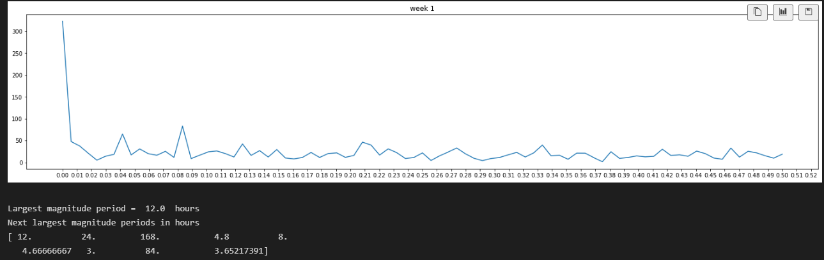

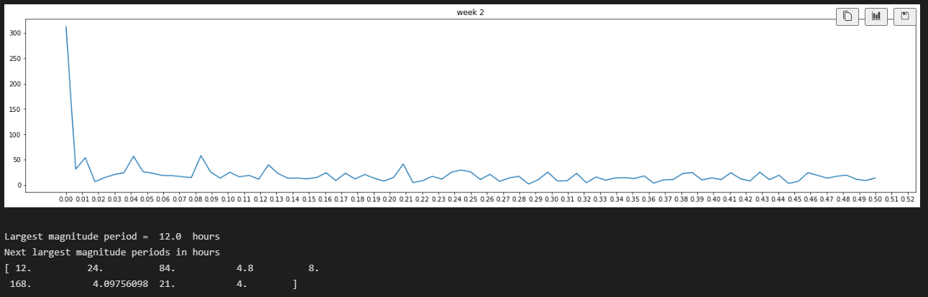

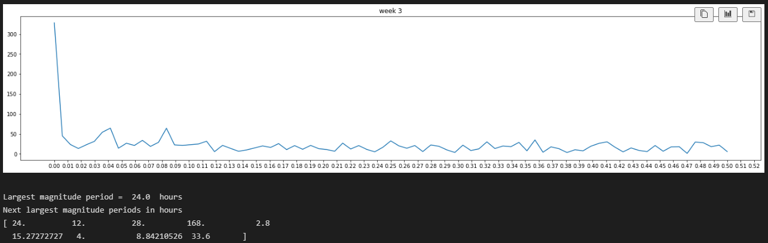

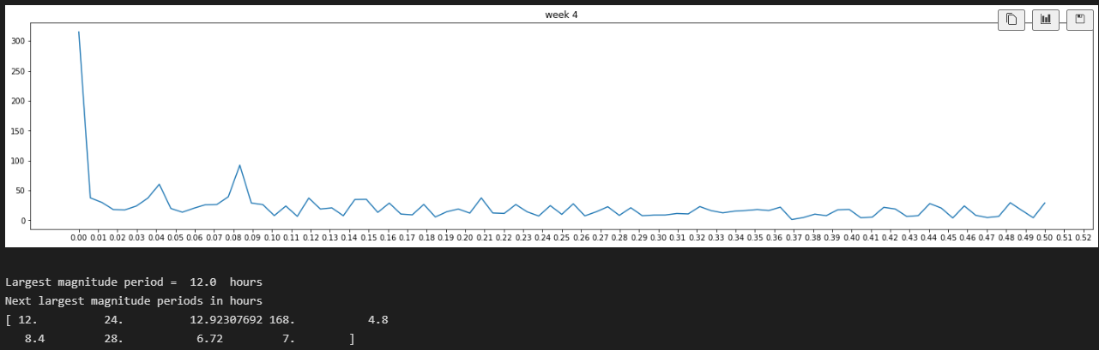

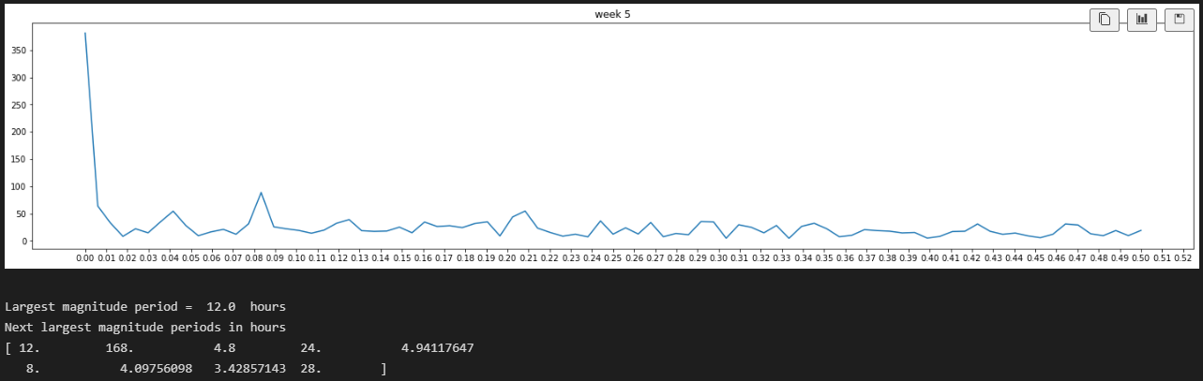

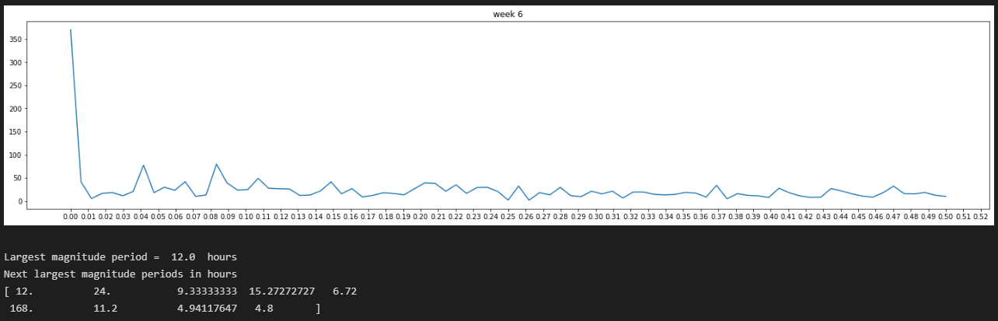

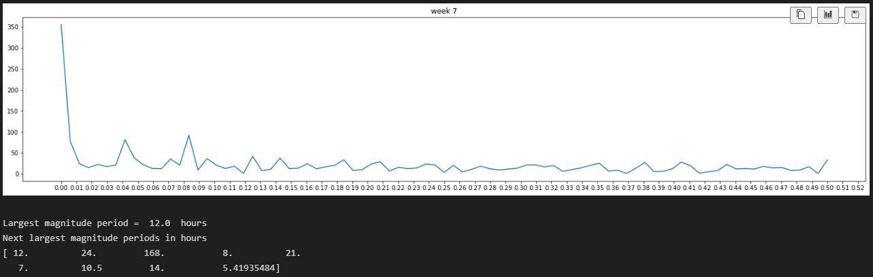

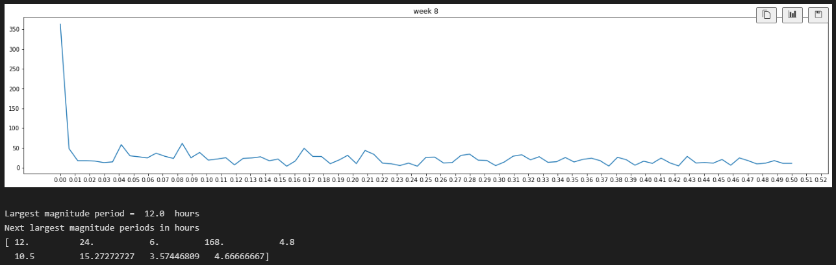

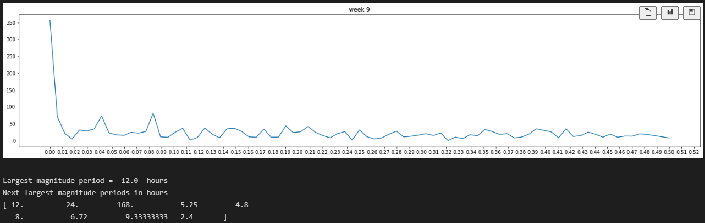

## IFFT of weekly demand time series (10 weeks)

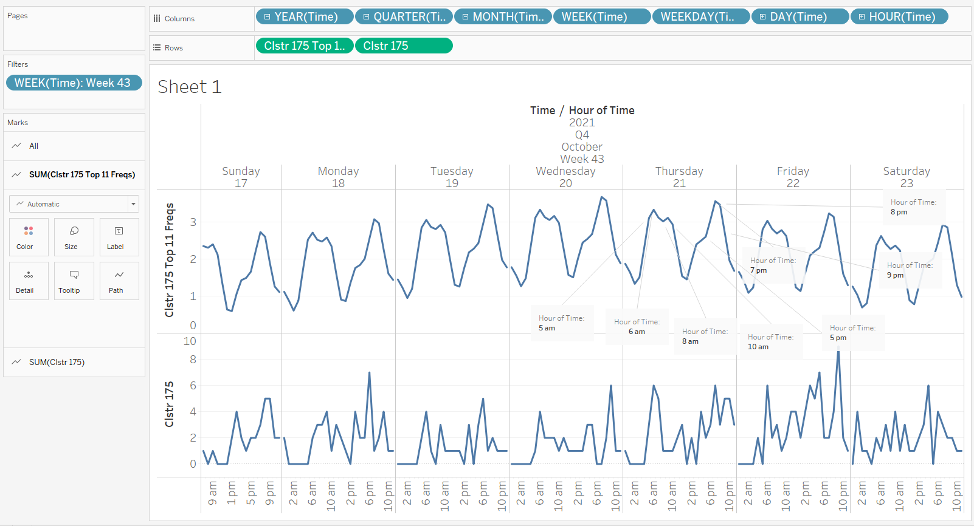

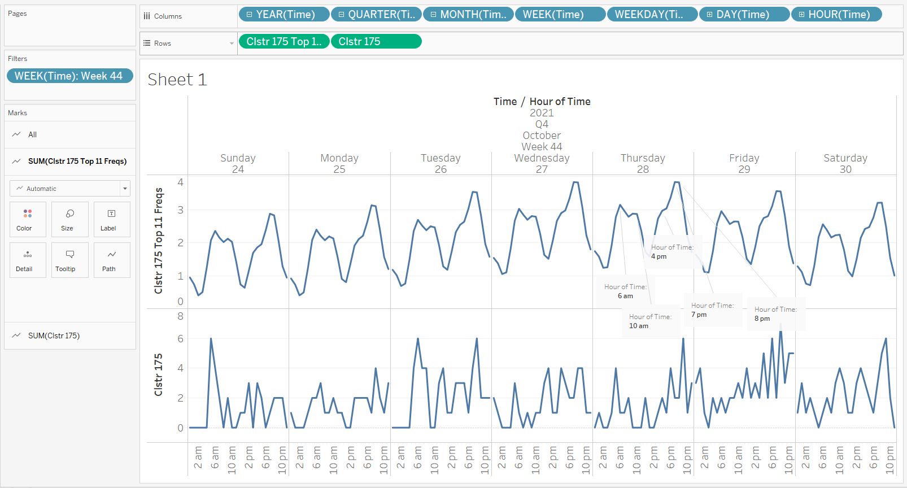

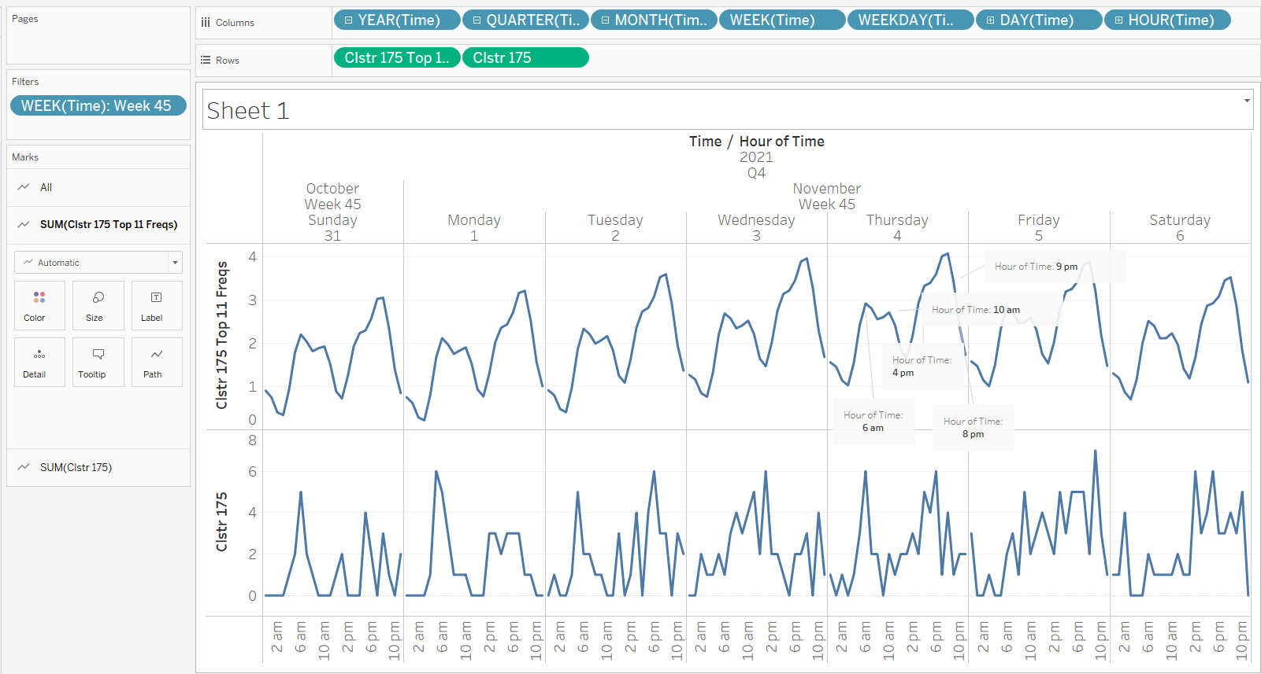

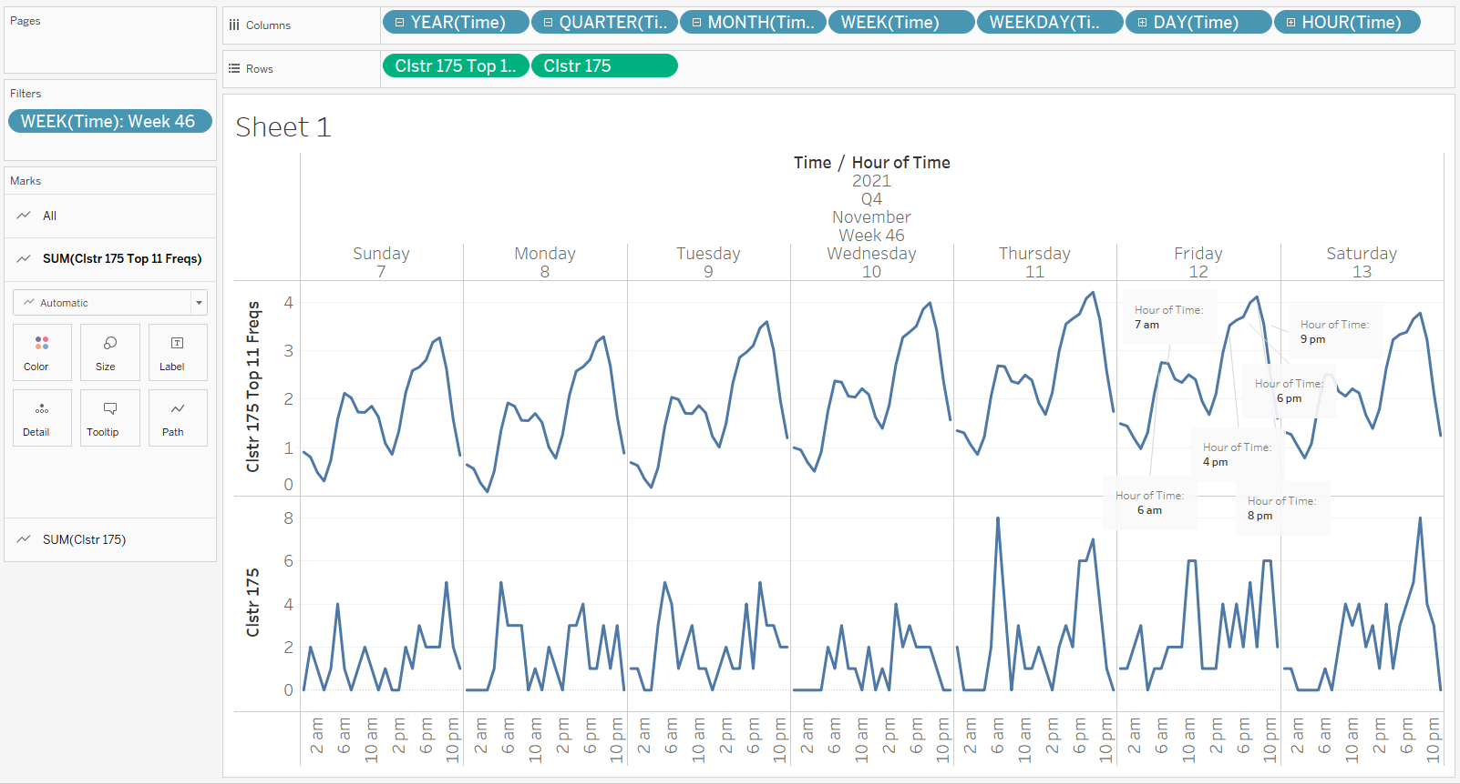

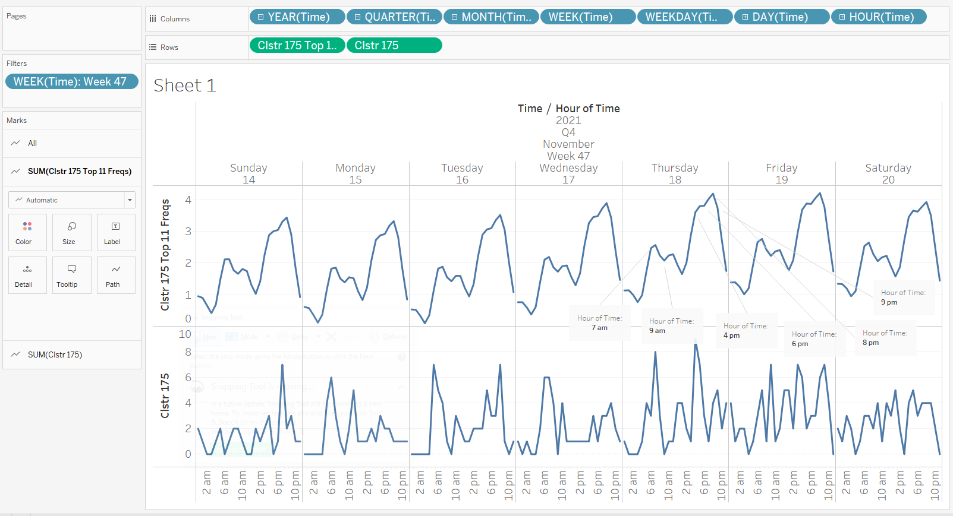

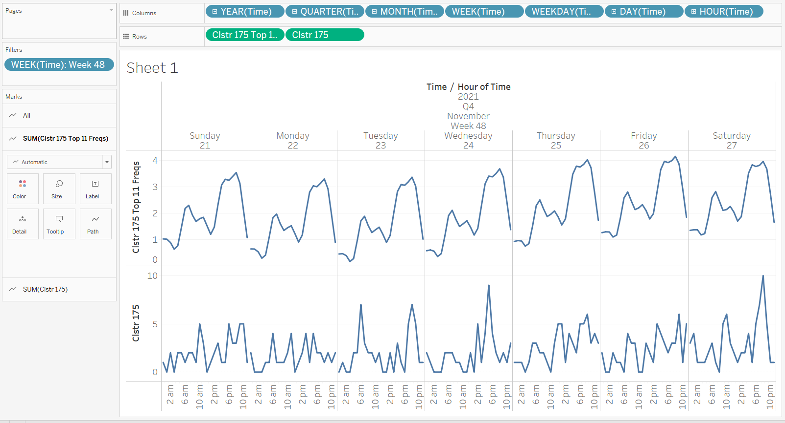

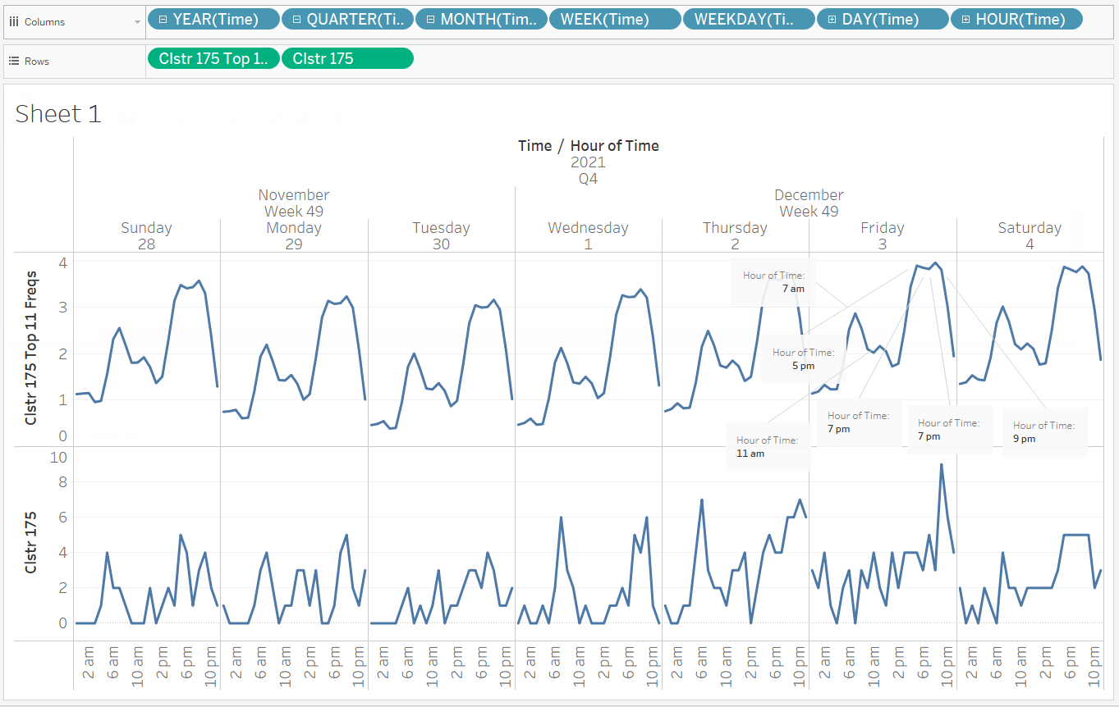

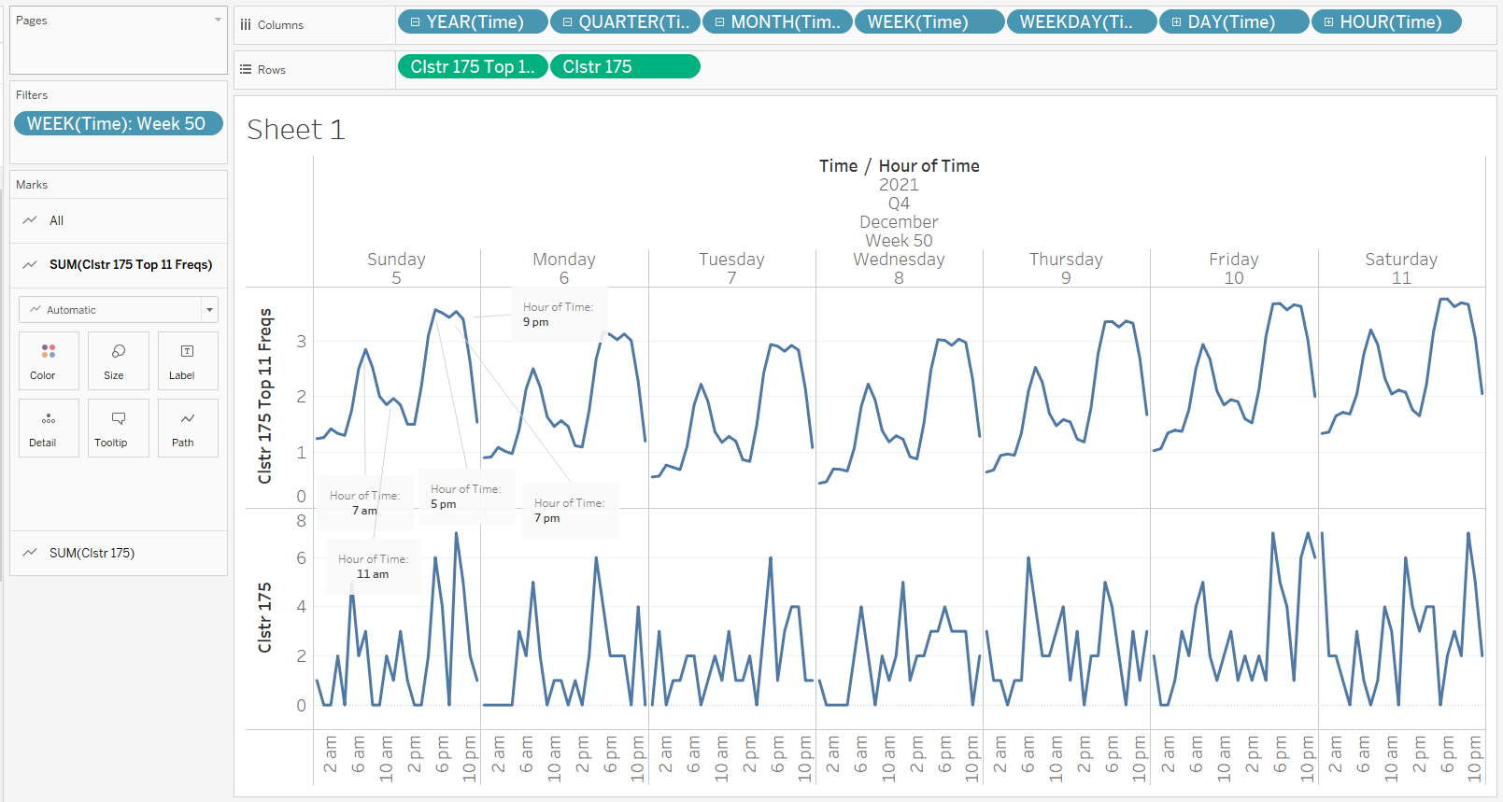

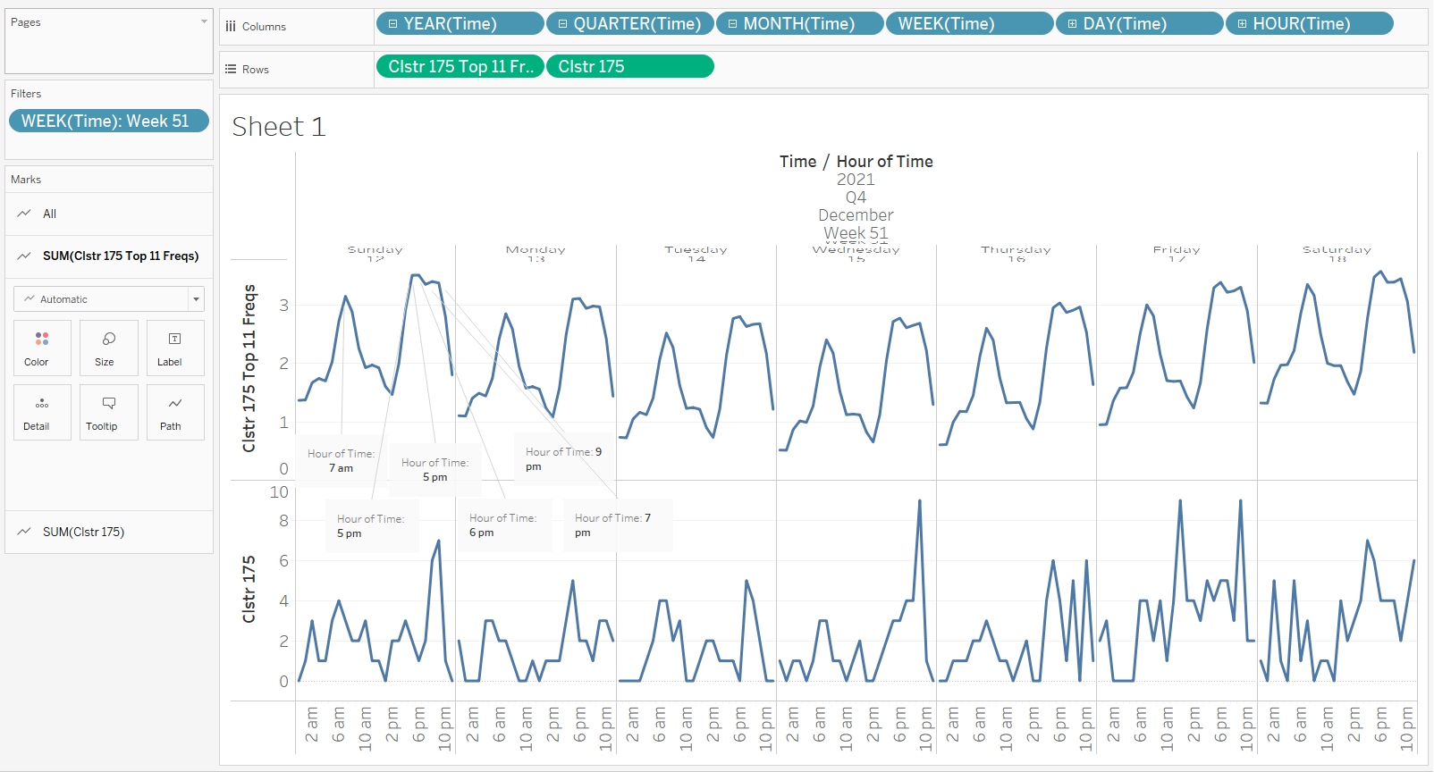

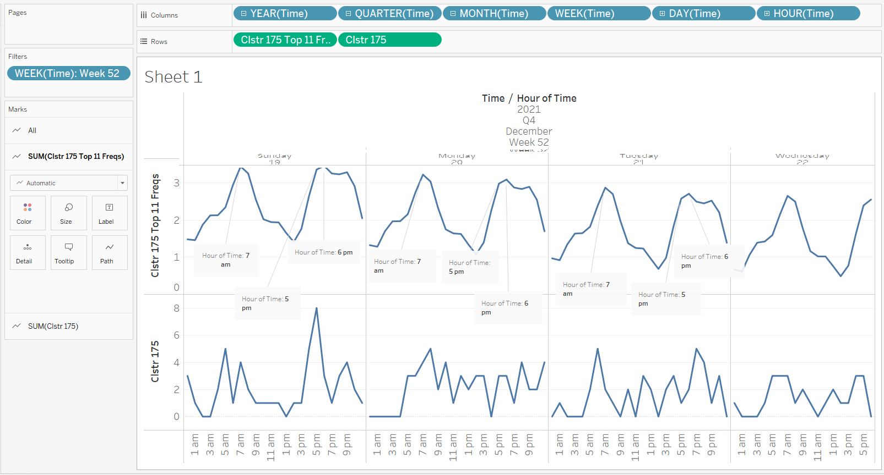

## Seasonality near weekend

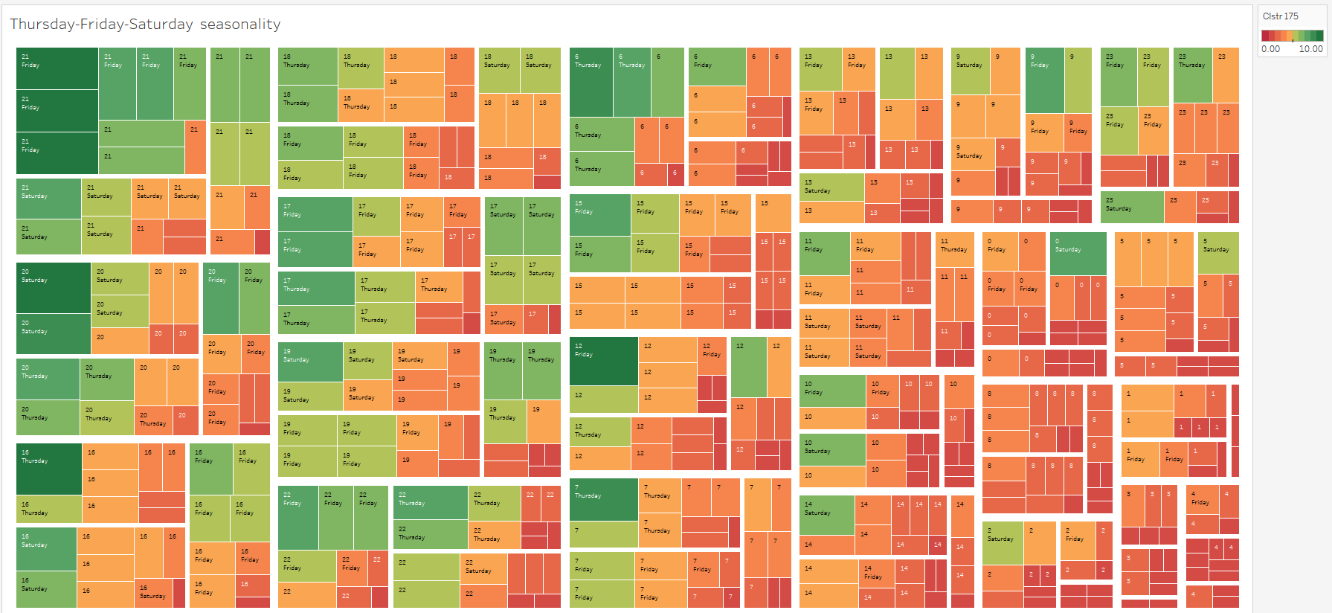

## Seasonality near weekdays

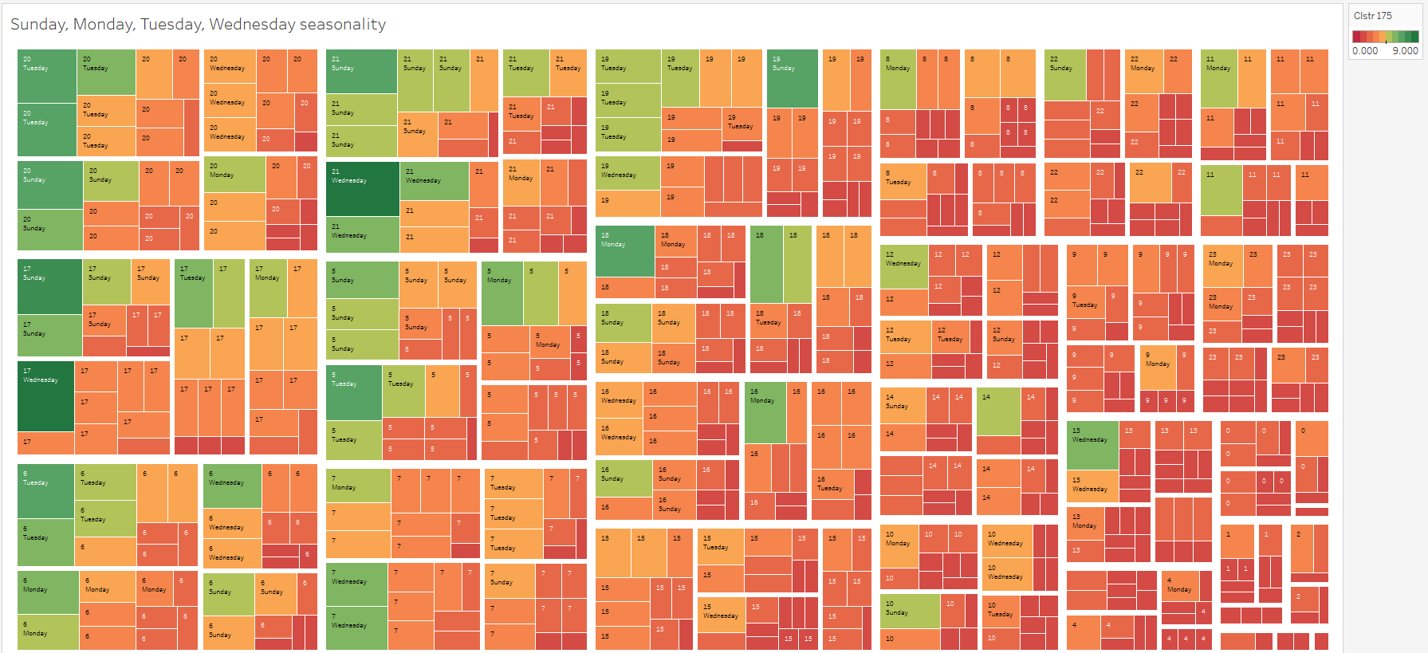

## Daily Seasonality across weeks (HEATMAP)

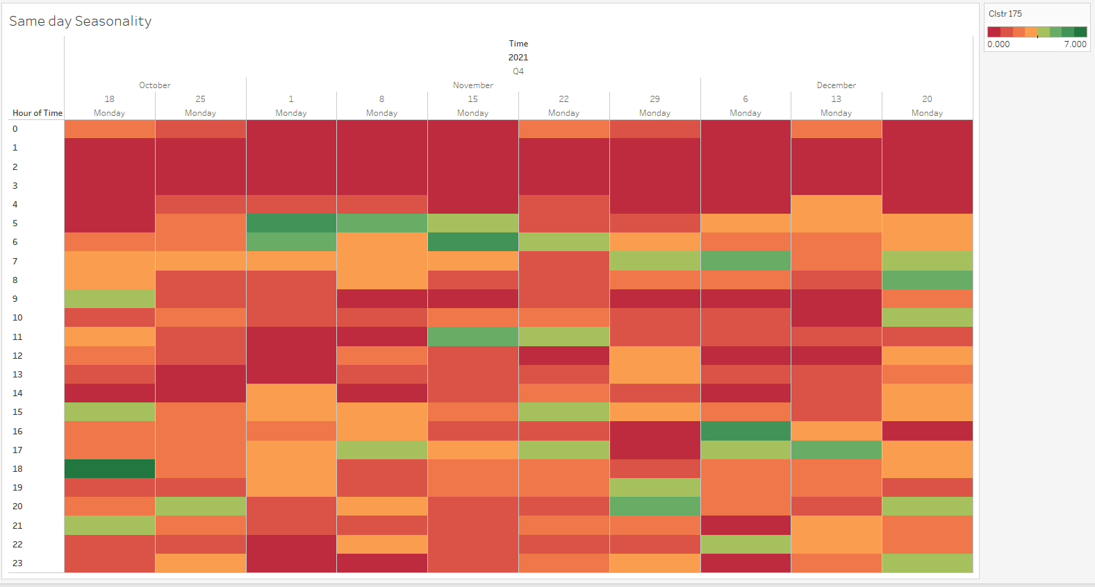

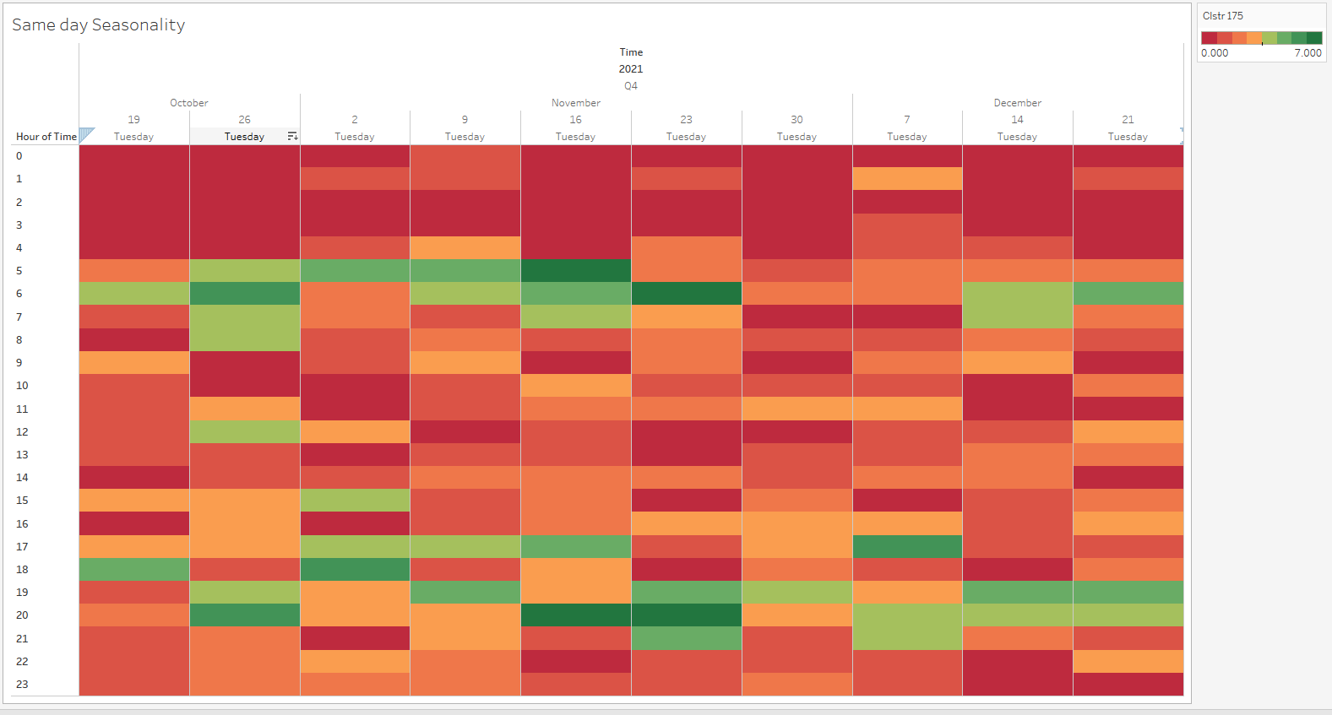

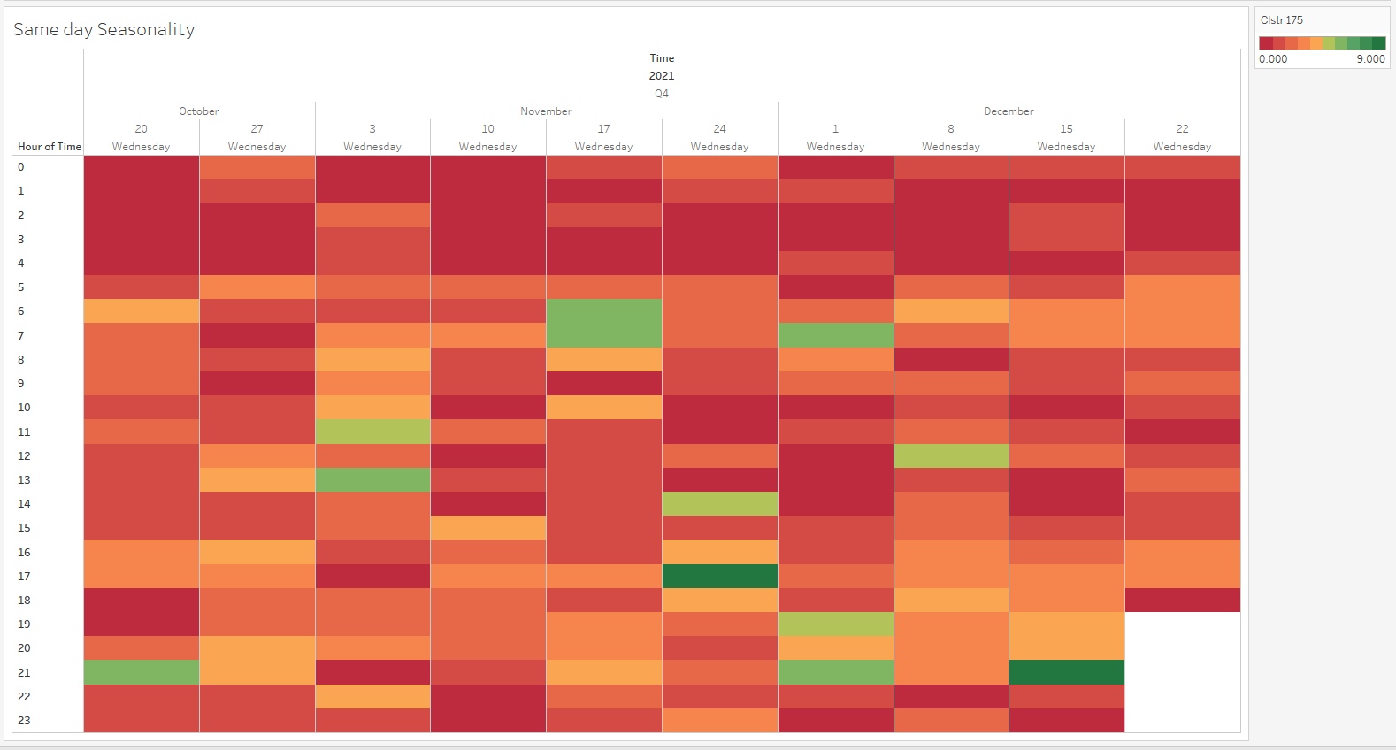

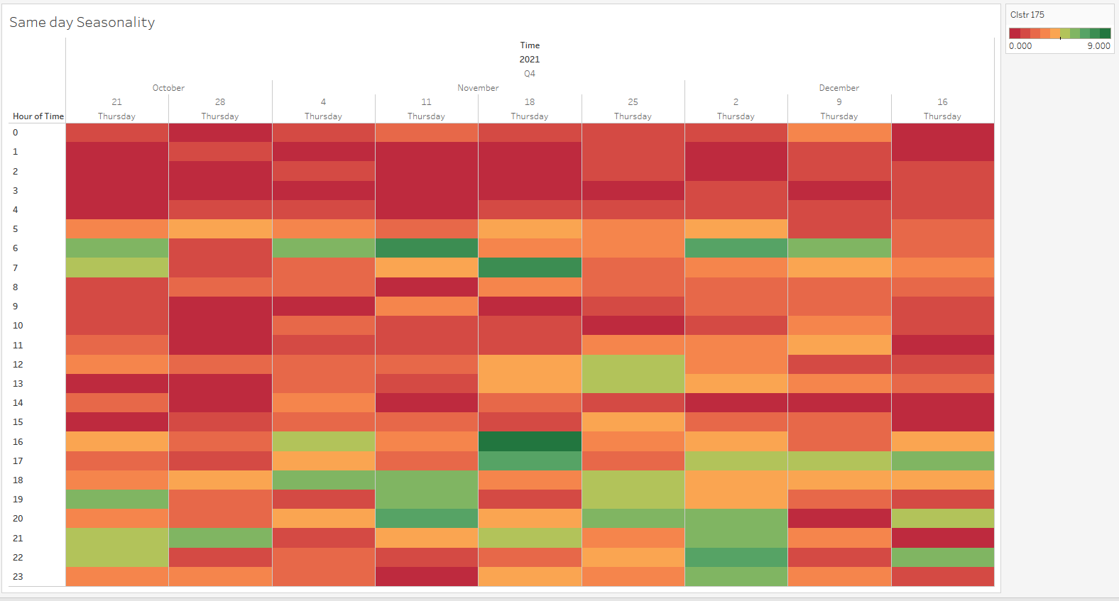

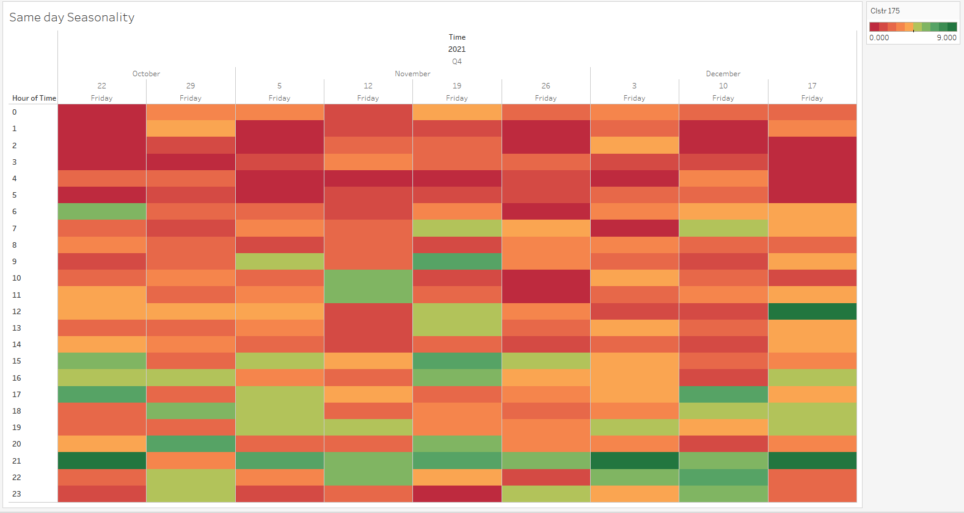

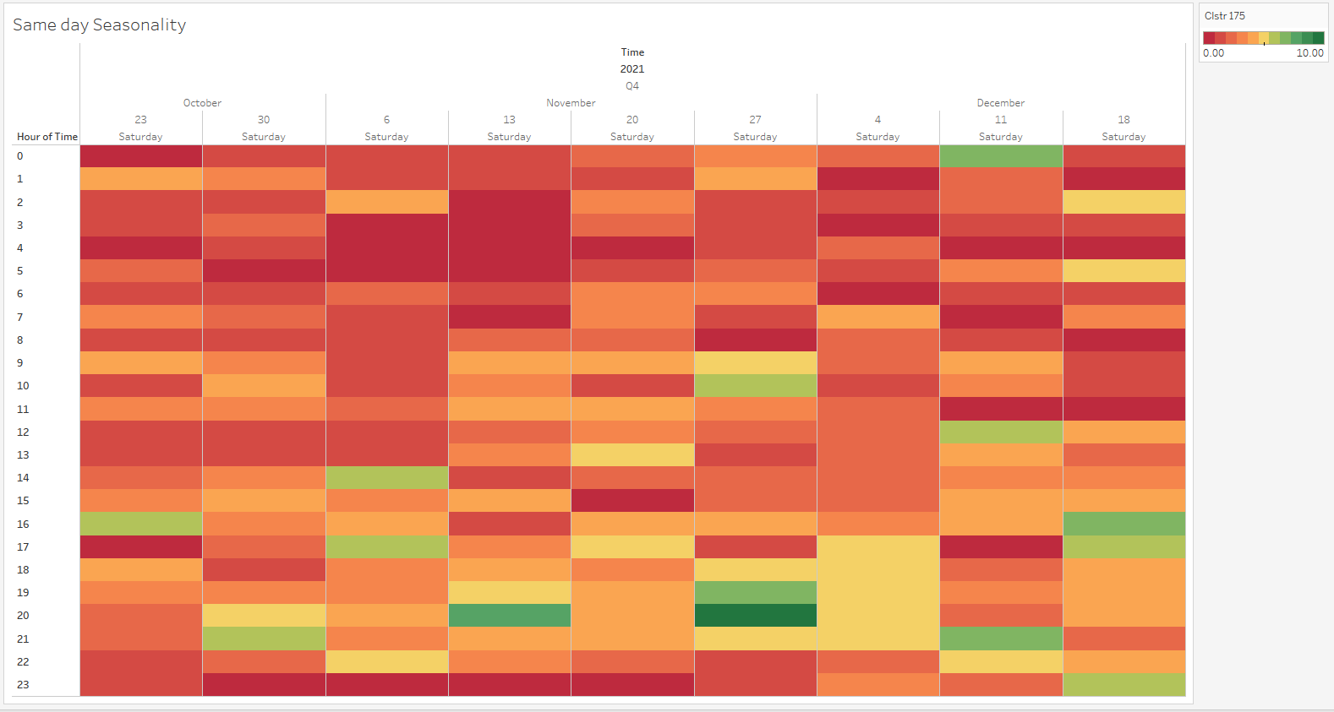

## Daily Seasonality across weeks (TREEMAP)

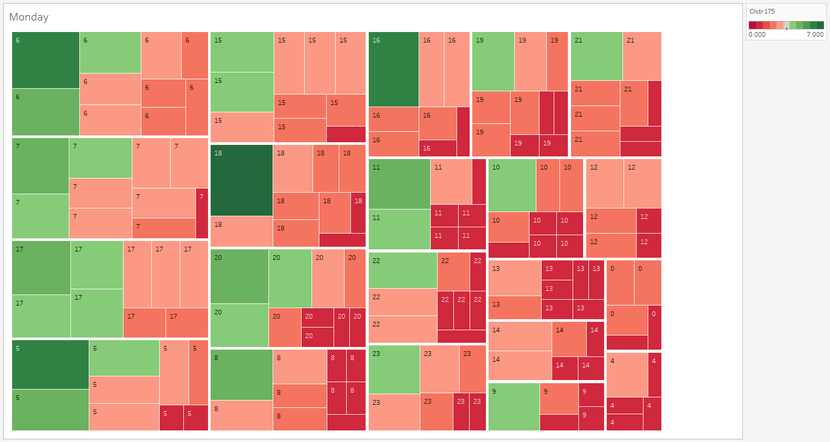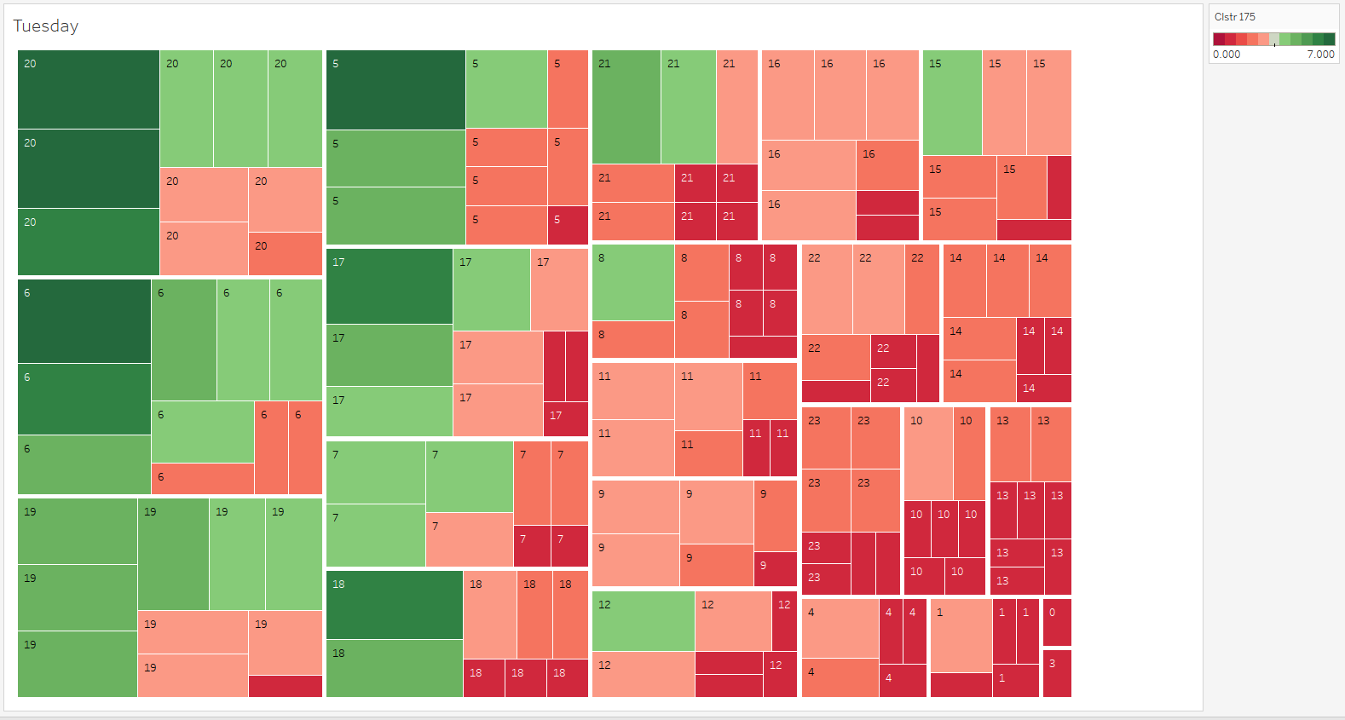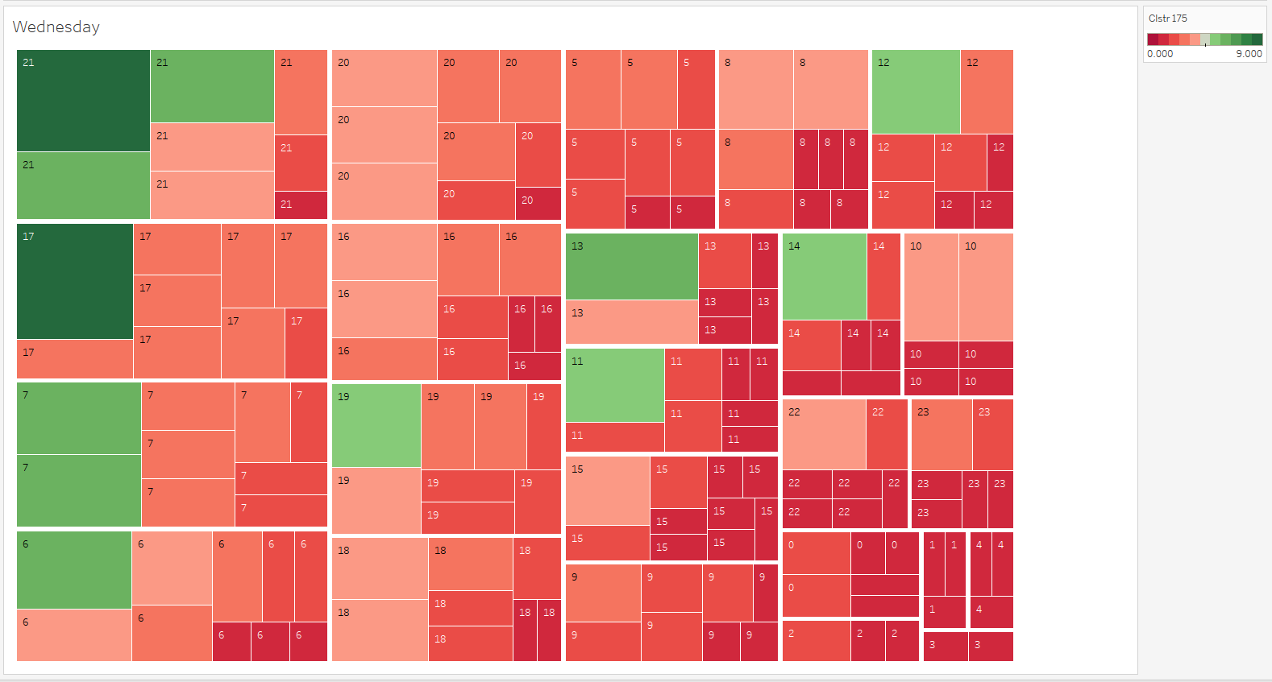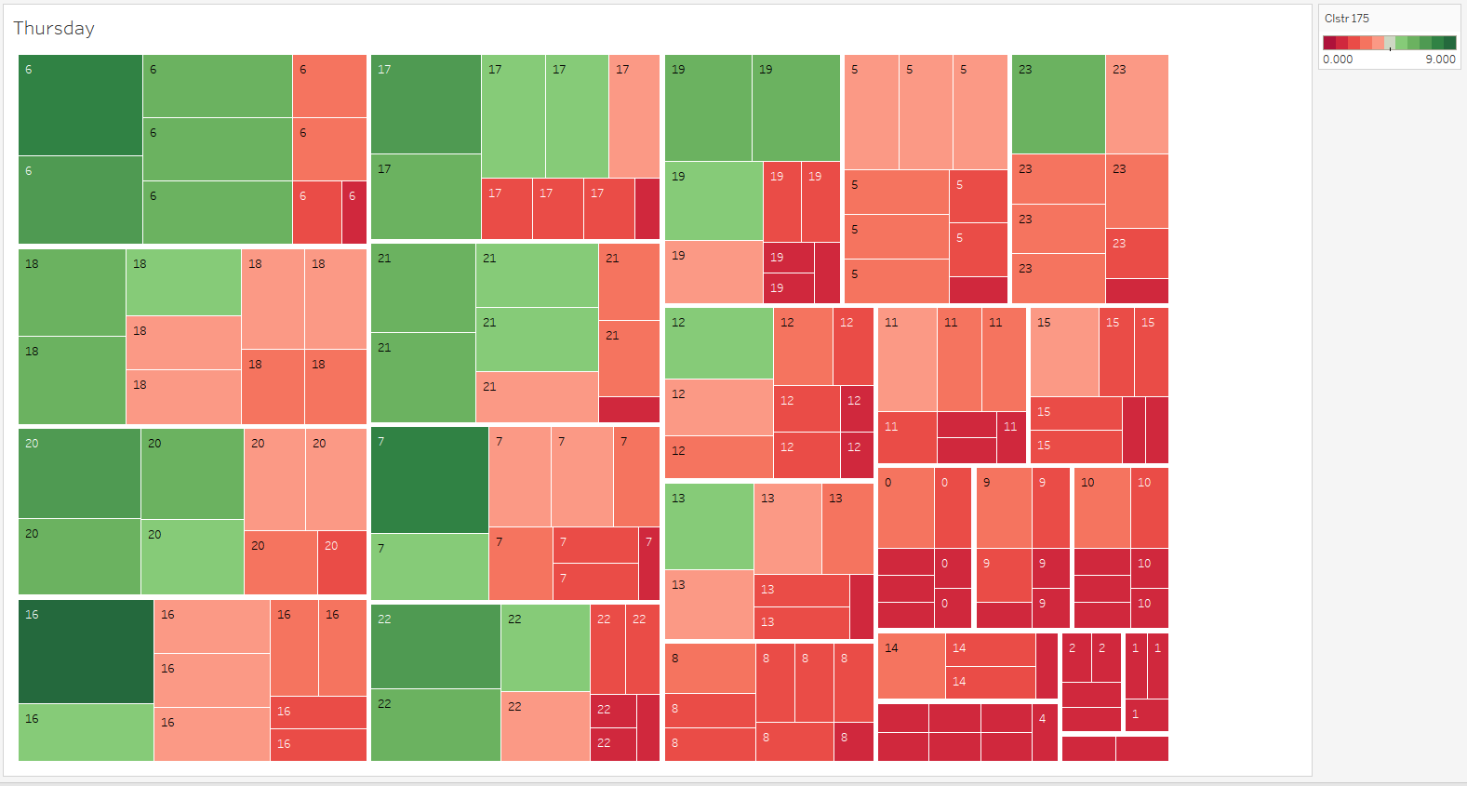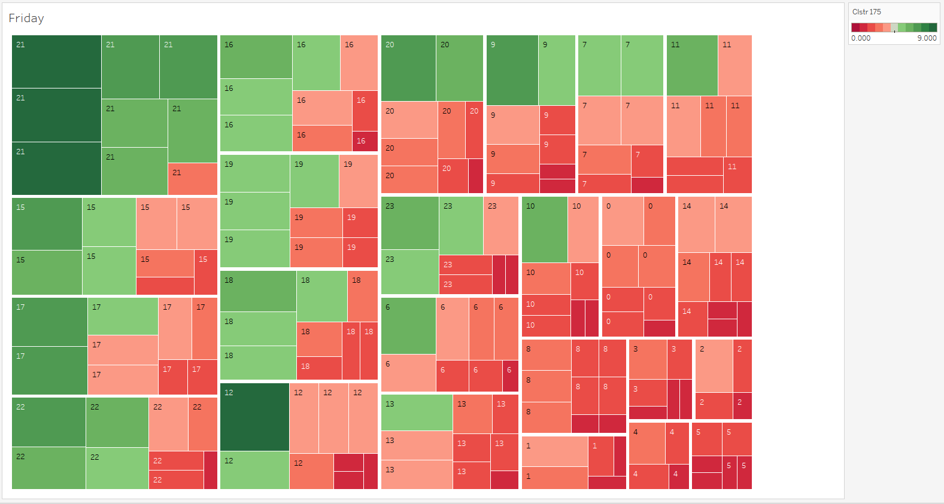

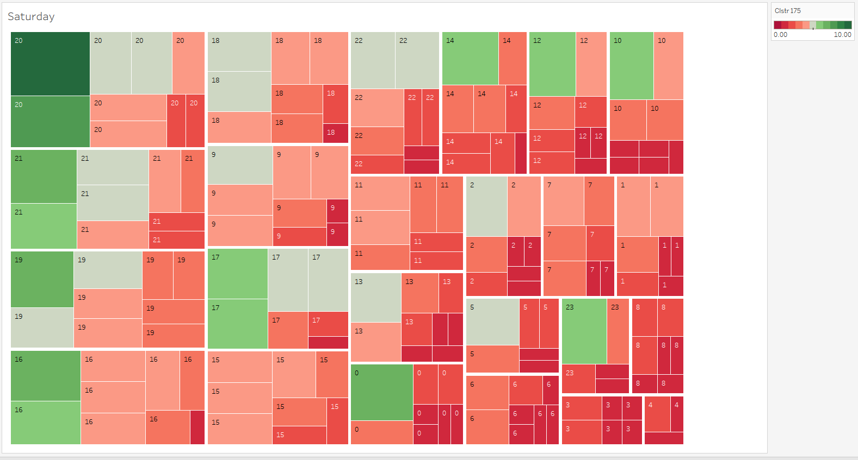

## Weekly distribution for each month

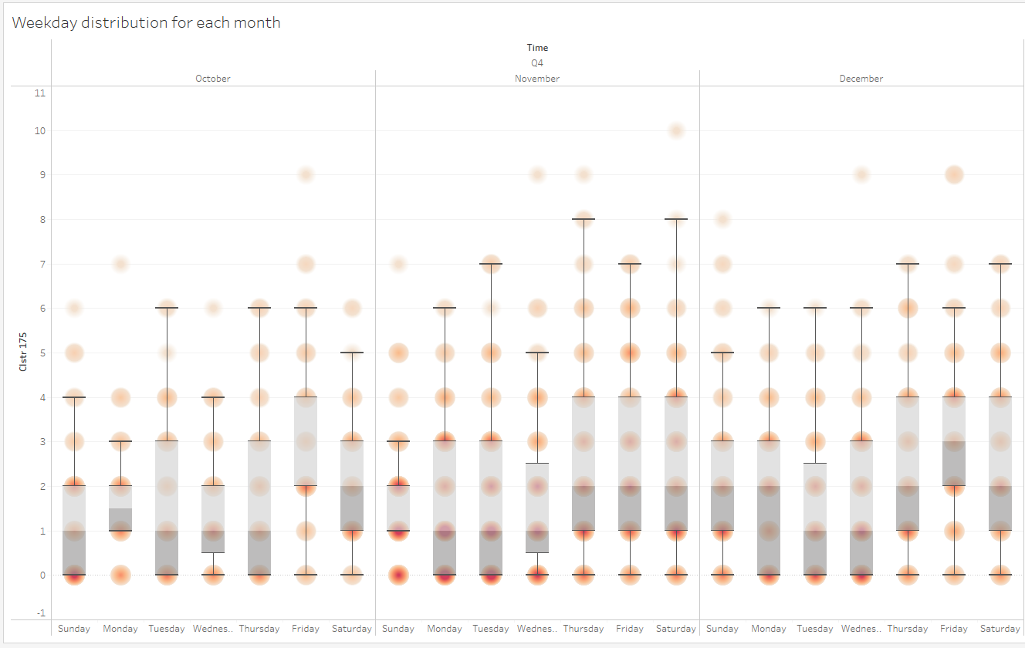

## Seasonality across different days of a week (TREEMAP).

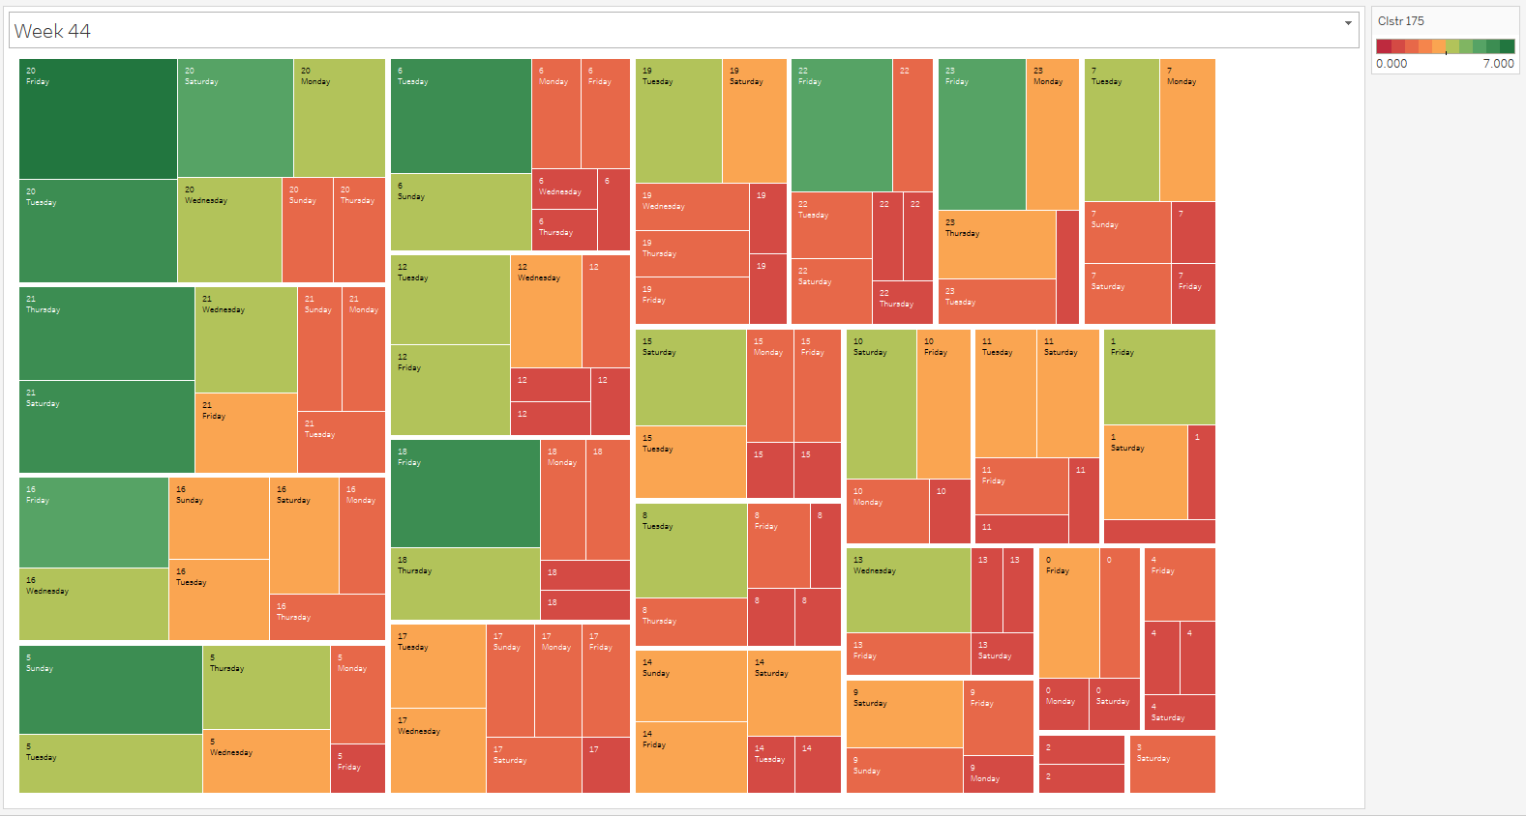

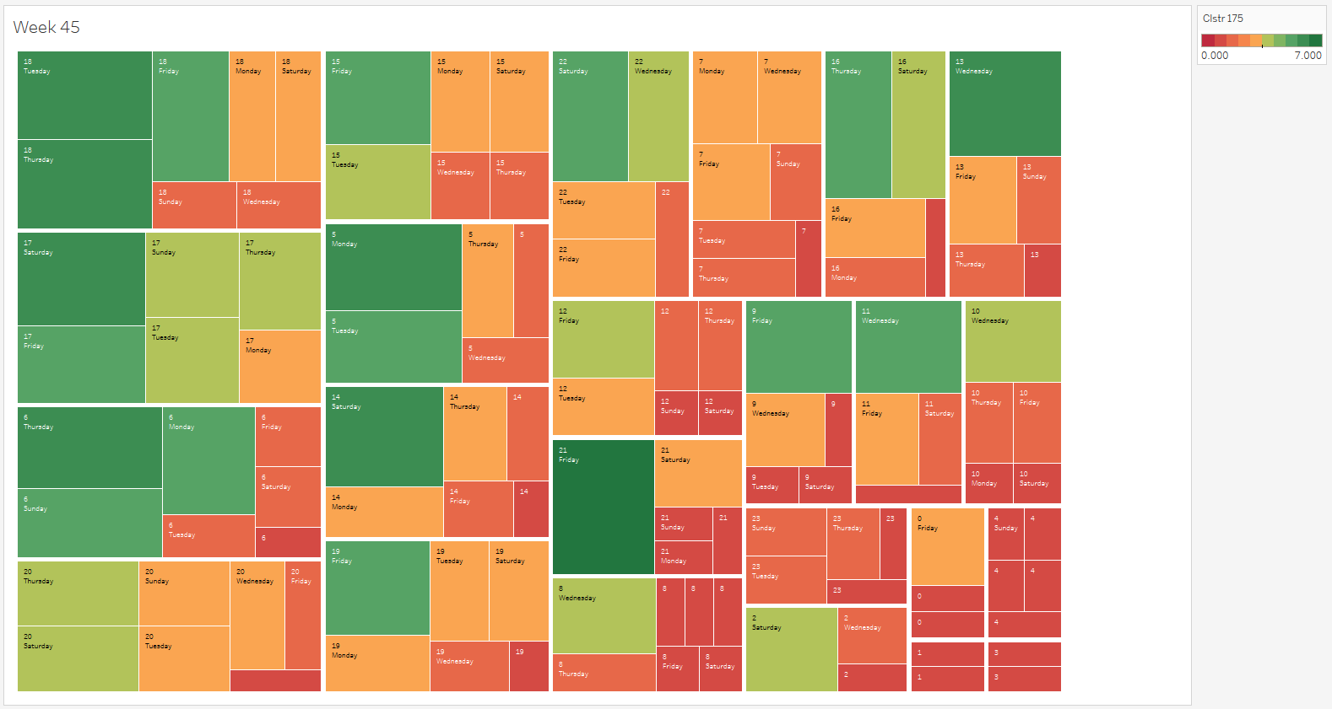

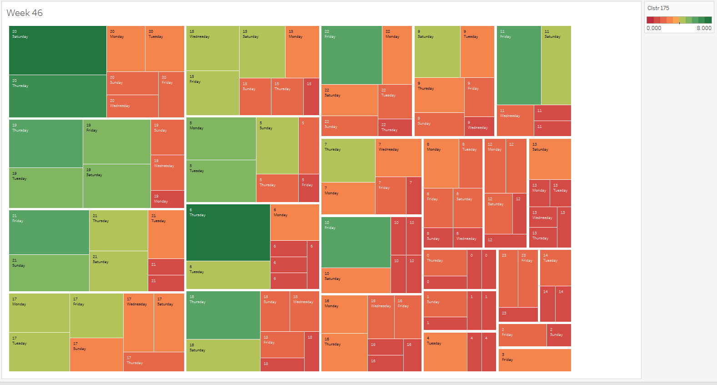

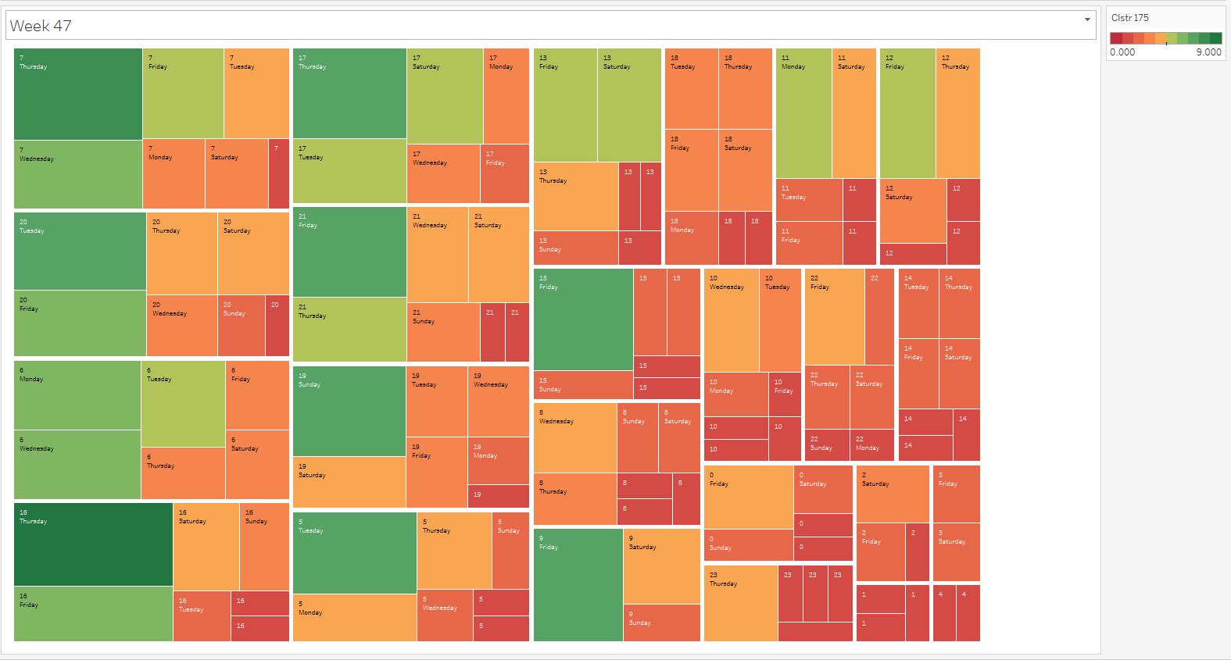

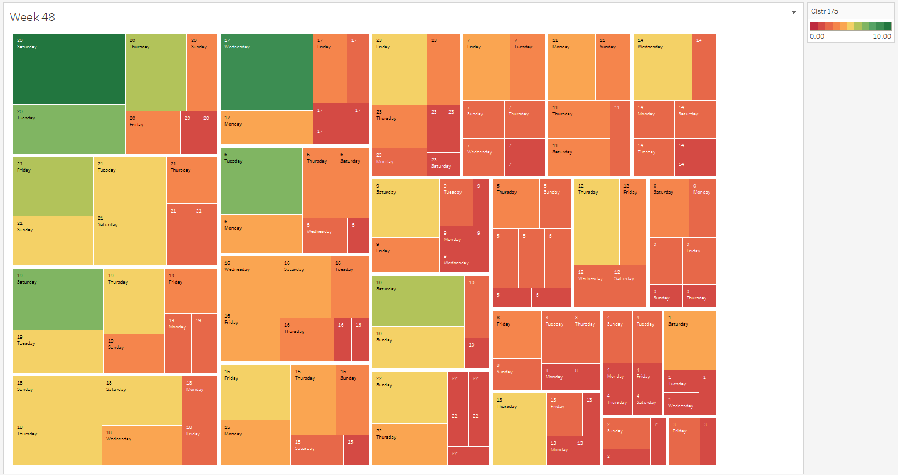

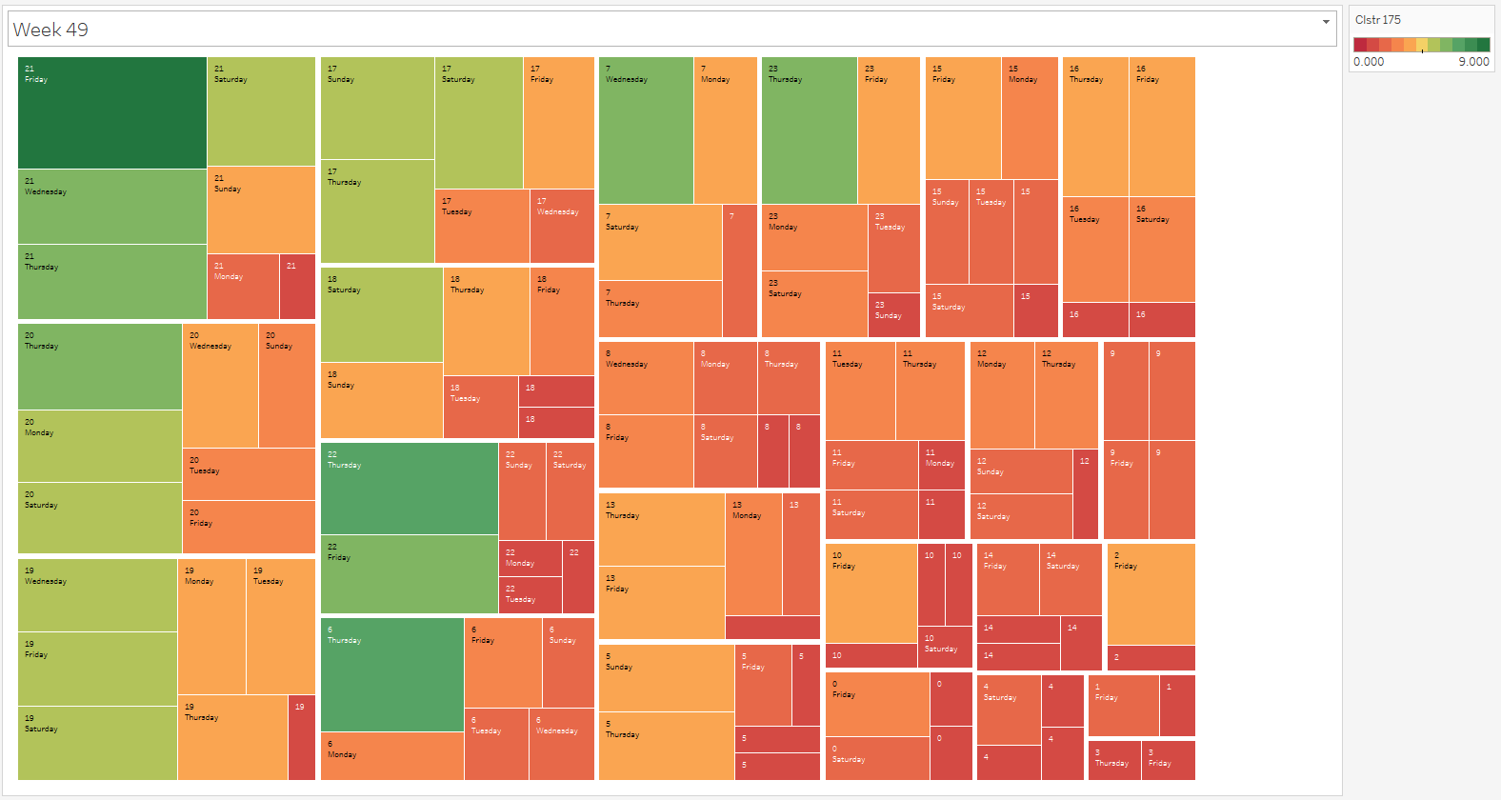

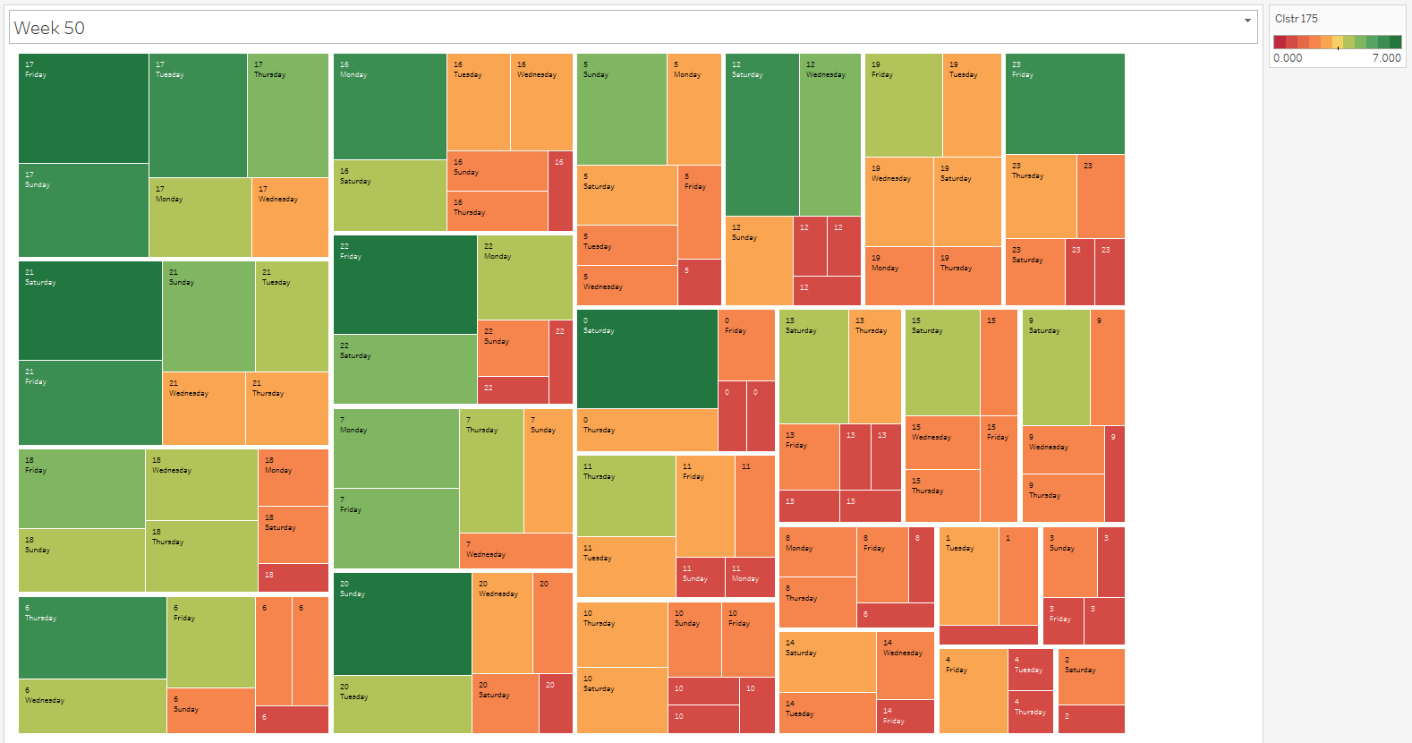

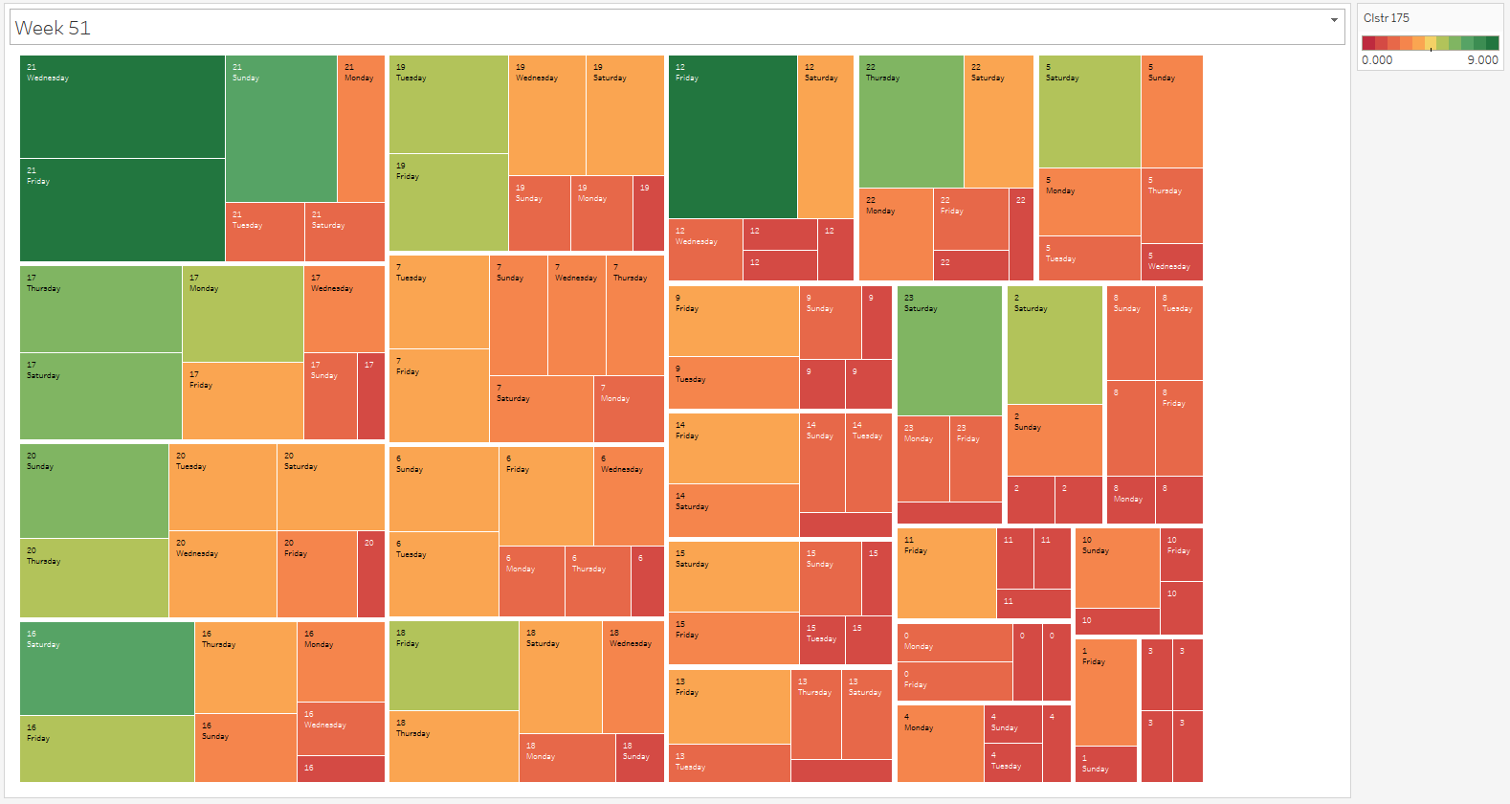

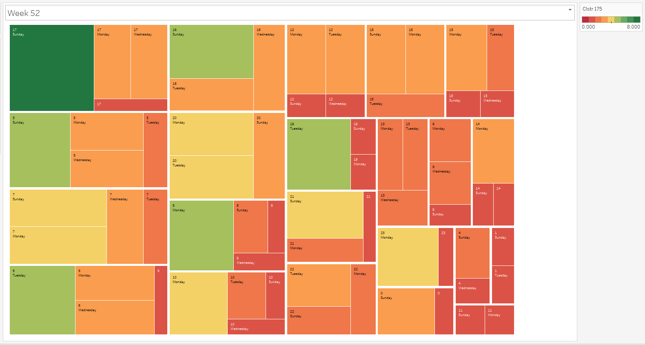

## Seasonality across different days of a week (HEATMAP).

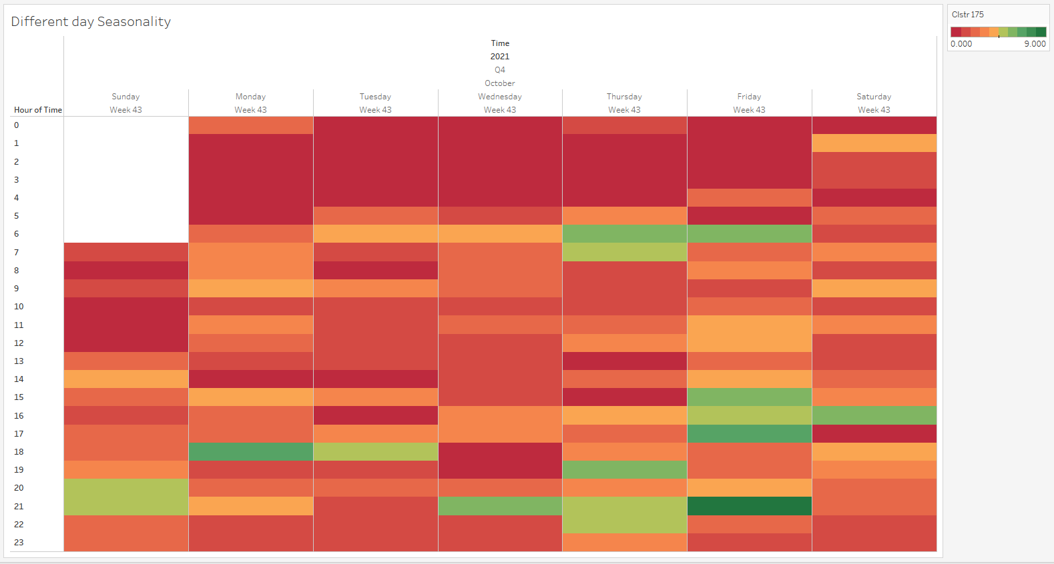

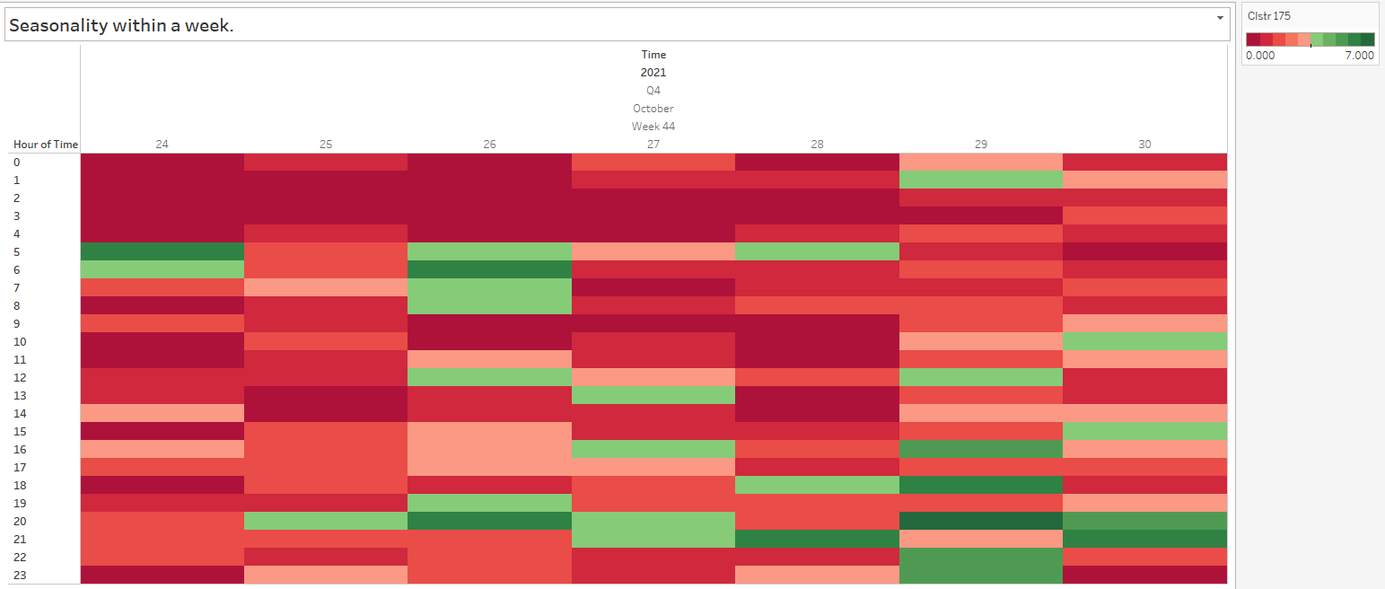

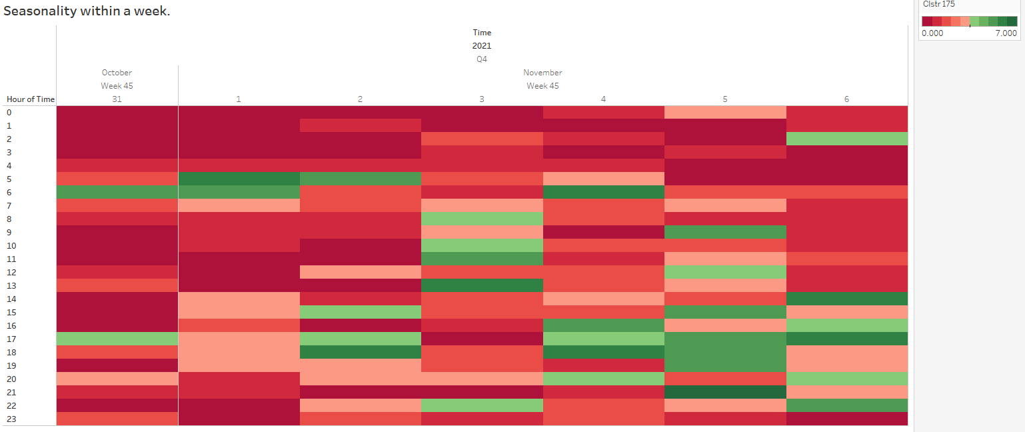

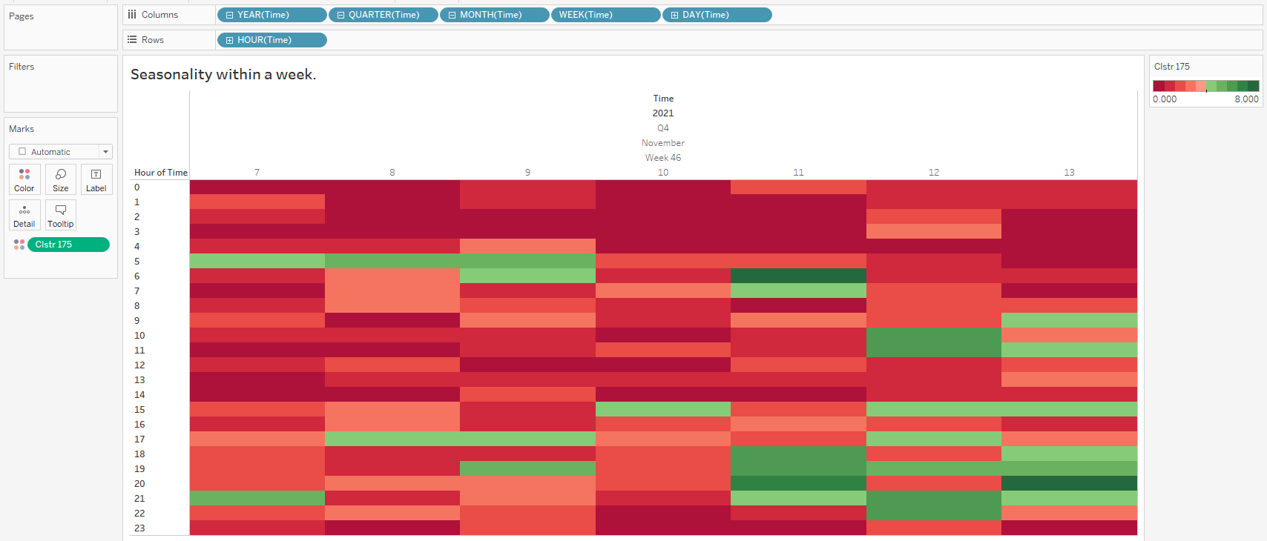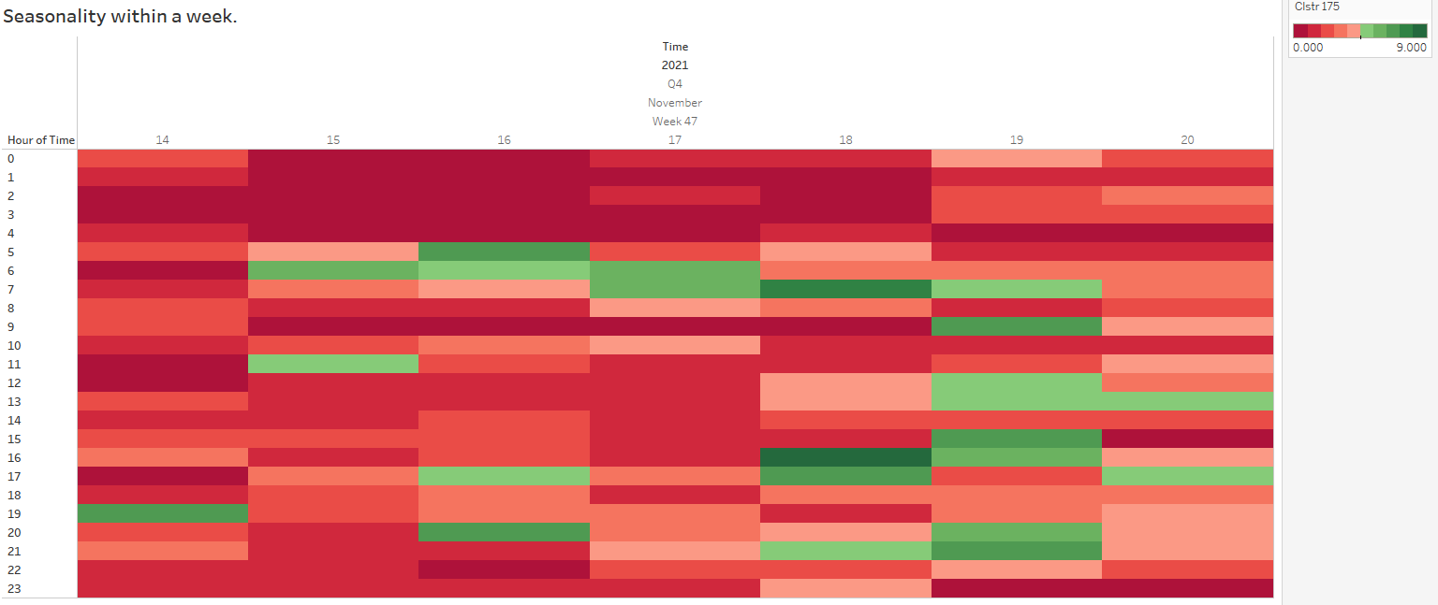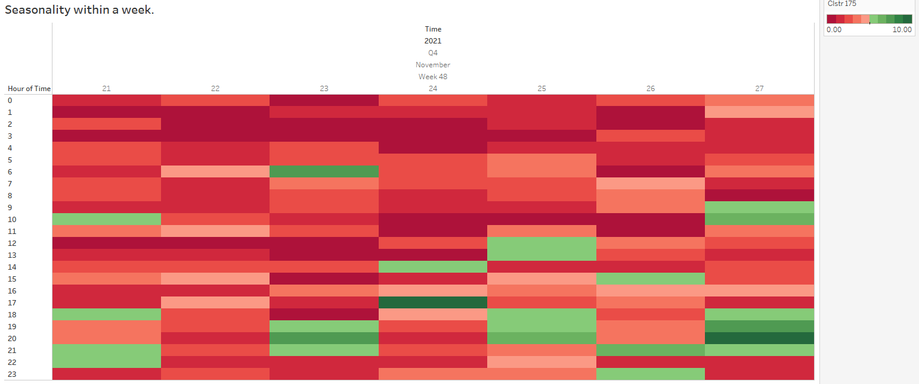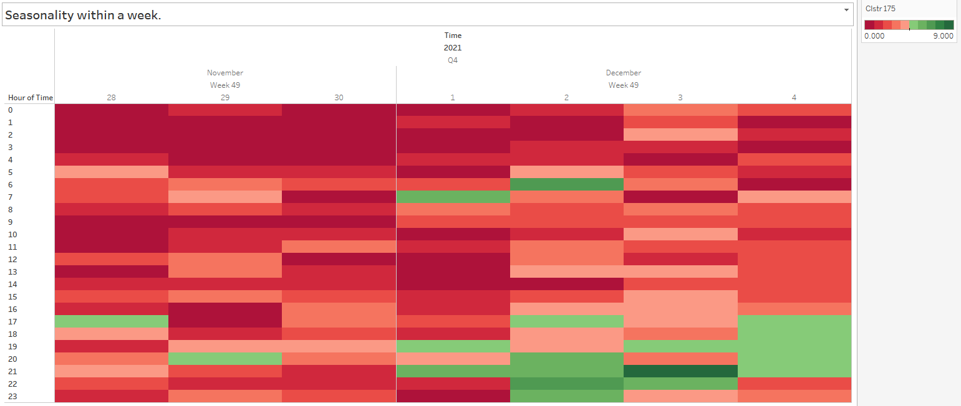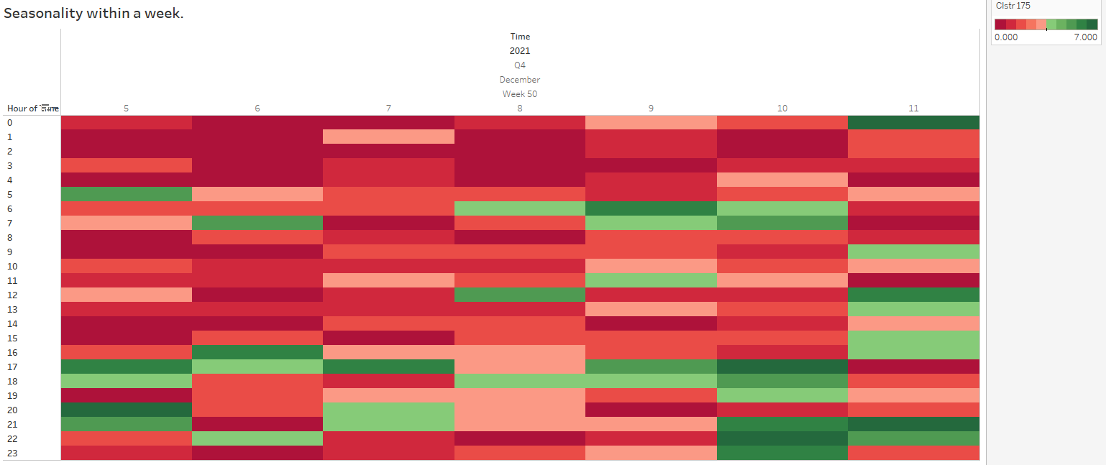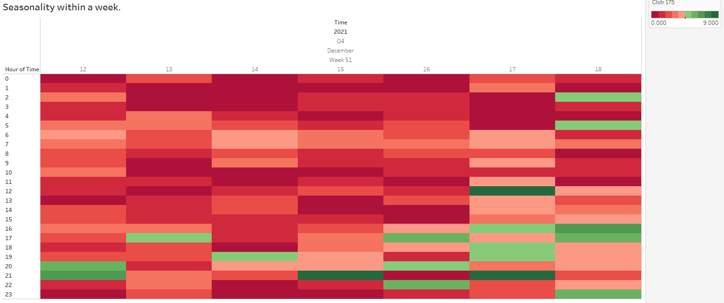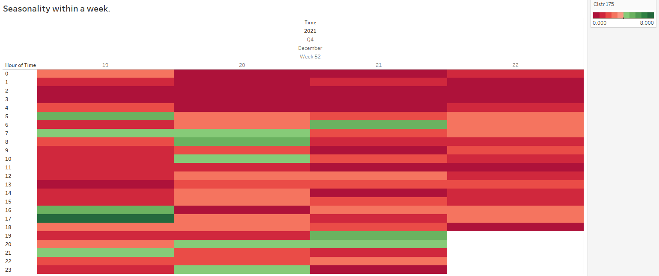

## Frequency distribution plot of temperature

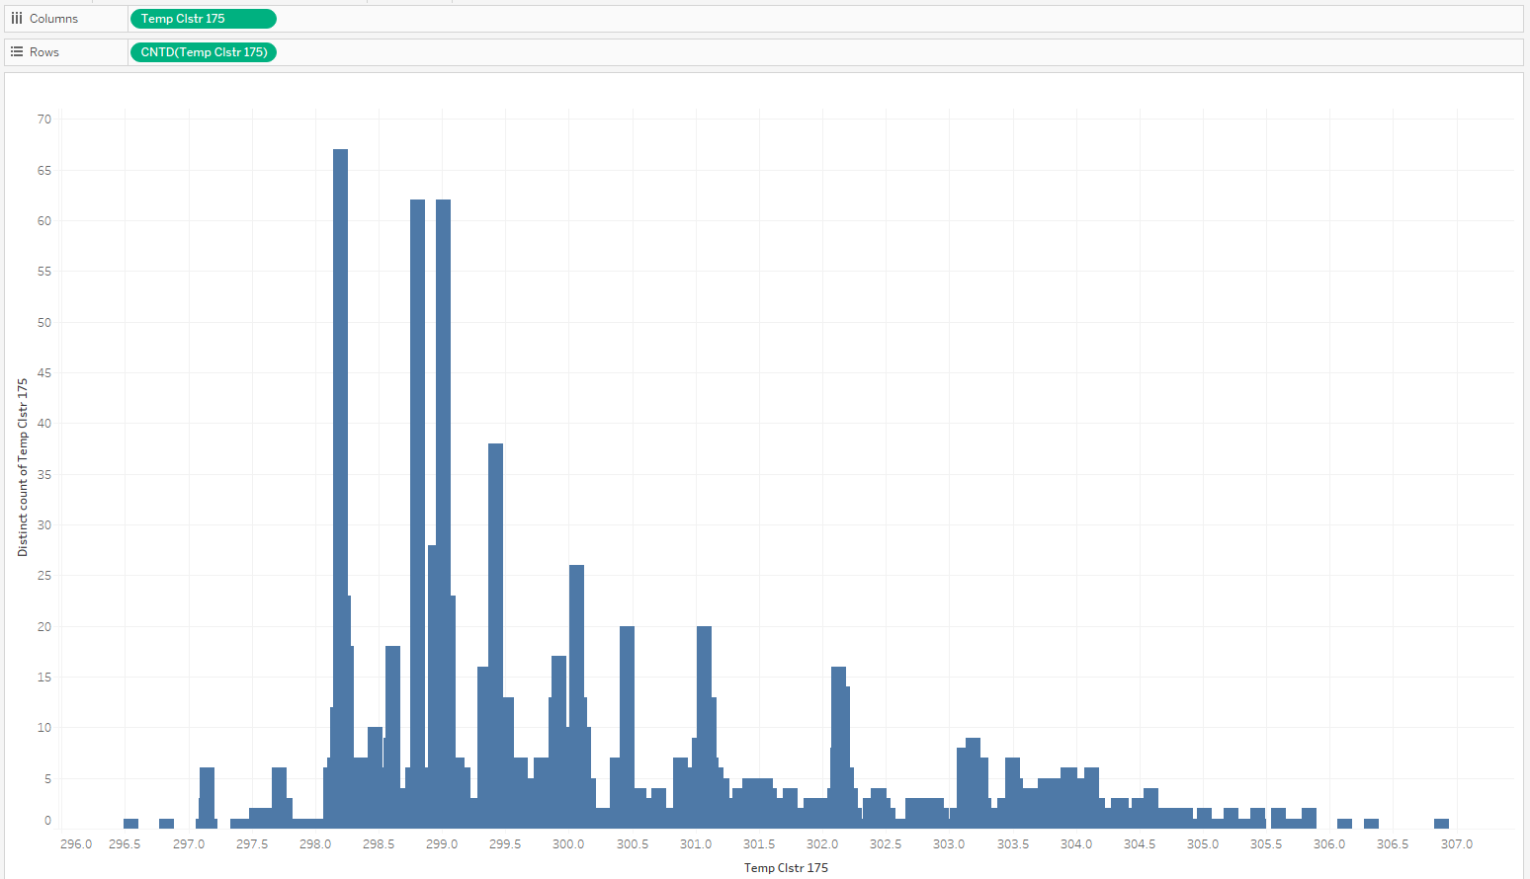

## Hourly temperature boxplot

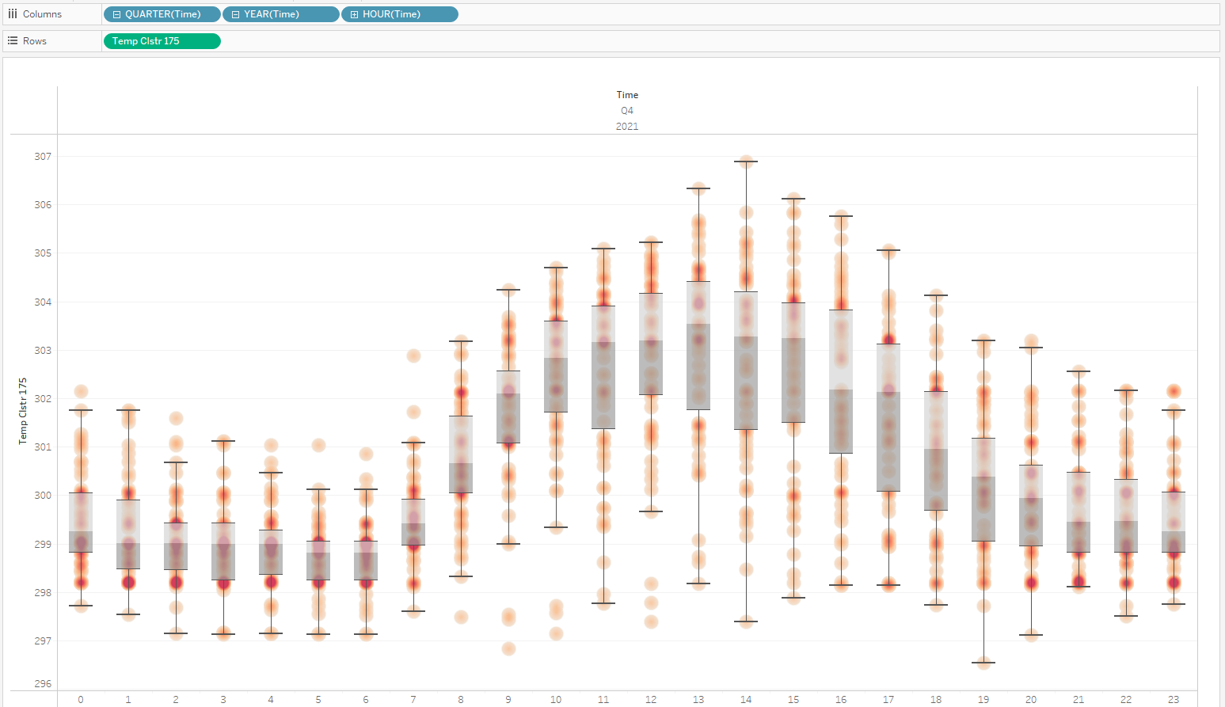

## Treemap of weekend temperature seasonality

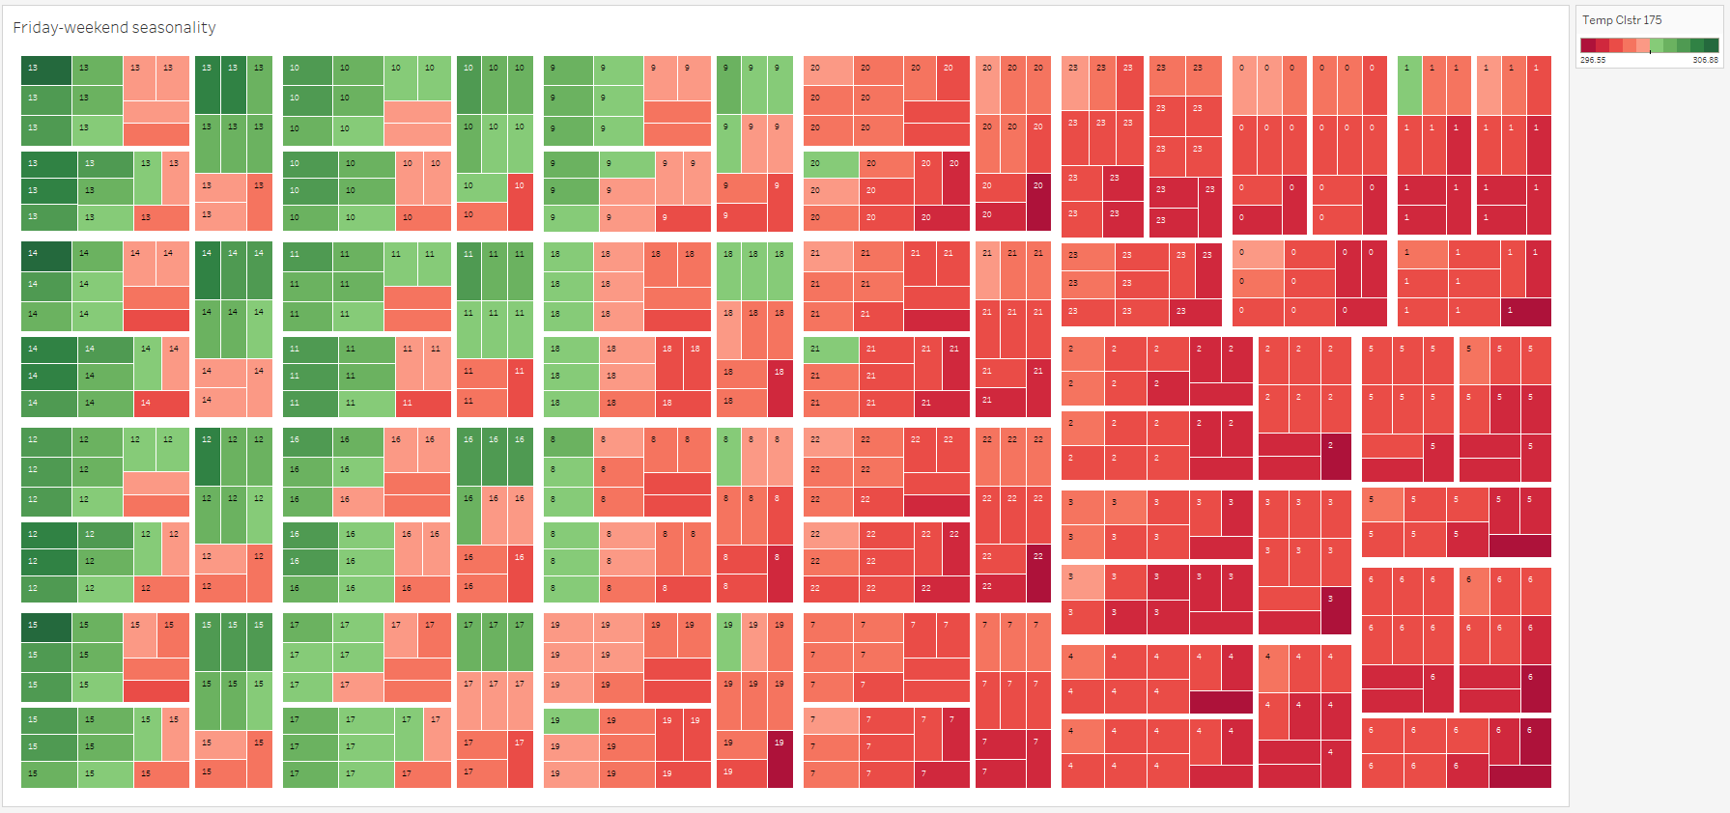

## Treemap for weekdays temperature seasonality

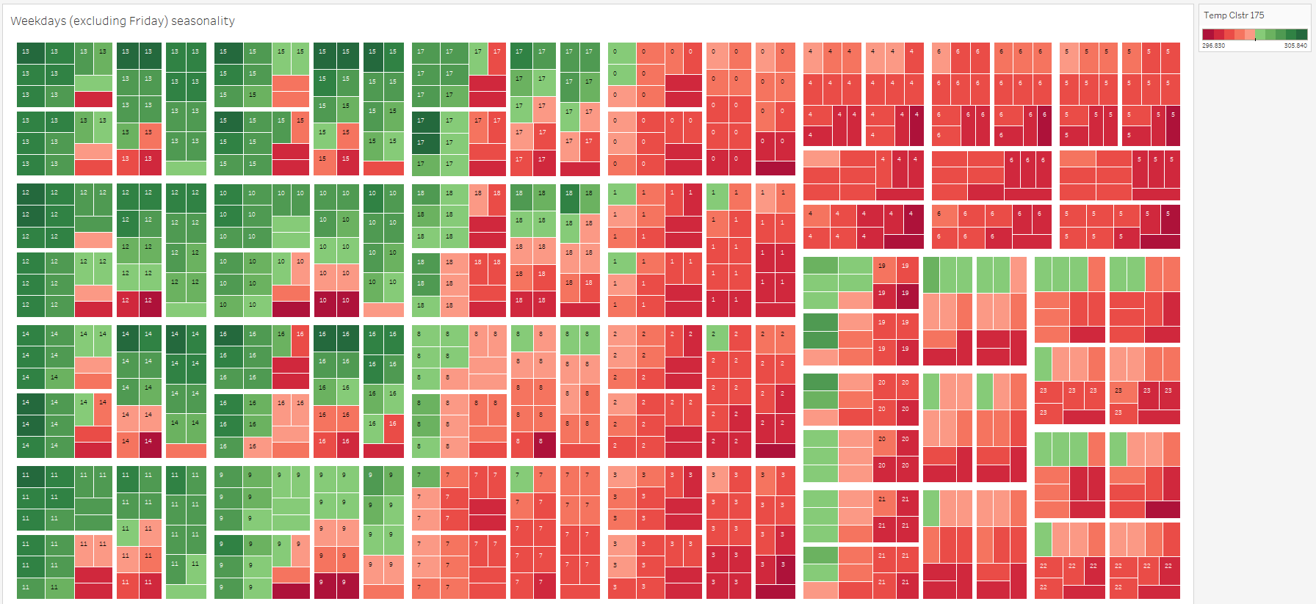

## Daily temperature boxplot

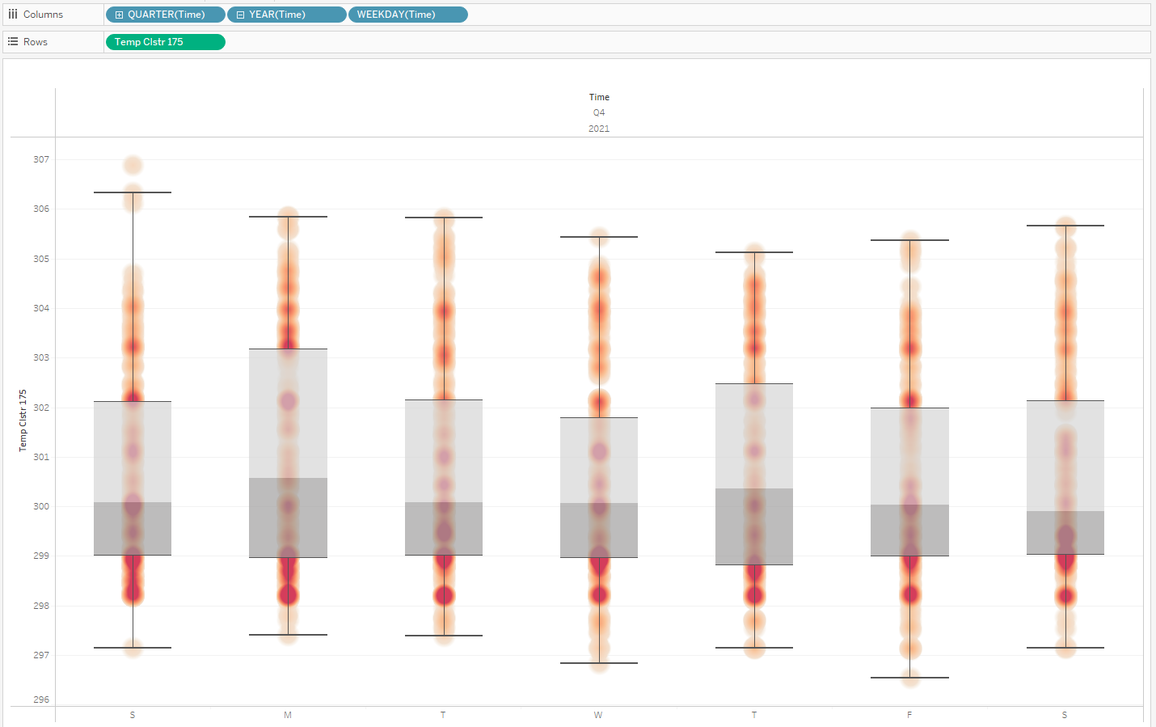

## Frequency distribution plot of humidity

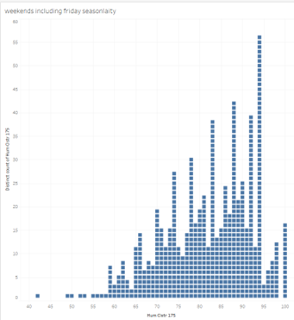

## Hourly humidity boxplot

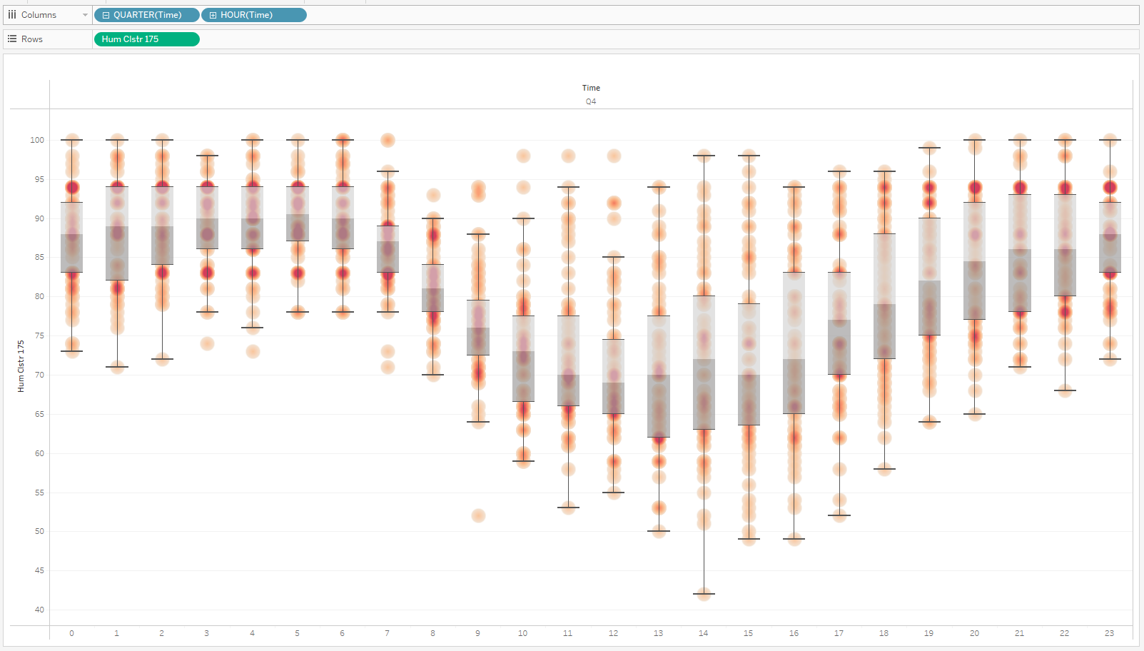

## Treemap of weekend humidity seasonality

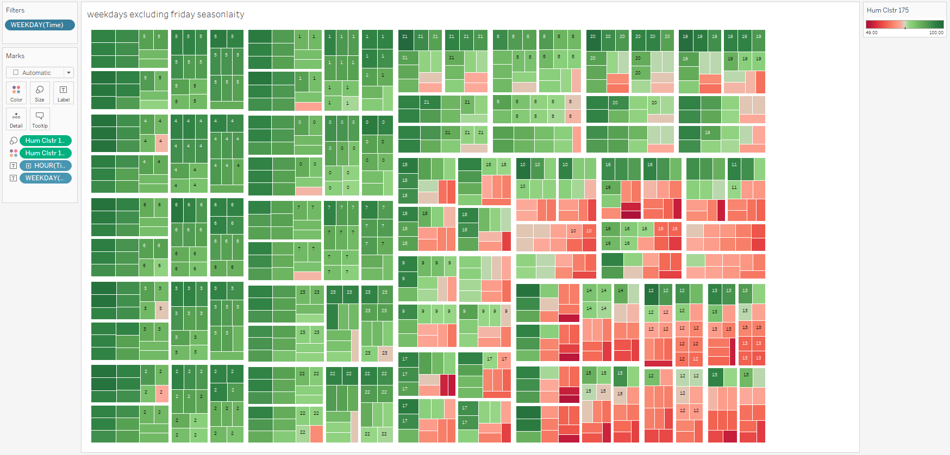

## Treemap for weekdays humidity seasonality

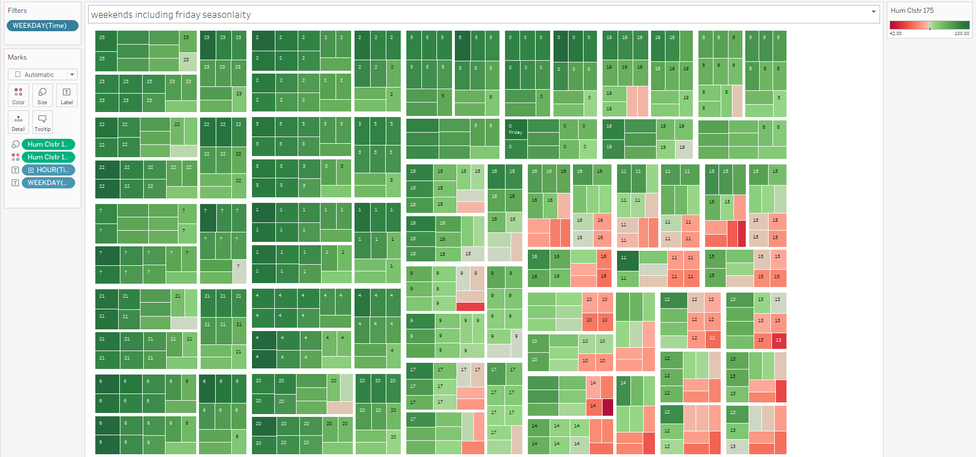

## Daily humidity boxplot

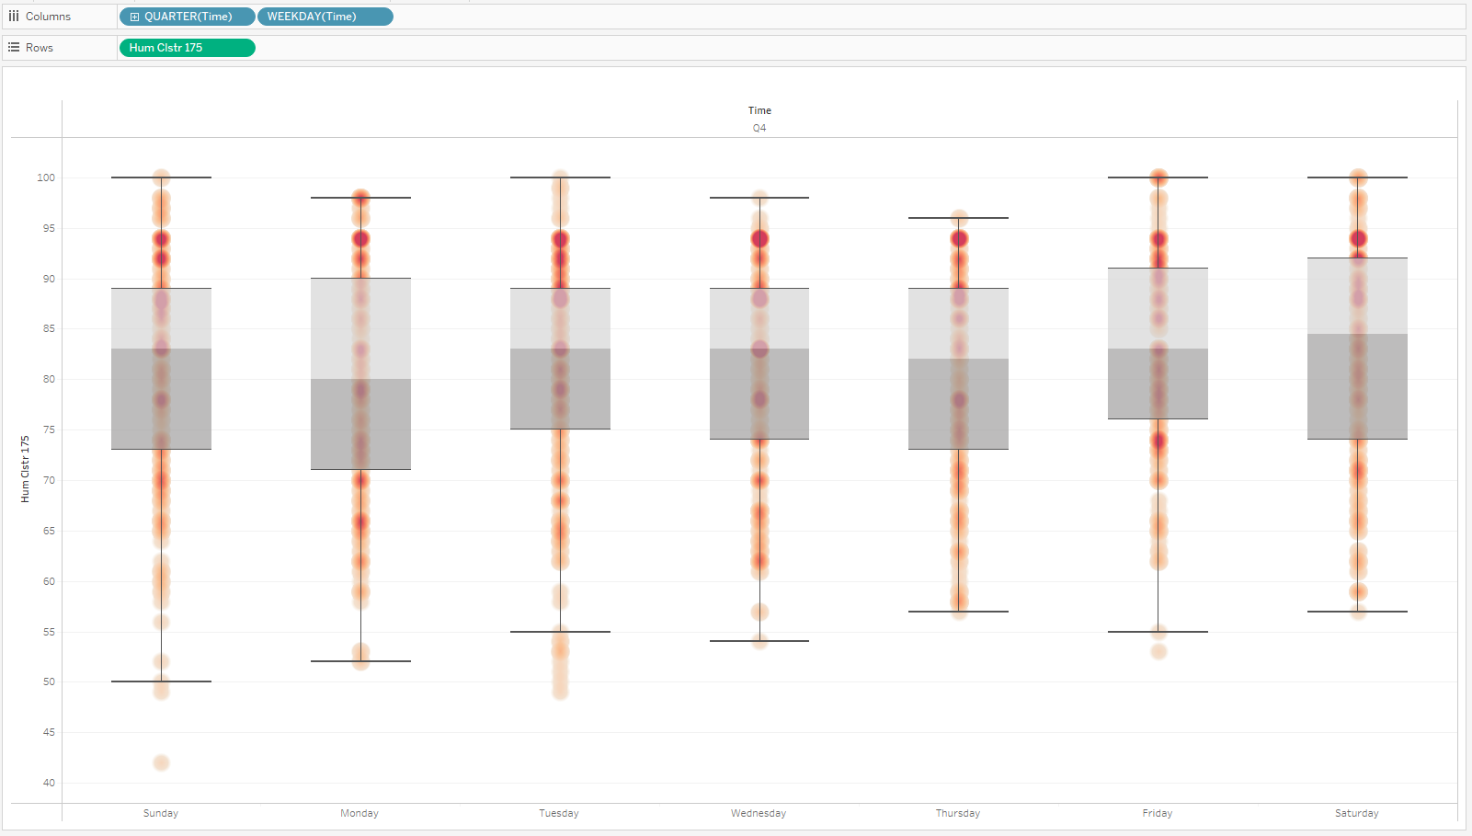

## ARCNBM of the remaining 5 models

Coefficients:

Estimate Std.Error CI(lower) CI(upper)

(Intercept) 0.0698 0.0425 -0.0136 1.53e-01

beta_1 0.2602 0.0392 0.1833 3.37e-01

beta_16 -0.0729 0.0372 -0.1459 6.93e-05

beta_24 0.0505 0.0394 -0.0268 1.28e-01

beta_48 0.0591 0.0398 -0.0189 1.37e-01

beta_91 -0.0478 0.0381 -0.1225 2.68e-02

beta_168 0.2188 0.0391 0.1421 2.95e-01

alpha_1 -0.0582 0.0573 -0.1705 5.41e-02

alpha_16 -0.0413 0.0465 -0.1323 4.98e-02

alpha_24 0.2731 0.0795 0.1173 4.29e-01

alpha_48 -0.2151 0.0605 -0.3336 -9.66e-02

alpha_91 -0.0592 0.0499 -0.1571 3.87e-02

alpha_168 0.3929 0.0734 0.2490 5.37e-01

sigmasq 0.1122 NA NA NA

Standard errors and confidence intervals (level = 95 %) obtained

by normal approximation.

Link function: log

Distribution family: nbinom (with overdispersion coefficient 'sigmasq')

Number of coefficients: 14

Log-likelihood: -2008.226

AIC: 4044.453

BIC: 4115.154

QIC: 4070.956

Coefficients:

Estimate Std.Error CI(lower) CI(upper)

(Intercept) 0.0698 0.0425 -0.0136 1.53e-01

beta_1 0.2602 0.0392 0.1833 3.37e-01

beta_16 -0.0729 0.0372 -0.1459 6.93e-05

beta_24 0.0505 0.0394 -0.0268 1.28e-01

beta_48 0.0591 0.0398 -0.0189 1.37e-01

beta_91 -0.0478 0.0381 -0.1225 2.68e-02

beta_168 0.2188 0.0391 0.1421 2.95e-01

alpha_1 -0.0582 0.0573 -0.1705 5.41e-02

alpha_16 -0.0413 0.0465 -0.1323 4.98e-02

alpha_24 0.2731 0.0795 0.1173 4.29e-01

alpha_48 -0.2151 0.0605 -0.3336 -9.66e-02

alpha_91 -0.0592 0.0499 -0.1571 3.87e-02

alpha_168 0.3929 0.0734 0.2490 5.37e-01

sigmasq 0.1122 NA NA NA

Standard errors and confidence intervals (level = 95 %) obtained

by normal approximation.

Link function: log

Distribution family: nbinom (with overdispersion coefficient 'sigmasq')

Number of coefficients: 14

Log-likelihood: -2008.226

AIC: 4044.453

BIC: 4115.154

QIC: 4070.956

Coefficients:

Estimate Std.Error CI(lower) CI(upper)

(Intercept) 0.00782 0.0338 -0.05847 0.07411

beta_1 0.20696 0.0416 0.12550 0.28841

beta_2 -0.15936 0.0403 -0.23827 -0.08045

beta_16 -0.06510 0.0240 -0.11206 -0.01814

beta_23 0.02524 0.0374 -0.04802 0.09850

beta_24 0.06819 0.0394 -0.00913 0.14551

beta_48 0.00830 0.0216 -0.03409 0.05069

beta_91 -0.02283 0.0247 -0.07130 0.02564

beta_103 -0.07469 0.0385 -0.15011 0.00073

beta_104 0.04492 0.0396 -0.03272 0.12257

beta_109 -0.07165 0.0281 -0.12679 -0.01651

beta_168 0.22653 0.0406 0.14705 0.30602

beta_169 -0.18984 0.0477 -0.28329 -0.09639

alpha_1 0.75067 0.1026 0.54957 0.95178

alpha_2 -0.03940 0.0551 -0.14748 0.06868

alpha_16 0.03439 0.0221 -0.00899 0.07778

alpha_23 0.07133 0.0533 -0.03305 0.17570

alpha_24 -0.06963 0.0574 -0.18211 0.04285

alpha_48 -0.03825 0.0250 -0.08720 0.01069

alpha_91 0.02704 0.0251 -0.02212 0.07620

alpha_103 0.04644 0.0498 -0.05126 0.14414

alpha_104 -0.03696 0.0474 -0.12981 0.05589

alpha_109 0.05428 0.0245 0.00617 0.10239

alpha_168 0.58806 0.0824 0.42662 0.74950

alpha_169 -0.39766 0.1003 -0.59429 -0.20103

sigmasq 0.09827 NA NA NA

Standard errors and confidence intervals (level = 95 %) obtained

by normal approximation.

Link function: log

Distribution family: nbinom (with overdispersion coefficient 'sigmasq')

Number of coefficients: 26

Log-likelihood: -1975.098

AIC: 4002.196

BIC: 4133.499

QIC: 4019.409

Coefficients:

Estimate Std.Error CI(lower) CI(upper)

(Intercept) 0.0698 0.0425 -0.0136 1.53e-01

beta_1 0.2602 0.0392 0.1833 3.37e-01

beta_16 -0.0729 0.0372 -0.1459 6.93e-05

beta_24 0.0505 0.0394 -0.0268 1.28e-01

beta_48 0.0591 0.0398 -0.0189 1.37e-01

beta_91 -0.0478 0.0381 -0.1225 2.68e-02

beta_168 0.2188 0.0391 0.1421 2.95e-01

alpha_1 -0.0582 0.0573 -0.1705 5.41e-02

alpha_16 -0.0413 0.0465 -0.1323 4.98e-02

alpha_24 0.2731 0.0795 0.1173 4.29e-01

alpha_48 -0.2151 0.0605 -0.3336 -9.66e-02

alpha_91 -0.0592 0.0499 -0.1571 3.87e-02

alpha_168 0.3929 0.0734 0.2490 5.37e-01

sigmasq 0.1122 NA NA NA

Standard errors and confidence intervals (level = 95 %) obtained

by normal approximation.

Link function: log

Distribution family: nbinom (with overdispersion coefficient 'sigmasq')

Number of coefficients: 14

Log-likelihood: -2008.226

AIC: 4044.453

BIC: 4115.154

QIC: 4070.956

Coefficients:

Estimate Std.Error CI(lower) CI(upper)

(Intercept) 0.0698 0.0425 -0.0136 1.53e-01

beta_1 0.2602 0.0392 0.1833 3.37e-01

beta_16 -0.0729 0.0372 -0.1459 6.93e-05

beta_24 0.0505 0.0394 -0.0268 1.28e-01

beta_48 0.0591 0.0398 -0.0189 1.37e-01

beta_91 -0.0478 0.0381 -0.1225 2.68e-02

beta_168 0.2188 0.0391 0.1421 2.95e-01

alpha_1 -0.0582 0.0573 -0.1705 5.41e-02

alpha_16 -0.0413 0.0465 -0.1323 4.98e-02

alpha_24 0.2731 0.0795 0.1173 4.29e-01

alpha_48 -0.2151 0.0605 -0.3336 -9.66e-02

alpha_91 -0.0592 0.0499 -0.1571 3.87e-02

alpha_168 0.3929 0.0734 0.2490 5.37e-01

sigmasq 0.1122 NA NA NA

Standard errors and confidence intervals (level = 95 %) obtained

by normal approximation.

Link function: log

Distribution family: nbinom (with overdispersion coefficient 'sigmasq')

Number of coefficients: 14

Log-likelihood: -2008.226

AIC: 4044.453

BIC: 4115.154

QIC: 4070.956

## Diagram Description automatically generatedDetailed Block DiagrAM

# 13 FAQ

1. What is the difference between Autocorrelation and FFT?
   1. ACF: Any instance Correlated by all lags. FFT: any instance is correlated by the same point in the period.

# 14 Bibliography

David Salinas, V. F. (2020). DeepAR: Probabilistic Forecasting with Autoregressive Recurrent Networks. *International Journal of Forecasting*.

Gneiting. (n.d.). Probabilistic forecasts, calibration and sharpness.

Hyndman, R. J. (n.d.). Retrieved from https://otexts.com/fpp2/arima.html

Liboschik, T. (n.d.). Retrieved from chrome-extension://efaidnbmnnnibpcajpcglclefindmkaj/https://cran.r-project.org/web/packages/tscount/vignettes/tsglm.pdf

Mustafa. (n.d.). Retrieved from https://mmuratarat.github.io/2019-02-07/bptt-of-rnn

pierre. (n.d.). *verification of probabilistic forecasts*. Retrieved from https://www.youtube.com/watch?v=Ffo8XilZAZw